Domestic wastewater treatment using integrated constructed wetland – microbial fuel cell reactor with bioelectricity generation

Anjishnu Biswas1 , Saswati Chakraborty2

1 Department of Civil Engineering, IIT Guwahati, India
2 Department of Civil Engineering, IIT Guwahati, India

E-mail: anjishnu18@iitg.ac.in

Abstract

Integration of different technologies with constructed wetlands has become the major focus of latest wetland research so as to overcome the drawbacks of constructed wetlands, particularly the large area footprint. The current study focuses on the long term treatment of raw domestic wastewater using integrated constructed wetland – microbial fuel cell reactor (CW-MFC) for the removal of organics and coliform and to monitor the bioelectricity production. Raw wastewater was collected from the IIT Guwahati sewage treatment plant and was treated using three identical reactors for 325 days. One CW-MFC, and the other two are constructed wetland (CW) and microbial fuel cell (MFC) controls. Typha angustifolia was collected from local marshlands and used in the CW and CW-MFC reactors as wetland vegetation. In terms of COD removal, the CW-MFC reactor achieved 93% efficiency whereas CW and MFC controls achieved 87% and 86% efficiencies, respectively. BOD removal efficiency in the CW-MFC, MFC and CW reactors were found to be similar around 92%. The total coliform removal was better in the CW (log 2.946) than CW-MFC (log 2.925). However the faecal coliform removal in CW-MFC was much higher (log 3.511) compared to CW (log 2.94). Significant effect of temperature variation throughout the year was observed in coliform removal, as the efficiency dropped significantly during winter time. However, not much seasonal variation was observed in electricity production and organic removal performance of the reactors. The maximum open circuit voltage in CW-MFC reactor was 886 mV and in the MFC was 487 mV during complete study. The maximum power density (PD), and current density (CD) for CW-MFC was observed to be 4.65 mW/m2 and 1.32 mA/m2 and for MFC were 1.32 mW/m2 and 16.58 mA/m2 respectively. Coulombic efficiency for CW-MFC and MFC were 0.93 and 0.55% respectively. Plants played a positive role in enhancing the electrical performance of the integrated system compared to the unplanted MFC by increasing the redox potential. Presence of dissolved oxygen was also detected near the rhizosphere of the planted reactors in minute levels.
Student Academic Board (SAB), Indian Institute of Technology Guwahati, Guwahati, Assam, India

Keywords: CW-MFC, Bioelectricity, Wastewater treatment

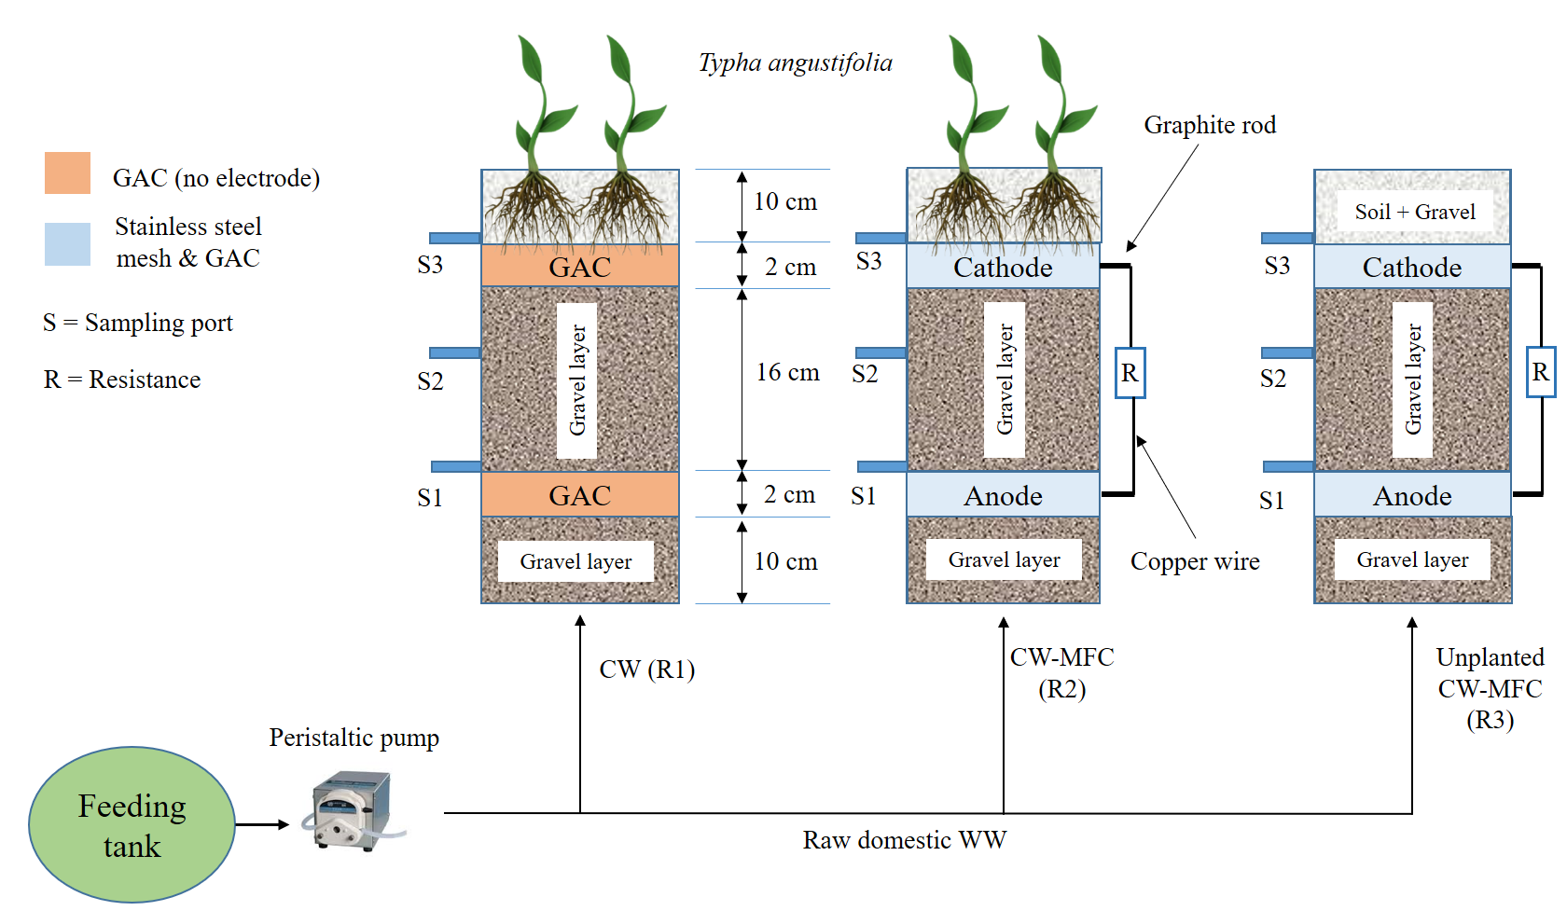

Figure 1. Schematic diagram of reactor system

