Assessment of Sewage Treatment Plant of IIT Guwahati: A Case Study

Anjishnu Biswas1 , Saswati Chakraborty2

1 Department of Civil Engineering, IIT Guwahati, India
2 Department of Civil Engineering, IIT Guwahati, India

E-mail: anjishnu18@iitg.ac.in

Abstract

The sewage treatment plant of IIT Guwahati is a facultative lagoon system comprising a grit chamber, two facultative lagoons with provision of mechanical aeration, a baffled polishing pond and a disinfection unit. The flow chart of the STP is shown in figure 1. In the current study the final effluent was obtained from the polishing pond which acts as a tertiary treatment unit. The treated effluent was analysed for COD, BOD, pH, and total coliforms. After the effluent analysis, it was found that the overall efficiency of the treatment plant was around 45 to 50% in terms of BOD and COD removal. The mean COD and BOD removal of the IITG STP was found to be 50.9 ± 3.9% and 44.6 ± 5% respectively. The average COD and BOD concentrations in IITG STP effluent was 87.3 ± 13 and 58.8 ± 8.2 mg/L. The effluent BOD value was much higher than the effluent standards (30 mg/L) prescribed in the environmental protection act, 1986, for surface water discharge (CPCB, 2017). The average pH of the effluent was 6.9 and the most probable number (MPN) for total and faecal coliform was 150000 and 78166 per 100 mL corresponding to log removal of 1.9 and 2.05 respectively. The high MPN values seek for the application of additional treatment units focusing on removal of coliforms for the purpose of wastewater reuse.
Student Academic Board (SAB), Indian Institute of Technology Guwahati, Guwahati, Assam, India

Keywords: WASTEWATER TREATMENT, FACULTATIVE LAGOON, COLIFORM

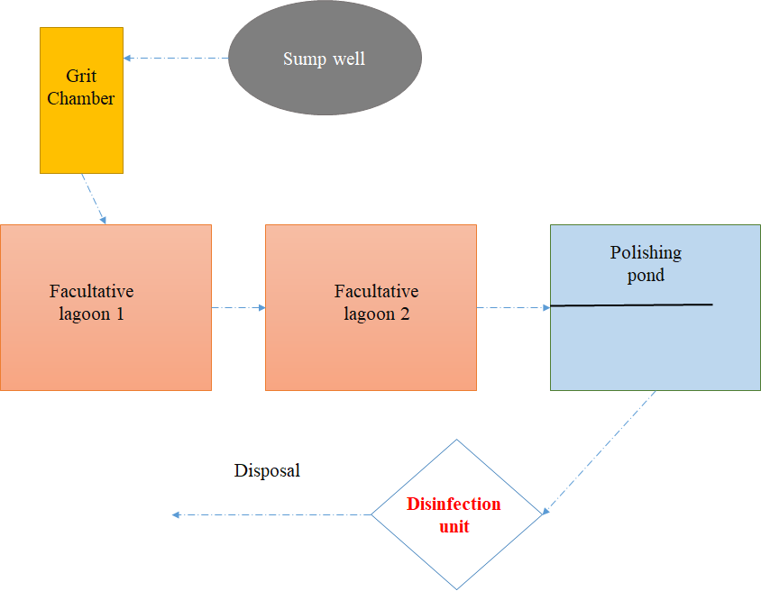

Figure 1. Flow chart of IITG sewage treatment plant

