Impact of associated carbohydrate binding modules, CBM3A and CBM3B in stability and catalysis by an β-1,4 endoglucanase, AtGH9C-CBM3A-CBM3B from Acetivibrio thermocellus ATCC 27405
Ardhendu Mandal*, Abhijeet Thakur and Arun Goyal
Carbohydrate Enzyme Biotechnology Laboratory, Department of Biosciences and Bioengineering, Indian Institute of Technology Guwahati, Guwahati, Assam
*Corresponding author. Tel: +91 9564359408, E-mail: ardhendu_mandal@iitg.ac.in

Abstract

A new multimodular enzyme of the family 9 GH (AtGH9C-CBM3A-CBM3B) from thermophilic anaerobic bacterium Acetivibrio thermocellus ATCC27405 was explored for biochemical properties and reaction mechanism and the role of its associated CBMs in substrate catalysis was elucidated. AtGH9C-CBM3A-CBM3B is a multi-modular endoglucanase containing a GH9 catalytic module (AtGH9C) at N-terminal followed by two different CBMs, CBM3A and CBM3B, joined by a linker sequence at C-terminal. The gene expressing the full length multi-modular β-1,4-endoglucanase (AtGH9C-CBM3A-CBM3B) and its truncated derivatives (AtGH9C-CBM3A, AtGH9C, CBM3A and CBM3B) GH9 catalytic module with one CBM (AtGH9C-CBM3A), only GH9 catalytic module (AtGH9C) and the two CBMs i.e., CBM3A and CBM3B were independently cloned and expressed in Escherichia coli BL21(DE3) cells and purified. AtGH9C-CBM3A-CBM3B showed maximal activity at 55°C and optimum pH was 7.5. AtGH9C-CBM3A-CBM3B exhibited highest activity against carboxy methyl cellulose (58.8 U/mg) followed by lichenan (44.5 U/mg), β-glucan (36.2 U/mg) and hydroxy ethyl cellulose (17.9 U/mg). A similar trend was observed for AtGH9C-CBM3A with lower activity than the full-length endoglucanase, AtGH9C-CBM3A-CBM3B indicating the involvement of CBMs in catalysis. AtGH9C showed insignificant activity against the substrates, signifying the essential requirement of CBMs in catalysis. Mg²⁺ ion significantly enhanced the catalytic activity of AtGH9C-CBM3A-CBM3B. Moreover, EDTA and EGTA lowered the enzyme activity as well as the T_{m} from 65°C to 60°C, demonstrating that it contains inherent Mg²⁺ ions involved in catalysis and structure stability. The predominant presence of cellotetraose and higher oligosaccharides during 24 h in TLC analysis of in carboxymethyl cellulose (CMC) hydrolysis hydrolysates by AtGH9C-CBM3A-CBM3B indicated that the enzyme is an endo-β-1,4-glucanase. AtGH9C alone is ineffective in CMC hydrolysis, however, its activity was partially recovered by the addition of equimolar concentration of CBM3A, CBM3B or CBM3A+CBM3B by 47%, 13% or 50%, respectively. Moreover, the associated CBMs imparted thermostability to the catalytic module, AtGH9C. These results showed that the physical association of AtGH9C with its associated CBMs and the cross-talk between CBMs are necessary for AtGH9C-CBM3A-CBM3B to perform effective catalysis on cellulosic substrates.
Student Academic Board (SAB), Indian Institute of Technology Guwahati, Guwahati, Assam, India
Research & Industrial Conclave 2023 "An amalgamation of Academia, Industry & Start-up
"

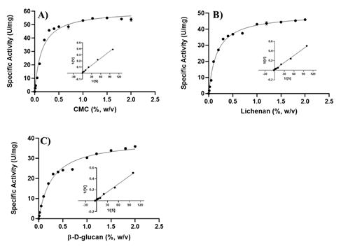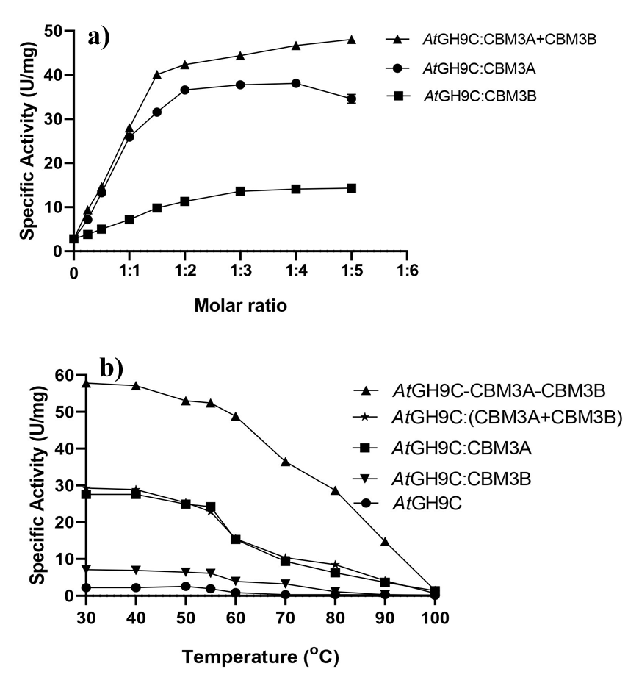
Fig. 1: Michaelis-Menten and Lineweaver-Burk plots (inset) for determining the kinetic parameters of AtGH9C-CBM3A-CBM3B against (a) Carboxy methylcellulose, (b) Lichenan and (c) β-glucan.

Fig. 2: Interaction study of catalytic module, AtGH9C and CBMs (CBM3A, CBM3B or CBM3A+CBM3B) at a) different molar concentrations and b) at different temperatures.

