Preparation and characterization of activated carbon from dried coconut shell for treating petroleum refinery wastewater

K.Viswanath Aswani¹, Ajay S Kalamdhad^{1,2,*}, Chandan Das^{1, 3,*}
¹ Centre for the Environment, Indian Institute of Technology Guwahati, Assam – 781039
² Department of Civil Engineering, Indian Institute of Technology Guwahati, Assam – 781039
³ Department of Chemical Engineering, Indian Institute of Technology Guwahati, Assam – 781039
*Corresponding Author
Email: cdas@iitg.ac.in (C. Das); kajay@iitg.ac.in (A. Kalamdhad)

Abstract

A well-developed and cost - efficient activated carbon(AC) was synthesized using dried coconut shell. In this study, dried coconut shells were chemically treated to produce AC. The physicochemical characteristics of the optimised AC were measured using characterization techniques as XRD, SEM, FTIR, and TGA. The FTIR results showed that, on the surface of AC abundant oxygen-containing functional groups were observed with uneven and significant porosity. A number of physical characteristics were also determined, including bulk density, volatile matter content, ash content, moisture content, porosity, and surface area. BET was utilised to measure the pore volume and surface area of the synthesised AC. Pre-treatment at 600°C helped to improve the AC with high surface area, good yield and granular form. The addition of biomass increased the physicochemical characteristics of AC. Compared to commercially available AC, the synthesized AC demonstrated a significantly better capacity in removing contaminants from petroleum refinery wastewater (PRW). The removal of several inorganic pollutants from PRW was accomplished using synthesized AC. Thisstudy shown that AC can be employed as an effective adsorbent for the elimination of various contaminants in PRW. In this research, agricultural waste was converted into a porous adsorbent in addition to being recycled. The method of waste disposal matched both the needs of the market at the time and the environmental regulations.

Keywords: Activated carbon; Adsorption; Agricultural waste; Coconut Shell; FTIR; Petroleum Refinery
Wastewater; SEM; XRD; TGA

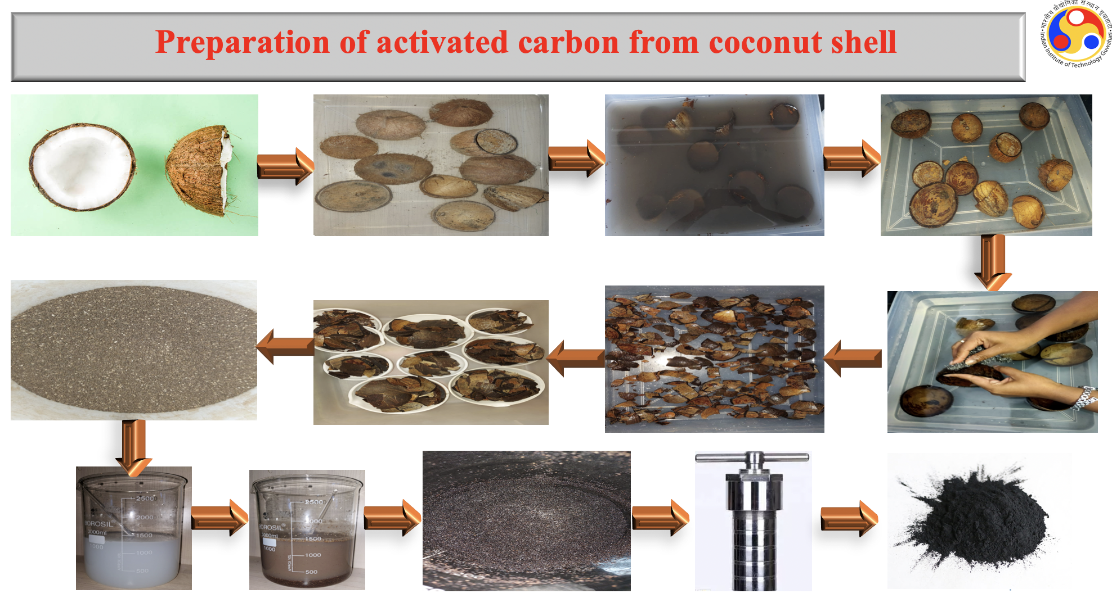

References:
- Laine, J. and Yunes, S., 1992. Effect of the preparation method on the pore size distribution of activated carbon from coconut shell. Carbon, 30(4), pp.601-604.
- Liang, Q., Liu, Y., Chen, M., Ma, L., Yang, B., Li, L. and Liu, Q., 2020. Optimized preparation of activated carbon from coconut shell and municipal sludge. Materials Chemistry and Physics, 241, p.122327.
- Hu, Z. and Srinivasan, M.P., 1999. Preparation of high-surface-area activated carbons from coconut shell. Microporous and Mesoporous Materials, 27(1), pp.11-18.

