Walking Aid Device for the Visually Impaired

Chirag Ramesh Hegde1, Ayush Dilip Athawale2 and Kulkarni Venkatesh Sanjeev3

1, 2 Department of Electronics & Electrical Engineering, IIT Guwahati, India
3 Department of Mechanical Engineering, IIT Guwahati, India

E-mail: r.chirag@iitg.ac.in, ayush.dilip@iitg.ac.in, kulkarni.venkatesh@iitg.ac.in

Abstract

Walking canes are the most widely used walking aid device for the visually challenged. The regular cane effectively identifies obstacles on the ground but cannot detect overhanging objects. Over the years, several technological innovations have improved the sensitivity and accuracy of these devices. The improved cane uses ultrasonic sensors to detect the surrounding environment. The feedback is provided to the user using a grid of haptic feedback on the palm with varying intensity to indicate the proximity of the objects in the surrounding. However, this technology has some drawbacks, such as the lack of feedback about objects behind the user, added weight and bulk, social stigma and sensory overload due to constant haptic feedback. Additionally, it may be challenging for the user to differentiate between the intensity and direction of the feedback on the palm, which is a small area.
Student Academic Board (SAB), Indian Institute of Technology Guwahati, Guwahati, Assam, India
Research & Industrial Conclave 2023 "An amalgamation of Academia, Industry & Start-up”
"
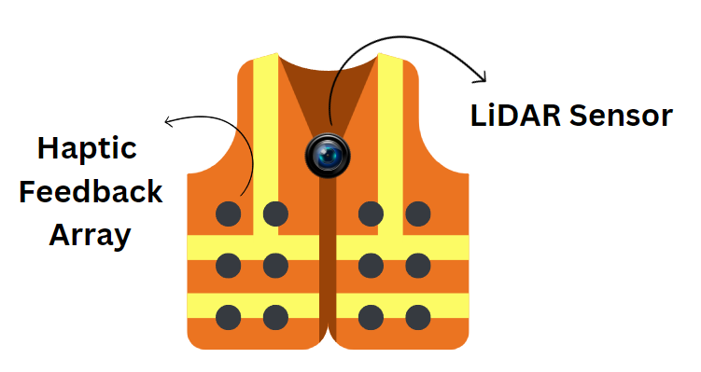
To overcome the above-mentioned problems, we have developed an entirely new perspective in our design, eliminating the need for sensors on a white cane. The new design focuses on developing a wearable vest with integrated sensors and feedback systems. The vest design allows for natural wear, which eliminates the issue of holding heavy equipment in their hands. With sensors and feedback added to the back of the vest, an alert can be triggered if something is near the user's back. The expanded feedback area makes it easier for the user to determine the direction and proximity of the object more clearly. Additionally, the vest's wearable design may help alleviate the social stigma associated with assistive devices, as it can easily blend in as a jacket.
Initially, the team planned to use ultrasonic sensors to provide feedback to the user. However, ultrasonic sensors come with a significant drawback. Many ultrasonic sensors would be required to obtain high-resolution object detection in different directions, making the device cost-inefficient and bulky. The ultrasonic sensors were then replaced with a LiDAR (Light Detection and Ranging) sensor to address this issue to obtain a high-resolution depth map of the surroundings. This depth map is then converted into a low-resolution depth map to indicate the prominent objects and the vest's feedback mechanism can be triggered, providing the user with valuable information about their environment. This approach solves the problem of using multiple ultrasonic sensors and makes the device more practical and efficient for the user.
The feedback is provided using a grid of haptic feedback, with each grid cell denoting the direction of the obstacle in the surrounding. The intensity of feedback indicates the proximity of the object to the user. Since the grid is spread out over a large body area, the chances of sensory overload are significantly reduced.
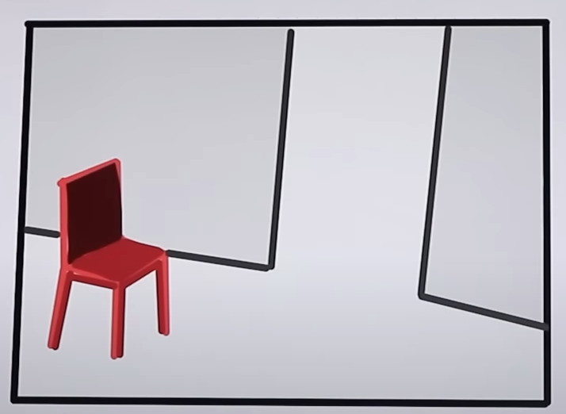
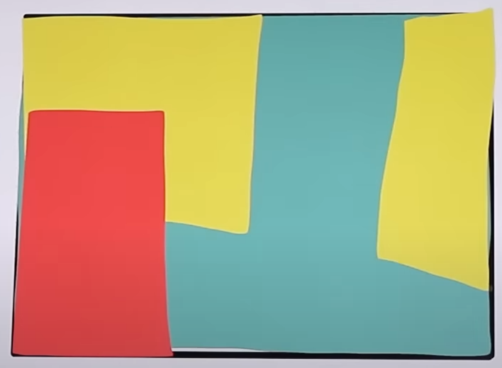
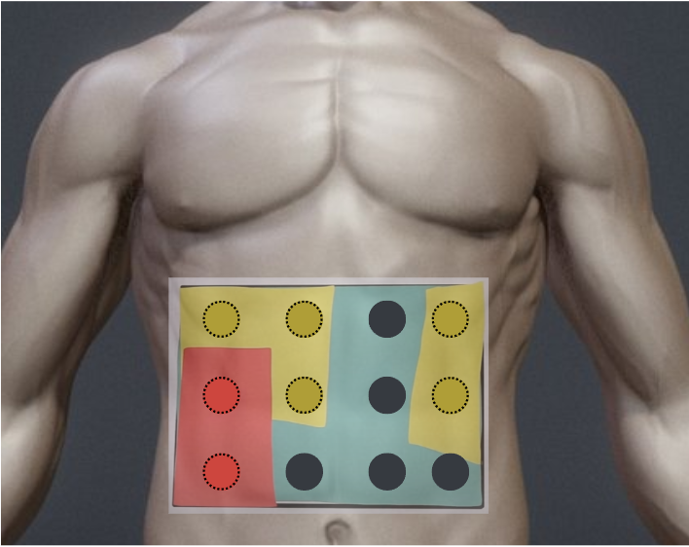
High-Resolution Depth Map
Low-Resolution Depth Map
Haptic Feedback

