Graphene Based Smart TLSO (Thoracic Lumbar Sacral Orthosis) Braces

Ayush Yadav1 , Sushil Subhash Adwe2 and Sanket3

1 Department of Electronics & Electrical Engineering, IIT Guwahati, India
2 Department of Mechanical Engineering, IIT Guwahati, India

E-mail: ayush.yadav@iitg.ac.in, ssubhash@iitg.ac.in, sanket19@iitg.ac.in

Abstract
Student Academic Board (SAB), Indian Institute of Technology Guwahati, Guwahati, Assam, India
A TLSO (Thoracolumbosacral Orthosis) is a type of back brace used to support and immobilize the thoracic, lumbar, and sacral regions of the spine. It is often used to treat conditions such as spinal fractures, scoliosis, and degenerative disc disease. The device is typically made of a combination of plastic and metal, and is custom-fit to the individual's body. It is worn under clothing and is typically worn for several months at a time to help stabilize the spine and promote healing. The existing braces in the market are rigid in nature and cannot be adjusted according to the body shape of the patient. Already existing custom fabricated braces lack proper ventilation which in certain cases leads to dead skin. They lack adequate padding which worsen the overall experience of the user and are uncomfortable to wear for prolonged periods of time. They only provide single form of control and could be cumbersome.
To overcome the above-mentioned problems, we have developed an entirely new perspective in our device that incorporates advanced technology such as sensors, microprocessors, and wireless connectivity to provide additional features and benefits compared to traditional TLSO braces. To enable greater immobilisation and patient comfort, the TLSO described in this patent includes an anatomical design that follows the contours of the spine. By using aero spacer lining and ventilated panels, the anterior plate, posterior plate, and support panel are all given airflow for optimal breathability and patient compliance.
Research & Industrial Conclave 2023 "An amalgamation of Academia, Industry & Start-up”
"

Initially, the team faced the issue of finding the best sensor for pressure-force measurement. After analysing the data available on web, we decided on choosing the state of the art i.e., graphene-based sensor. To make the brace applicable to people of all sizes and body types we decided to modify it using a system of pulley and straps which would be made automatic using a combination of servo motor and pulley system.
Considering the pressure points present in an adult body, the corresponding number of sensors would be used. Each distinct part of the brace may have one or multiple sensors depending on the location. The brace would be designed to avoid putting pressure on the crucial areas like sternum, ribcage, abdomen, to prevent discomfort and irritation. The assembly would also comprise of foam to cover the sensors placed inside the brace in order to avoid discomfort for the patient. Since foams exhibit the typical hysteresis behaviour expected from energy absorbing materials, they are chosen such that the energy absorbed is minimum and the sensors are calibrated accordingly. A threshold value of pressure would be set for each sensor by the doctor himself according to each patient at the time of first installation. If during an activity being performed by the patient the pressure value crosses a certain threshold the brace would loosen itself, thereby, eliminating the need for the removal of the brace in said case, as is the case with current braces. The whole system would be connected to a centralised app which would take into consideration the data received from all the sensors, and subsequently adjust the tightness and orientation of the brace.

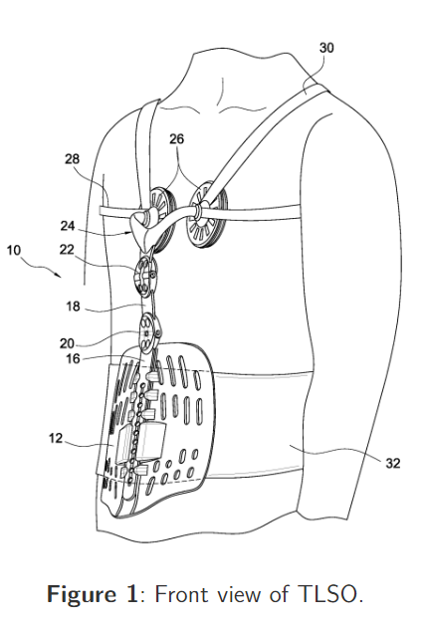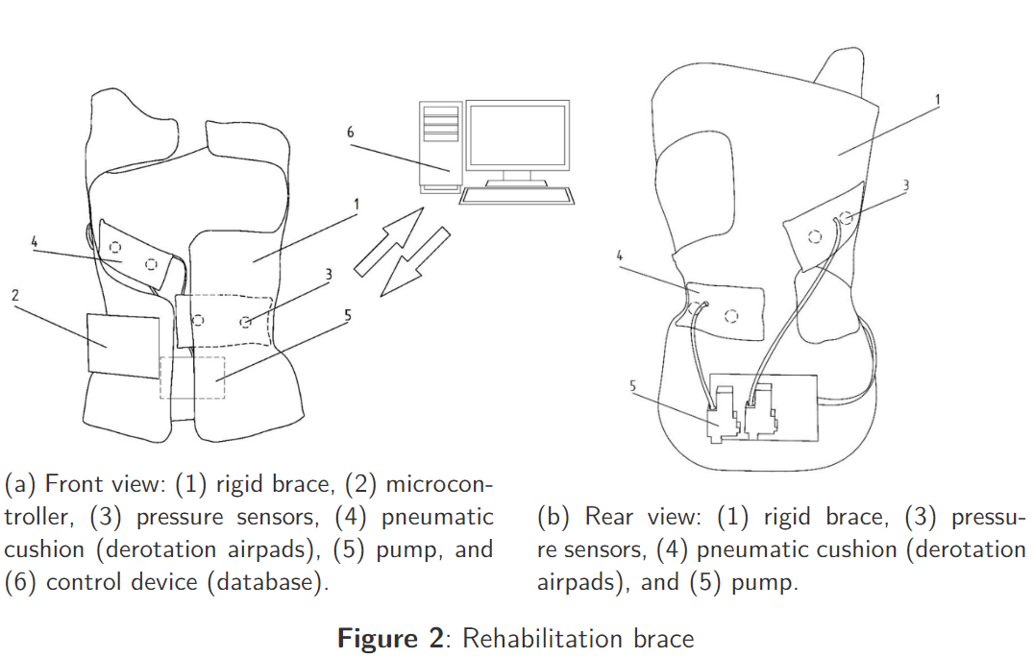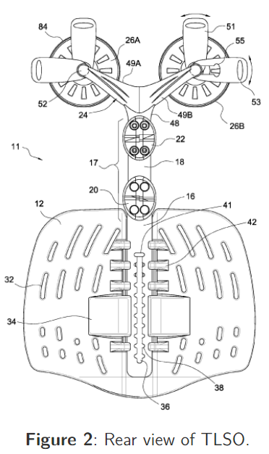

In conclusion, the brace can be used for different activities namely standing, maximum inspiration, maximum expiration, supine position/lying on the back, prone position/lying on the abdomen etc. This ensures that the brace is applicable for long term use. Medically, it is recommended that, one must wear the existing brace 18-23 hours a day for it to prove effective which is usually discomforting and hampers the daily routine. Our proposed brace, not only make it bearable for longer duration, but also eliminates the need for frequent manual adjustments by virtue of its self-adjusting nature.

