Single Step Catalytic oxidation of methane to methanol using Fe/ZSM-5 Catalyst: Effect of oxidants

A. Akshay Soni1, B. Dr. Sanjay Katheria1

1 Department of Chemical Engineering and Technology, IIT (BHU) Varanasi

E-mail: akshaysoni.che21@itbhu.ac.in

Abstract

Natural gas, which consists of approximately 70-90% methane, is an important part of the energy system for decades. The utilization of methane after its extraction is a big challenge. Most of the methane reserves are in remote areas, so the transportation of gaseous methane to its user is a challenging task. Methane is typically transported in liquid form, liquified natural gas (LNG), and piping natural gas (PNG). The construction of a long-distance pipeline network is an expensive process. Furthermore, the liquefication of natural gas in the form of LNG and its regasification for its utilization is an energy-intensive process. These challenges make the utilization of methane a tedious task and alternative methods of its utilization are required.
As the previous literature survey shows that the direct oxidation of methane into methanol is possible in nature, by methane monooxygenase (MMO) enzymes [1]. In this study, a similar approach to mimic the properties of MMO, copper & iron-based catalyst supported on zeolite is studied for this process.
We synthesized a 2% Fe/ZSM-5 catalyst using the incipient impregnation method. For this purpose required amount of Fe(NO₃)₃.9H₂O is dissolved in distilled water. The iron salt solution was impregnated dropwise onto H-ZSM-5. The formed gel was transferred to a crucible and dried for 2 hours at room temperature then calcination was done at 550℃ for 5 h with a ramp rate of 3 ℃/min. The catalyst pallets were made using a pelletizer and sieved to get the particle within the size range of 225 μm to 400 μm for the testing.
The reaction was carried out in a stainless steel-packed bed tubular reactor. Two oxidants N₂O and O₂ were used to investigate the effect of oxidants. During the reaction, CH₄/O₂ was maintained at 10, and weight hourly space velocity (WHSV) was 1.45 g-h/mol. The catalyst was tested in the reactor with 200 mg of catalyst (20-40 mesh) placed between two quartz wool plugs.
In the first experiment, N₂O was used as an oxidant, the reaction temperature was 314 ℃ and 3 bar pressure. The run time of the experiment was 8h. Fig. 1 shows the variation of conversion with time, these are the preliminary results.

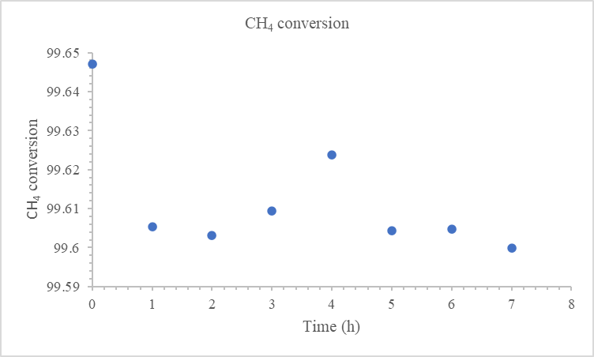
Fig 1: Methane conversion vs time.
In the second experiment, we used oxygen as an oxidant, and additionally, water was used as desorbing agent. In this method, WHSV and CH₄/O₂ are the same as in the first experiment and CH₄/H₂O was maintained 1. The reaction was carried out at a temperature of 450℃ and 5 bar pressure. The experiment was carried out for a typical run of 8h. The preliminary results show the conversion of methane is 5%.

Reference:
[1.] Shu, L.; Nesheim, J.C., Kauffmann, K. An Fe₂^{IV}O₂ Diamond Core Structure for the Key Intermediate Q of Methane Monooxygenase. Science 1997, 275, 515-518.

