Fluorescence Recovery to Improve the Resolution in Stochastic Optical Reconstruction Microscopy (STORM)

Amalesh Kumar1*, Anupam Bharadwaj1 , Rumela Mitra2, Bithiah Grace Jaganathan2 and Bosanta Ranjan Boruah1

1 Department of Physics, IIT Guwahati, India
2 Department of Biosciences and Bioengineering, IIT Guwahati, India

E-mail: amaleshkumar1@iitg.ac.in

Abstract

Stochastic optical reconstruction microscopy (STORM) is a single molecule localization microscopic technique where a super-resolved image is reconstructed by combining many image frames from different small subsets of fluorescence molecules. The fluorophores are blinked and randomly altered between the fluorescence on and dark state with a suitable excitation laser source. The work is mainly based on the recovery of fluorescence emission from the dye molecules once the blinking process has slowed or stopped. Exciting the sample with a shorter wavelength than the previous one used for photoswitching can further reactivate the blinking up to a reasonable time. The prolonged blinking is always helpful for reconstructing super-resolved images with a high signal density. We studied the actin filament with Alexa fluor 647 conjugated phalloidin dye in U-87MG cell line. 638nm laser activates the fluorophore to blink initially, whereas 405nm laser was used to reproduce the blinking upto two to five times longer than the previous one. Based on the observations and the increasing interest in achieving better super-resolved images with high localization precision, we believe that obtained result could significantly impact the field of microscopy for extensive applications.

Keywords: Super-resolution microscopy; Bioimaging; Fluorescence recovery; Energy transfer

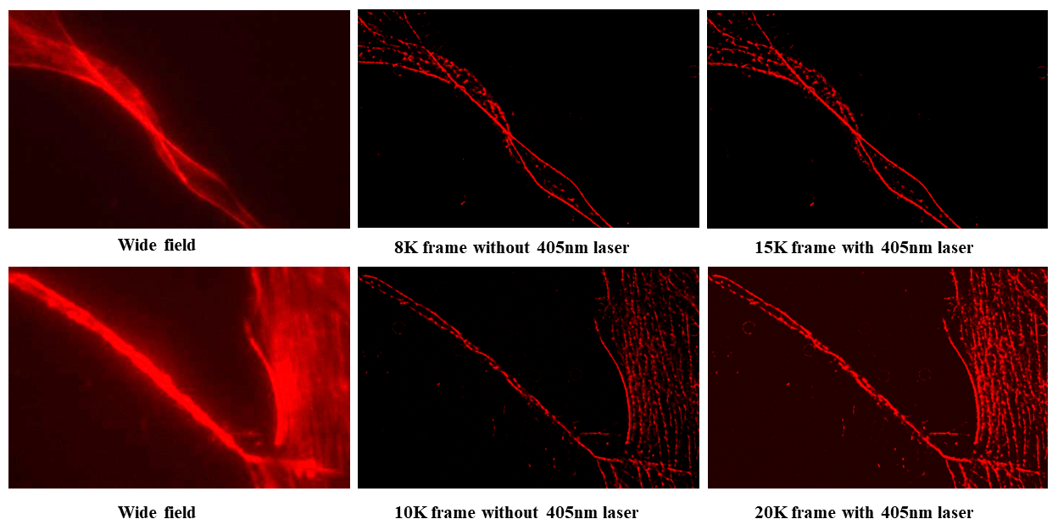

Fig.1 Reconstructed image of actin filament of U-87 cell line at two different fields of view
without and with 405nm laser

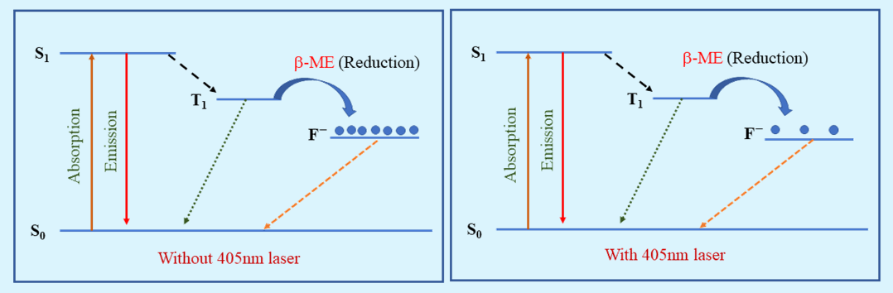

Fig.2 Energy level diagram showing the photoinduced effect of 405nm

