In silico Analysis of Cerebrovascular Disease and Stroke

A. Shrivastava1 , A. Suri2 and S. Roy1

1 Department of Applied Mechanics, Indian Institute of Technology Delhi, India
2 Department of Neurosurgery, All India Institute of Medical Sciences, New Delhi, India

E-mail: amar.shrivastava@am.iitd.ac.in

Abstract

'Cerebrovascular' word is a combination of two words i.e., cerebro and vascular. 'Cerebro' means 'brain' and vascular indicates 'arteries and veins'. Arteries move blood away from the heart, supplying oxygen and nutrients to the brain and veins move blood toward the heart. Diseases related to cerebral vasculature involve disorders in certain areas of the brain and blood vessels associated with it.
Student Academic Board (SAB), Indian Institute of Technology Guwahati, Guwahati, Assam, India

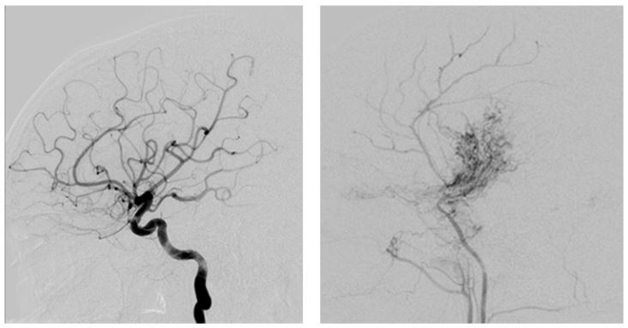
Figure 1: Image on the left showing normal vasculature of a healthy adult and on right are the blood vessels of a Moyamoya diseased patient.
Moyamoya disease is a Japanese term indicating a puff of smoke. This disease is more common in East Asian countries. Both children and adults are affected by this abnormal cerebrovascular disorder. It involves narrowing of internal carotid arteries at its terminals (see Figure 1). With the aid of Computational Fluid Dynamics, pattern of this disease can be understood, and its progression can be tracked by computing biomechanical or hemodynamic parameters to further predict and prevent future mini-strokes and strokes.

Keywords: Cerebrovascular, Biomechanics, Computational Fluid Dynamics, Moyamoya

