Development of an Optimization Strategy for Sustainable Manufacturing of Resin Transfer Moulded Composite Parts

Anita Zade1 and Raghu Raja Pandiyan Kuppusamy1

1 Department of Chemical Engineering, NIT Warangal, India
E-mail: raghuraj@nitw.ac.in

Abstract

The main objective of this work was to develop the in-house coded multi-objective stochastic optimization (MOSO) and non-dominated sorting differential evolution (NSDE) algorithms to optimize mould-filling and curing phases of resin transfer moulded (RTM) composite parts. Glass fibre-vinyl ester-based automotive bonnet and carbon fibre-RTM6-based aircraft wing flap composite parts were used as the case studies. Initially, thermal characterization of neat resins were studied using differential scanning calorimetry (DSC) and permeability measurements of reinforcement mats were performed using visualization technique. Subsequently, the multi-physics models defining resin flow in porous media, model to track resin-air interface, porous media heat transfer and resin cure kinetics were coupled to simulate mould filling and curing phases of the RTM process. Then, the NSDE algorithm was developed to optimize the mould gates and vents locations during mould-filling with a constraint of pre-fixed port numbers and the thermal gradients and cure time during curing with a constraint of extent of cure completion. Subsequently, the MOSO algorithm was developed for the simultaneous optimization of numbers and locations of gates and vents. Finally, a comparative assessment was made between algorithm-based optimized results and trial-and-error process simulation results to examine the efficacy of the proposed algorithms. From the mould-fill phase optimization, it was found that the MOSO algorithm predicted better mould fill time and dry spot content-port numbers Pareto front for both composite parts when compared to the NSDE algorithm. From the cure phase optimization, it was found that the NSDE algorithm predicted a converged thermal gradient-cure time Pareto front and the thermal gradients were reduced significantly with the cure time.
Student Academic Board (SAB), Indian Institute of Technology Guwahati, Guwahati, Assam, India
Research & Industrial Conclave 2023 "An amalgamation of Academia, Industry & Start-up”
"
Keywords: Mould-Fill Phase, Cure Phase, Multi-Objective Optimization
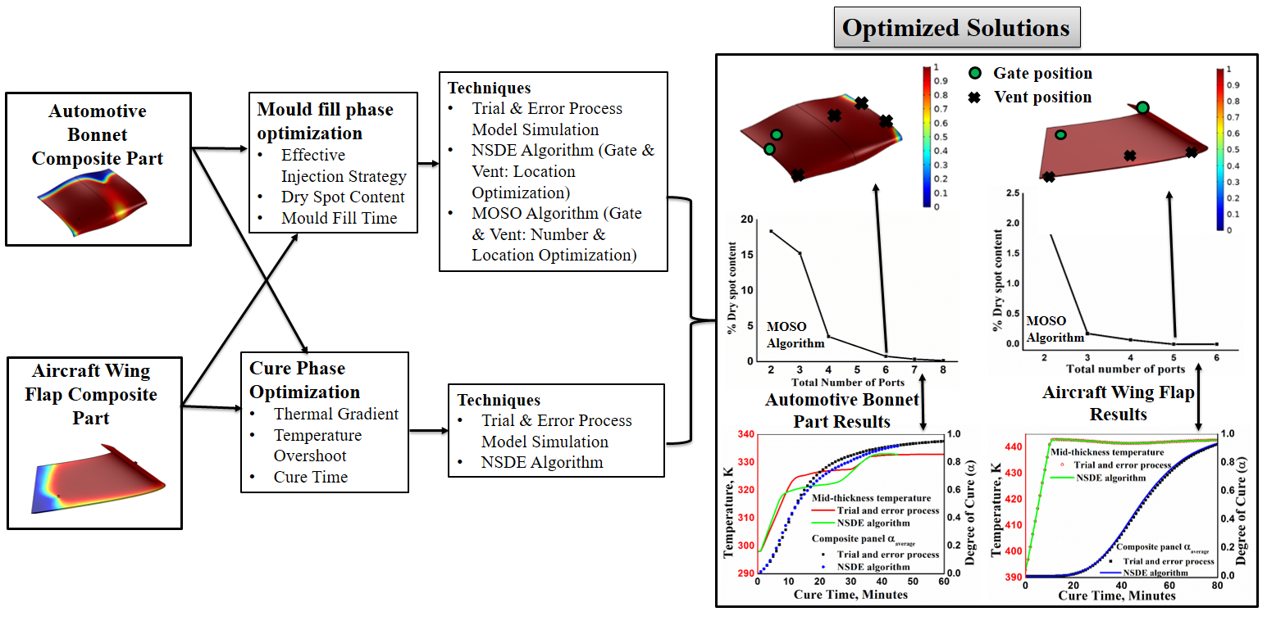
Figure 1. Graphical Abstract of Research Thesis Work
References
[1] S. G. Advani, M. E. Sozer, Process Modeling in Composites Manufacturing, 2003.
[2] A. Zade, S. Neogi, R. R. P. Kuppusamy, Polym. Compos. 2022, 43, 3426.
[3] G. Struzziero, A. A. Skordos, Compos. Part A Appl. Sci. Manuf. 2017, 93, 126.

