Ecorage- Automatic waste sorting system

A. Mehul Jain1 , B. Anshuman Agarwal2 and C. Garvit Surana1
1 Department of Physics, Sanskriti The Gurukul Guwahati, India

E-mail: mehul.jain@sanskritithegurukul.in

anshuman.agarwal@sanskritithegurukul.in

Abstract
Department of Physics, Sanskriti The Gurukul Guwahati, India

Department of Science, Sanskriti The Gurukul Guwahati, India
Ecorage is an innovative machine that is designed to separate different types of waste using various types of sensors such as inductive proximity sensors, soil moisture sensors, and ultrasonic sensors. The machine uses a conveyor belt system that passes the garbage through an array of sensors, which scans and detects the waste, allowing it to be sorted accurately.

The sorting process is accomplished by arranging the sensors in such a way that they detect specific properties of the waste as it passes through the conveyor belt. For instance, the inductive proximity sensor detects the presence of metals, the soil moisture sensor detects the moisture content of the waste, and the ultrasonic sensor measures the distance of the object. By combining the data from these sensors, the machine can differentiate between the different types of waste.

The sorted waste is then deposited into a spinning three-part bin, which is programmed with a custom algorithm to rotate automatically as the waste falls into it. This bin allows for the easy separation of different types of waste, making it more efficient and effective than traditional waste disposal methods.

The main processor of the Ecorage machine is the Arduino Uno, which is a versatile microcontroller board that is easy to program and can be used in a variety of applications. This allows the machine to be programmed with a custom algorithm, enabling it to sort the waste efficiently and effectively.

Overall, the Ecorage machine is a groundbreaking innovation in waste management. By using an array of sensors and a spinning three-part bin, it can effectively separate different types of waste, making it more efficient and environmentally friendly. Using Arduino Uno as the main processor ensures that the machine can be easily programmed and customized for different waste management needs.

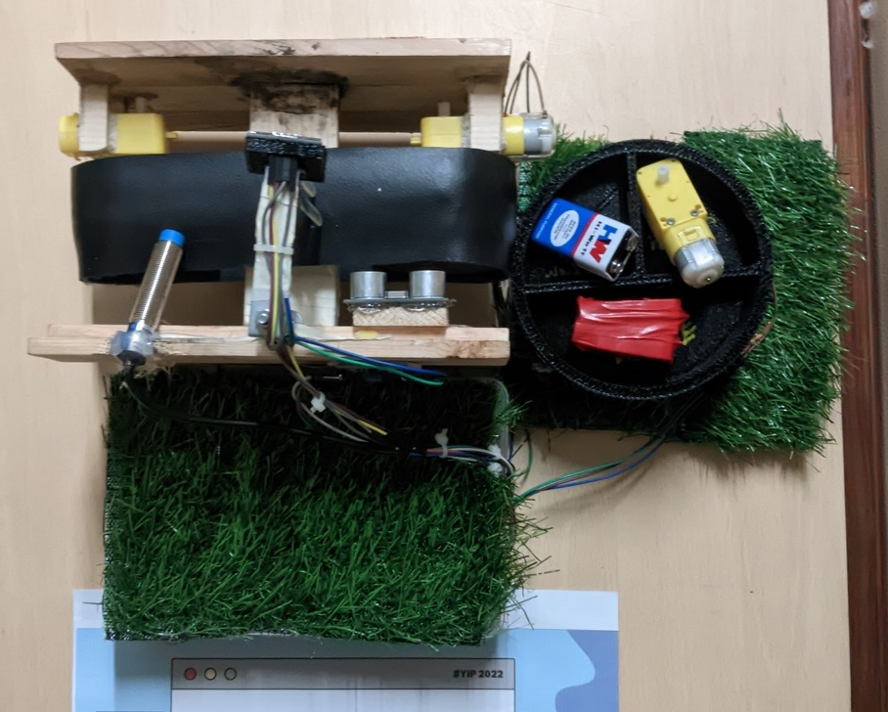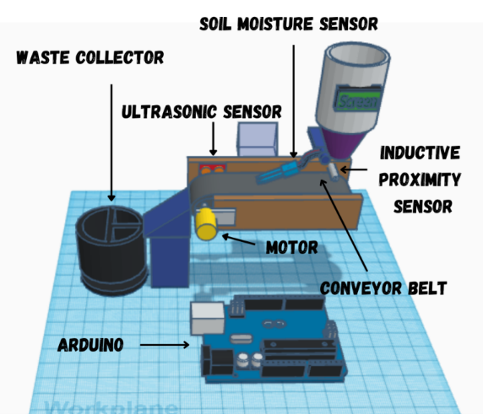
Figure 1: The working model of Ecorage Figure 2: The 3D Model and overview

