IoT based Fall detection system for disabled, elderly people

Ashish Kumar Mahato, Om Kumar ,
( Prof. S. K. Dwivedy - Department of ME, IITG)
Centre for Intelligent Cyber Physical Systems
Email:mahato@rnd.iitg.ac.in

Abstract

Falling is a major challenge faced by elderly and disabled people who live alone. They therefore need reliable surveillance so they can be assisted in the event of a fall. An effective fall detection system is needed to provide good care to such people as it will allow for communication with caregivers. Such a system will not only reduce the medical costs related to falls but also lower the death rate among elderly and disabled people due to falls. In recent years, the global population has continued to be aged. Our fast -paced lifestyle and long hour of working make it impossible to provide 24 hour care.
Student Academic Board (SAB), Indian Institute of Technology Guwahati, Guwahati, Assam, India
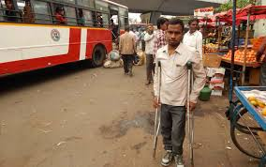
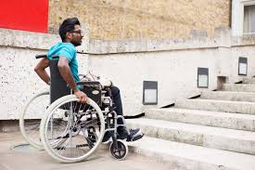


Research & Industrial Conclave 2023 "An amalgamation of Academia, Industry & Start-up”
"

This system can detect the elderly's falling by acceleration analysis. Then it will get the elderly's geographic position and send fall alarm short message to caregivers. So the elderly who has fallen can get timely help to minimize the negative influence.


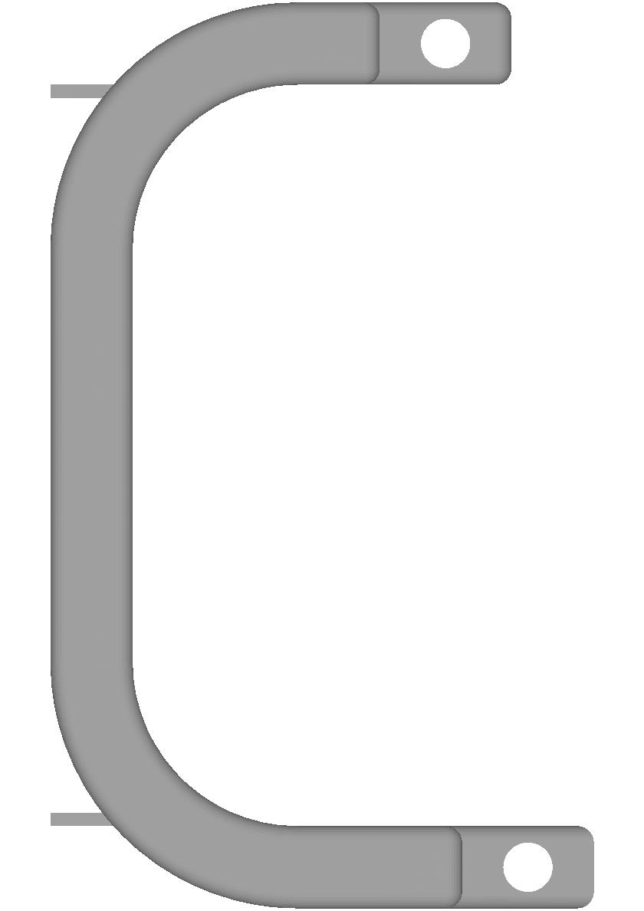

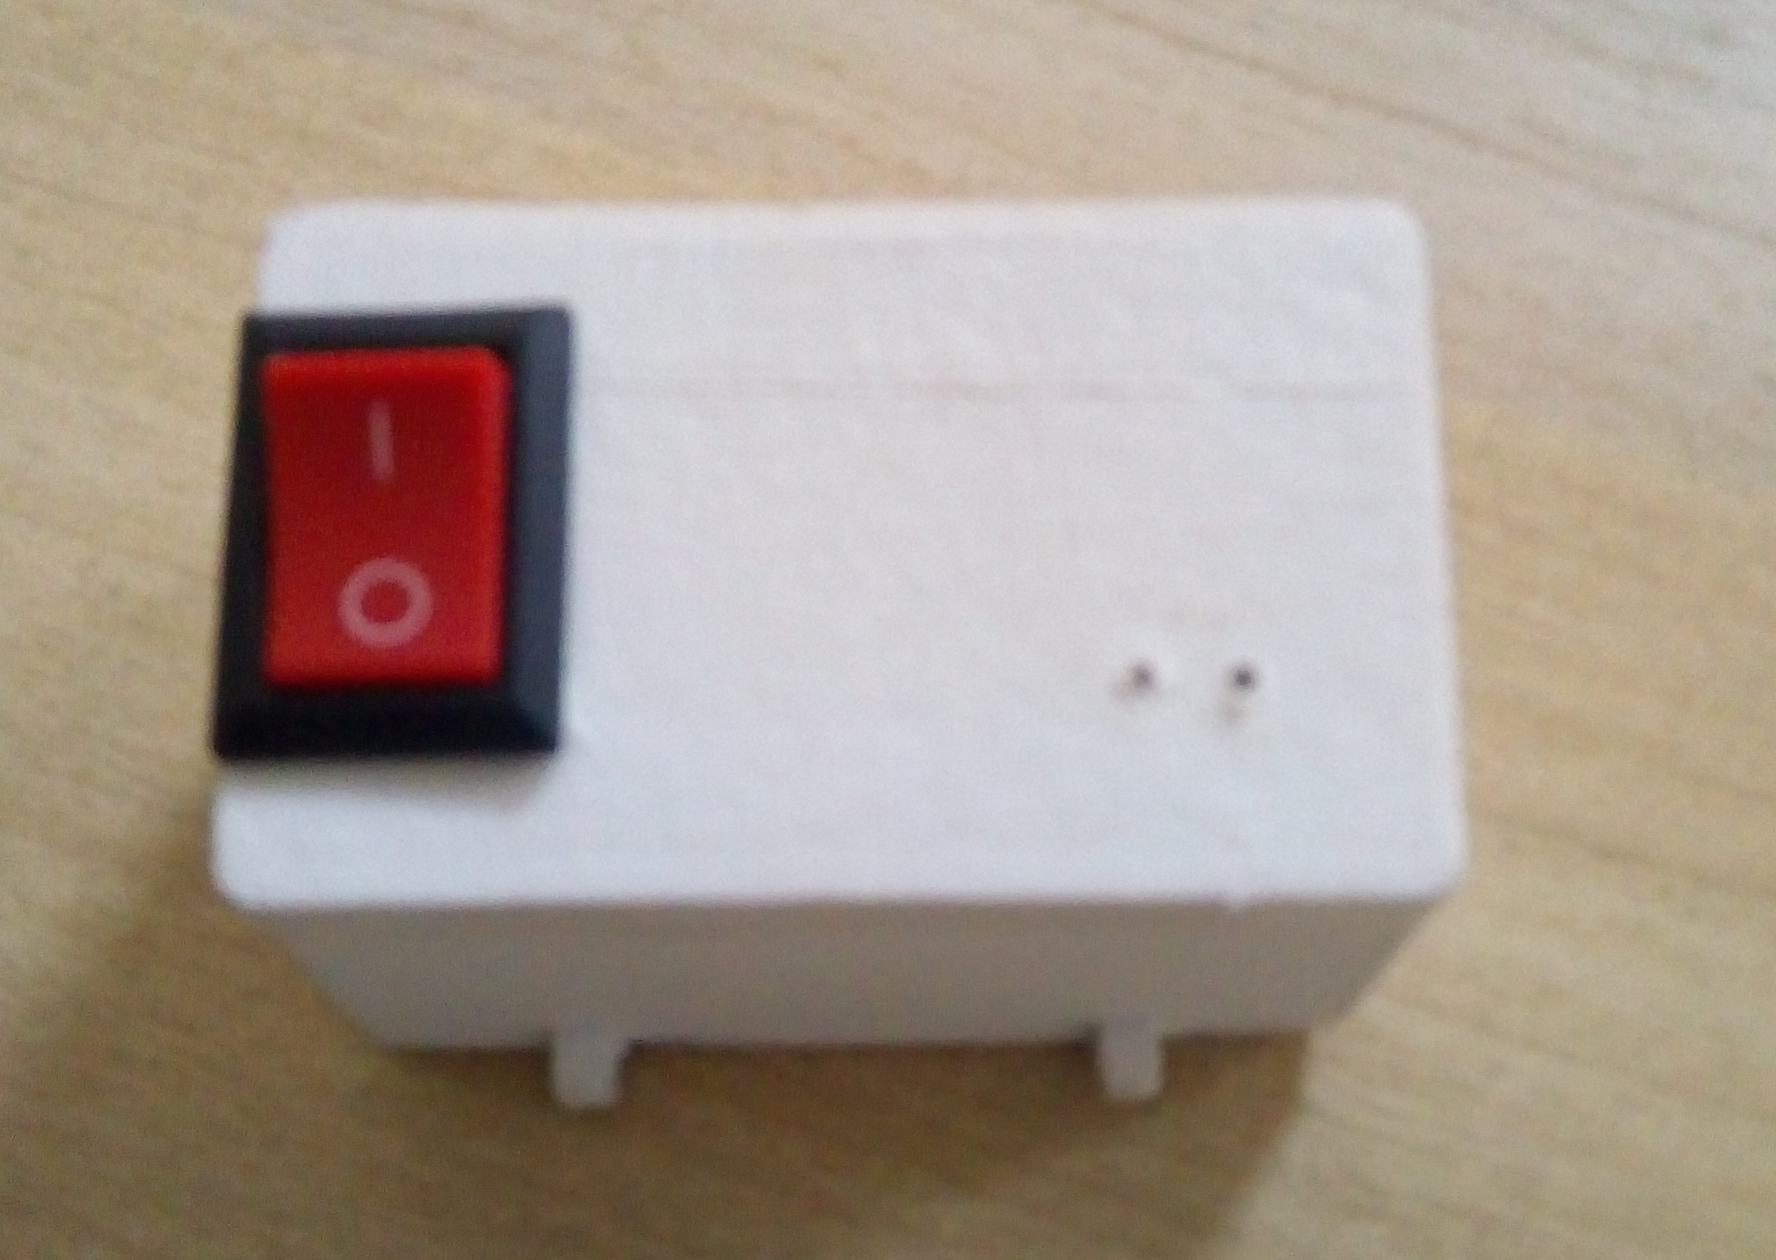
Design and 3D printed parts Specifications:
- Connectivity: Wi-Fi or Mobile Phone
- Battery: 500 mAh Lithium Ion
- Backup: 6hr in a Single Charge
- Input: 5V/1.5A

Architecture and Operation
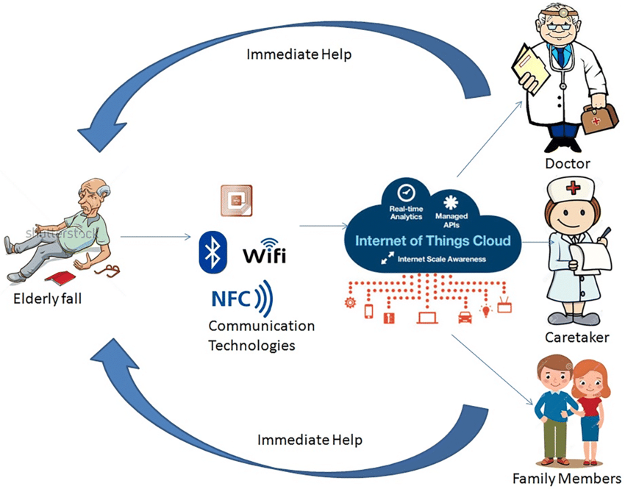
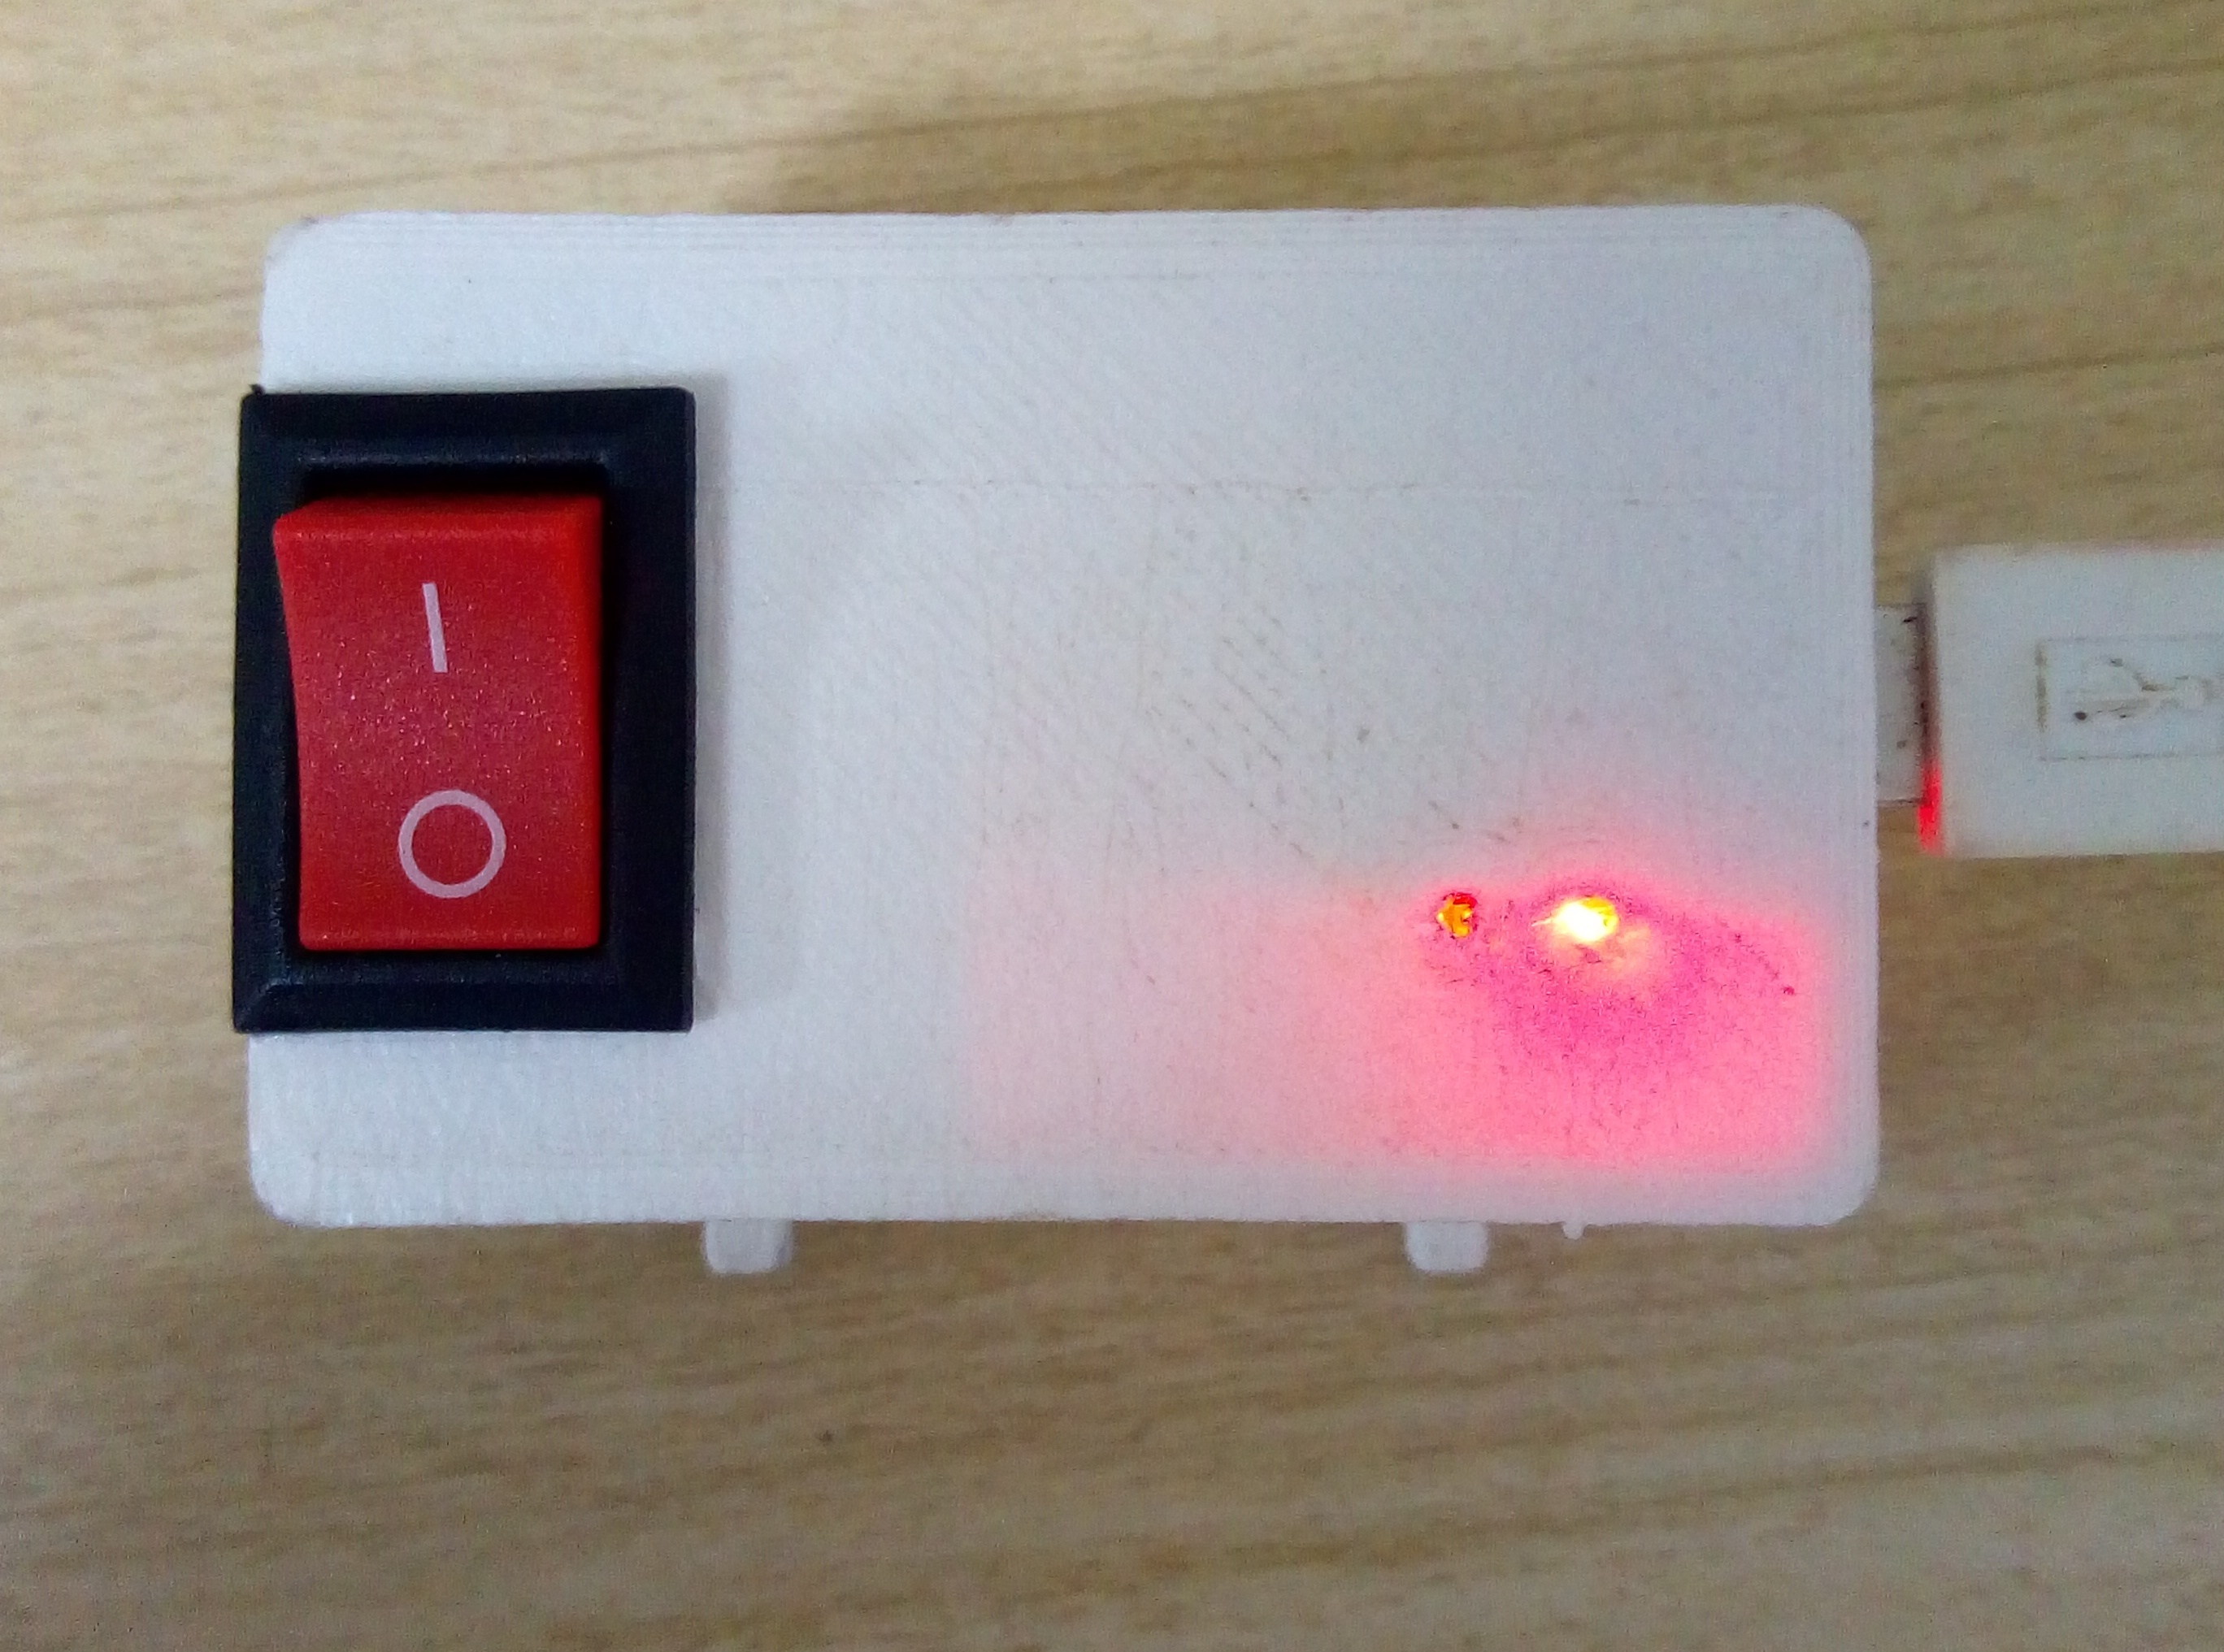
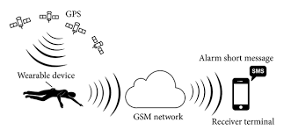

Fall detection system built-in gyroscope and an accelerometer sensor. The gyroscope is used to determine the orientation and the accelerometer provides information about the angle, such as X, Y, and Z-axis data. To detect the fall, we will compare the acceleration magnitude with the threshold value. If a fall is detected, the device sends a notification and email to the concerned person.
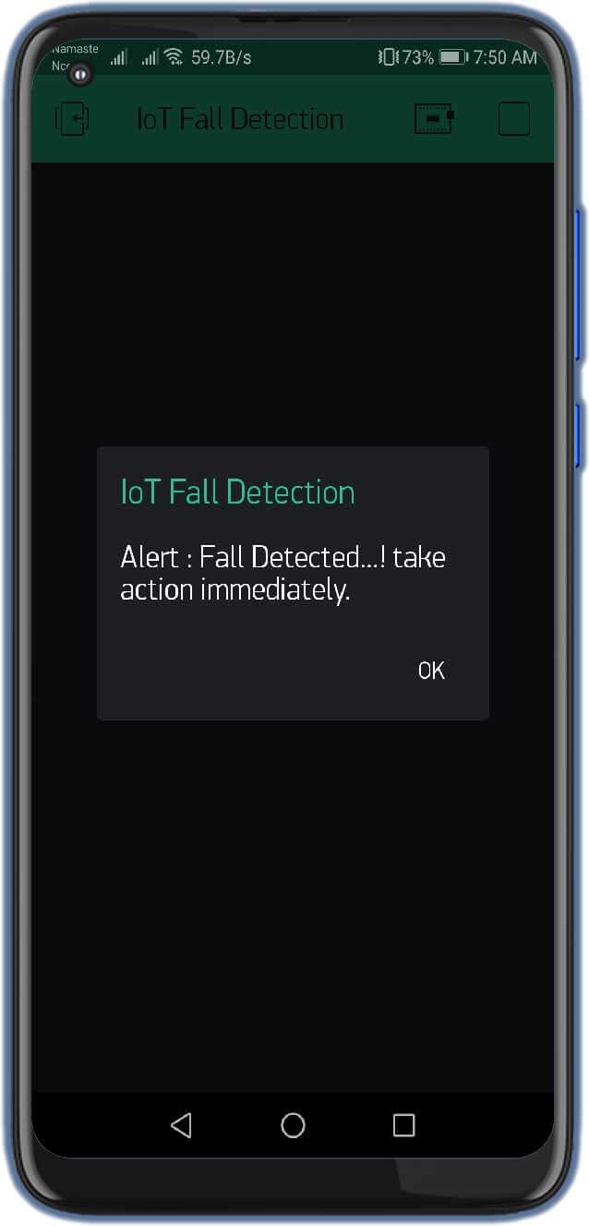

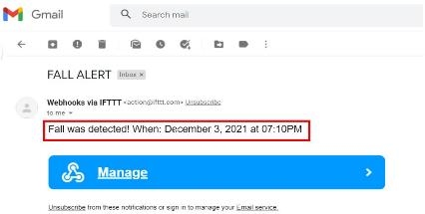
Prototype device
Mobile and Email alerts

