Garbage Filtering Drainage System

A. Ayush Gulgulia1 , B. Rishabh Goswami2

1 Department of Physics, Sanskriti The Gurukul Guwahati, India

E-mail: ayush.gulgulia@sanskritithegurukul.in
rishabh.goswami@sanskritithegurukul.in

Abstract
Department of Science, Sanskriti The Gurukul Guwahati, India

During heavy rains, the clogging of drains is a common problem faced by many cities worldwide. The accumulation of garbage in the drains not only disrupts the flow of sewage water but also leads to blockages, resulting in floods. This can cause significant damage to infrastructure and properties, and can also pose a severe threat to human lives. To overcome this problem, we have devised an innovative solution to ensure that the drains are clean and free from any blockages. One such solution is the installation of a mesh at the entry of the drain, which can filter out the garbage from the sewage. This mesh can be made of durable materials that can withstand harsh weather conditions and easily be cleaned.
Department of Physics, Sanskriti The Gurukul Guwahati, India

After fixed intervals of time, a roller can be used to push or sweep out all the garbage that has been collected by the mesh. The garbage can be stored in a smart tank which will automatically send a notification to the Municipal Corporation after the garbage reaches a certain level which can be set according to the needs. This tank can be easily accessed by garbage trucks, which can then dispose of it in a safe and environmentally friendly manner. The water can then be collected in a sewage tank, which is connected to the main outsource, ensuring that the flow of sewage water is uninterrupted. The implementation of this model can successfully overcome the issue of clogged drains. It is a cost-effective solution that can be implemented on a large scale, ensuring that cities can keep their drains clean and free from blockages.

In conclusion, the installation of a mesh at the entry of the drain, combined with the use of a roller and a storage tank for garbage collection, is an effective way to ensure that drains remain clean and free from blockages. This solution not only reduces the risk of floods but also makes the cleaning of drains more efficient. Our project also reduces the hard work given by the poor workers, life risk, and diseases spread by the harmful, toxic waste associated with the manual cleaning of drains, making it a safer and more efficient solution. It is a cost-effective solution that can be easily implemented in many cities worldwide.

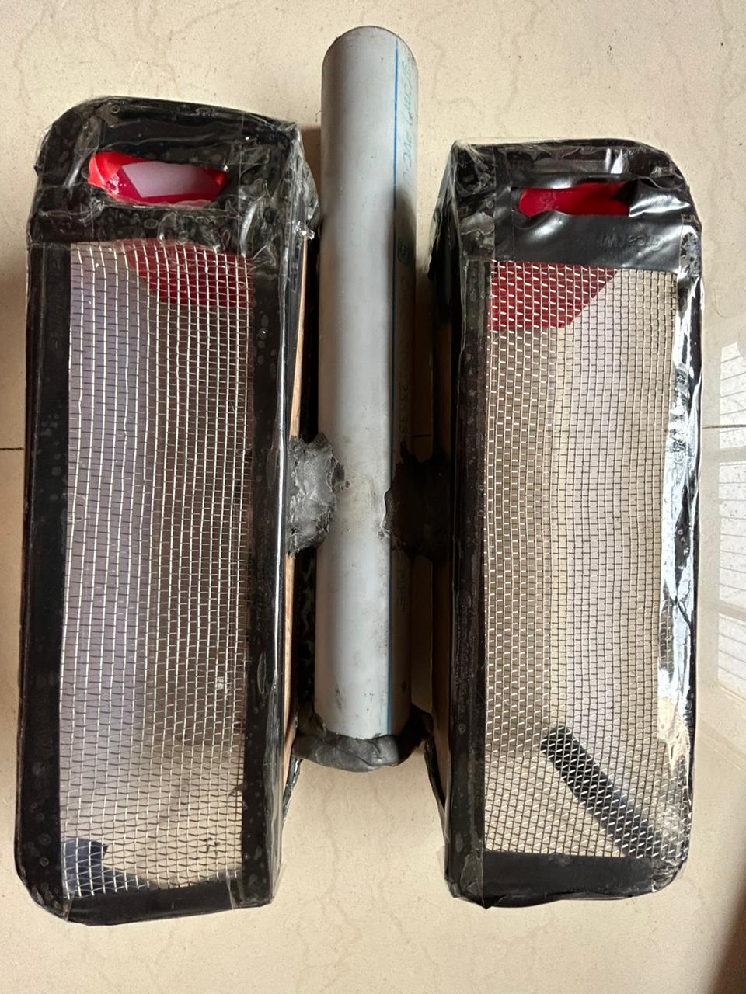

Figure 1: The working model of Garbage Filtering Drainage System

