Palladium-Catalyzed Annulative Coupling of Spirovinylcyclopropyl Oxindoles with p-Quinone Methides

Bijoy Debnath,¹ Tanumay Sarkar,¹ Pallab Karjee,¹ Siddhartha K. Purkayastha,²
Ankur K. Guha³ and Tharmalingam Punniyamurthy*¹

1 Department of Chemistry, IIT Guwahati, India
2 Department of Chemistry, Assam Don Bosco University, India
³ Advanced Computational Chemistry Centre, Cotton University, India

E-mail: bdebnath@iitg.ac.in

Abstract
Pd-catalyzed annulative coupling of spirovinylcyclopropyl oxindoles with p-quinone methides has been accomplished via cascade carbon-carbon bond formation to afford bis-spirooxindole scaffolds. The mild reaction conditions, diastereoselectivity, functional group diversity, post-synthetic transformations and mechanistic studies using DFT calculations are the important practical features.
Student Academic Board (SAB), Indian Institute of Technology Guwahati, Guwahati, Assam, India
Research & Industrial Conclave 2023 "An amalgamation of Academia, Industry & Start-up”
"

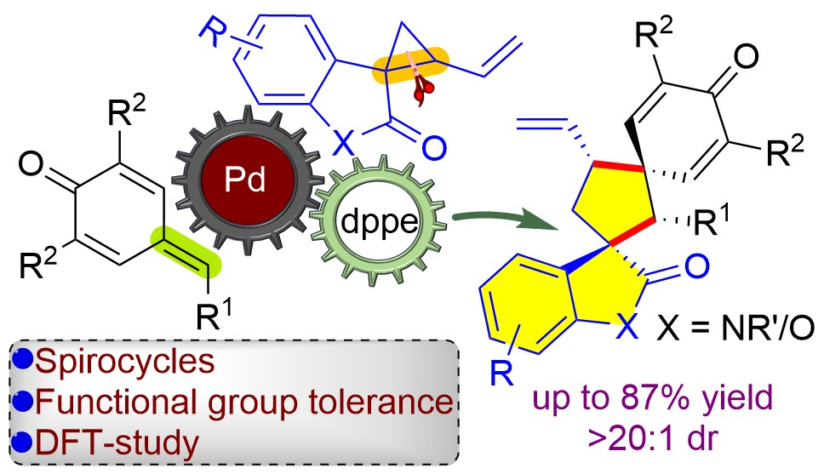

Keywords: Bis-spirooxindole, Diastereoselectivity, Cascade reactivity, Spirocycles.

References:
- Marti, C.; Carreira, E. M. J. Am. Chem. Soc. 2005, 127, 11505.
- Rottmann, M.; McNamara, C.; Yeung, B. K. S.; Diagana, T. T. et al. Science 2010, 329, 1175.
- Mercado-Marin, E. V.; Garcia-Reynaga, P.; Romminger, S.; Sarpong, R. et al. Nature 2014, 509, 318.
- Caruana, L.; Kniep, F.; Johansen, T. K.; Poulsen, P. H.; Jørgensen, K. A. J. Am. Chem. Soc. 2014, 136, 15929.
- Sarkar, T.; Das, B. K.; Talukdar, K.; Shah, T. A.; Punniyamurthy, T. ACS Omega. 2020, 5, 26316.

