A Temperature Tunable Synthesis of Tetrahydro-4H-pyrrolo[3,2-c]quinolin-4-ones and Dihydro-1H-benzo[b]azepines from 2-Aminobenzonitriles and Donor-Acceptor Cyclopropanes

Bikoshita Porashar, SubhamoyBiswas, Archana Kumari Sahu, Archana Chutia and Prof. Anil K. Saikia*

Department of Chemistry, Indian Institute of Technology Guwahati, Guwahati, Assam – 781039, India
*Email Address: asaikia@iitg.ac.in

Abstract

A temperature tunable one pot synthesis of tetrahydro-4H-pyrrolo[3,2-c]quinolin-4-ones and dihydro-1H-benzo[b]azepines from 2-aminobenzonitriles and donor-acceptor cyclopropanes mediated by SnCl₄ has been developed (Scheme 1). The reaction proceeds via sequential ring opening of donor acceptor cyclopropane ring followed by nucleophilic and electrophilic attack of amine and nitrile to the newly generated cation and anion and subsequent unprecedented rearrangement leading to two sets of structurally diverse molecules. The reaction is compatible to many electron-donating as well as electron-withdrawing functional groups in both the substrates giving moderate to good yields. This methodology can be extended towards the synthesis of tricyclic hexahydropyrrolo[3,2-c]quinolinone derivatives, the structure of which is found in biologically active molecules.

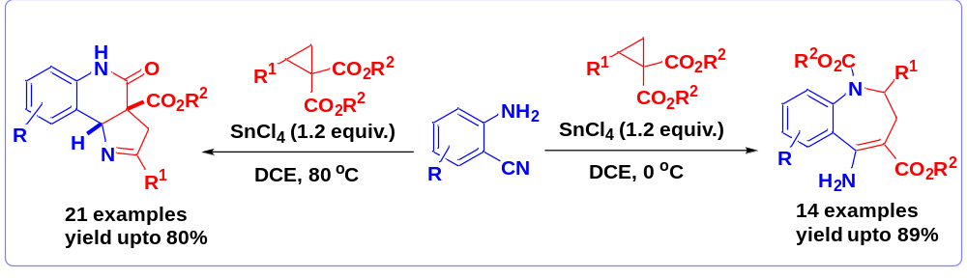
Scheme 1.

Keywords: cyclisation, Lewis acid, tetrahydro-4H-pyrroloquinolin-4-ones, dihydro-1H-benzo[b]azepines and rotamers.

References:
- B. Porashar, S. Biswas, A. K. Sahu. A. Chutia and A. K. Saikia, Organic Letters, 24 (2022), 9038-9042.

