Vertically Aligned 1D Surface ZnO Nanorods for Electrochemical Sensing of Agriculture Pesticides
Chandra Bhan^{1,}* and Animes Kumar Golder¹
¹Department of Chemical Engineering, IIT Guwahati, Assam, INDIA -781039

E-mail: bchandra@iitg.ac.in

Abstract

The pollutants of emerging nature and their adverse impacts on the environment are a major concern for environmental scientists and regulatory authorities across the globe. The accumulation of pesticides in the environment shows an increasing trend over the years due to their widespread use in modern agricultural practices and poses a potential threat to the environmental ecosystem. To address this issue, regulatory authorities are continuously working to impose stringent laws and regulations to control pesticide pollution. However, it is very essential to develop an efficient device for in-situ detection and determination of pesticides at their source irrespective to the geographical locations. Electrochemical sensors have shown great promises for in-situ trageted quantitative analysis of pesticides, heavy metal ions, pharmaceuticals, etc. They offer several advantages such as easy sample preparation, low cost, high sensitivity, selectivity, and low detection limit towards the target analytes. Furthermore, the modification of the working electrode surface using nanostructured catalysts such as ZnO, Co₃O₄, SnO₂, CuO, Bi₂S₃, AuNPs, AgNPs etc., could improve the sensitivity and selectivity of the electrochemical sensor in a great extent by facilitating the catalytic reaction between the target analyte and the electrode/catalyst surface. However, the delamination of nanostructures immobilized (not directly grown) at the electrode surface is a major setback during the course of electrochemical sensing, which can limit the repeatability and reproducibility of the sensing response. Vertically aligned nanorods (VANs) provide high specific surface area, high chemical stability, large aspect ratio, maximum surface roughness, and it could eliminate the potent problem of quick delamination of catalyst from the working electrode surface. Herein, we have synthesized VANs of ZnO onto the surface of fluorine-doped tin oxide (FTO) glass substrate using an aqueous chemical growth method. Additionally, it could remove the need of the binder and the immobilization process of nanostructures on the support electrode. The morphology of bare FTO and VANs of ZnO are shown in Figure 1. The VANs on the FTO surface is tested for electrochemical sensing of agricultural pesticides and their intermediates.
Student Academic Board (SAB), Indian Institute of Technology Guwahati, Guwahati, Assam, India
Research & Industrial Conclave 2023 "An amalgamation of Academia, Industry & Start-up”
"

Keywords: Vertically aligned nanorods; Chemical route; ZnO nanorods; Electrochemical pesticides sensing

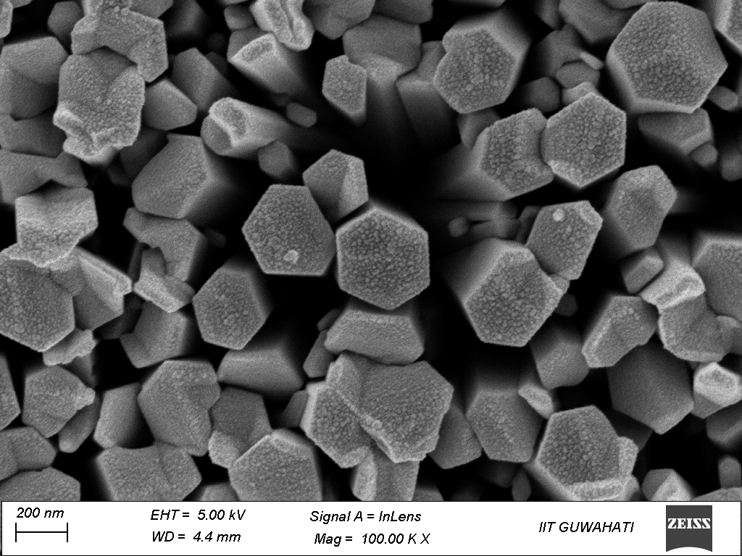
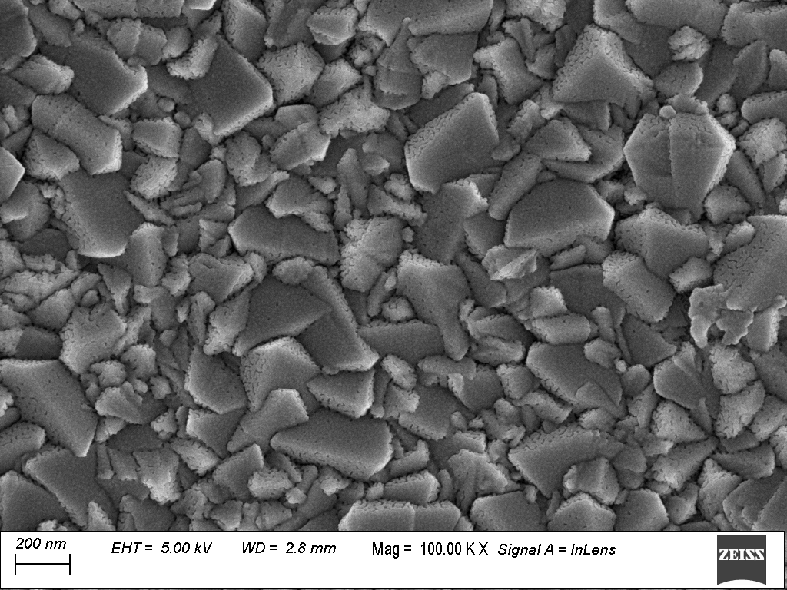

Figure 1: FESEM images of (a) bare FTO and (b) VANs of ZnO onto the surface of FTO glass substrate. Synthesis of VANs of ZnO onto the surface of FTO was performed at 95°C for 5h.

