A physics-informed machine-learning model of dissimilar friction stir welding to tailor residual stress using CEL approach

Debtanay Das*, Swarup Bag, and Sukhomay Pal
Department of Mechanical Engineering, Indian Institute of Technology Guwahati, Assam, India
E-mail:debtanay@iitg.ac.in

Abstract
Student Academic Board (SAB), Indian Institute of Technology Guwahati, Guwahati, Assam, India

Friction stir welding (FSW) is an important solid-state welding processes for joining similar and dissimilar combinations of materials. It provides successful welds at temperatures lower than the melting point temperature of the material. The dissimilar combination of AA6061-AZ31B alloys finds wide application in the aerospace and automotive industry due to the higher strength and creep resistance of the AA6061 and higher damping, and lighter weight of the AZ31B alloys. The effective modelling of the process is important to evaluate the possibility of the application of the welded materials to the industries. Further the prediction of defects such as the residual stresses, significantly affect the quality of the welded component. The residual stress is dependent on the temperature generation and heat flow. The influence of the residual stresses is more deleterious in dissimilar FSW due to the non-uniformity of the heat flow and material properties. This study deals with the prediction of temperature and stress for the complete duration of welding. A Coupled Eulerian and Lagrangian (CEL) model is potential to predict various thermo-mechanical responses of the FSW process. The experimentally validated numerical model further predicts the thermal and residual stress. The temperature profile is measured using the infrared camera, whereas the non-destructive X-Ray diffraction (XRD) method is used to measure the residual stress at different locations of the welded samples. The combined experimental and numerical results are used to develop a machine learning (ML) algorithm to predict the thermo-mechanical responses associated with the process. Different ML algorithms, such as the Decision Tree, Extra Tree, Random Forest, XGBoost, Gradient Boost, KNN were investigated for the current work, where Random Forest (RF) produced the best fit. The temperature and stress values were investigated at the start as well as the end of the welding. The value for the temperature test data at weld start and weld end are 99.81% and 99.85%, respectively. Similarly, the value for stress prediction at the start and the end of welding is above 96%. Moreover, the developed RF model is used to predict data for a completely different set of parameters, and the predicted result is within 5% of the actual result.
Research & Industrial Conclave 2023 "An amalgamation of Academia, Industry & Start-up”
"

Keywords: CEL, Residual stresses, XRD, FSW, Machine Learning, Random Forest

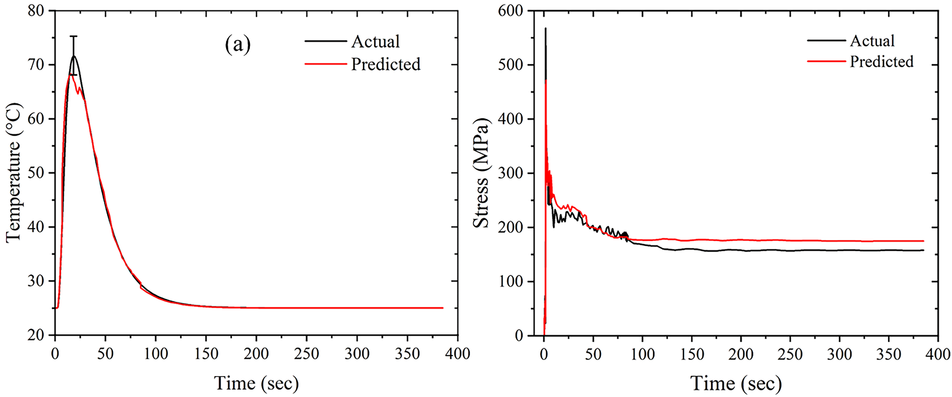
Fig. 1. Prediction of the (a) thermal and (b) stress distribution for FSW at 600 rpm and 60 mm/min

