Coupling Urine Diverting Flush Toilets with Anaerobic Co-Digestion in the Global South -
Modelling Climate Benefits in Kpong, Ghana

Giglberger, Felix1

1 School of Engineering & Design, Technical University Munich, Germany

E-mail: felix.giglberger@tum.de

Abstract

.
Student Academic Board (SAB), Indian Institute of Technology Guwahati, Guwahati, Assam, India
Research & Industrial Conclave 2023 "An amalgamation of Academia, Industry & Start-up”
"
In the Global South, urine diverting dry toilets have been successfully tested as feasible tools to increase sanitation coverage. However, many people desire flush toilets. Some approaches to treat wastewater from flush toilets have been implemented successfully, yet many sanitation projects have failed because operation and maintenance costs were too high. Biogas production from wastewater can be seen as a tool that benefits operators directly and tangibly, reducing the likelihood of sanitation projects to fail due to economic reasons once in operation. However, decentralized treatment systems in the Global South that can cope with larger quantities of flushwater do not provide reliable gas retrieval mechanisms. Fixed-dome digesters (FDDs) can provide a simple retrieval mechanism without the need for electricity or moving parts, allowing for sustainable gas collection. However, they are not used for treatment of diluted wastes, as this would make them unreasonably large. Urine diverting flush toilets (UDFTs) can save large quantities of water due to reduced flushwater consumption for urinations and could therefore enable the combination of flush toilets with biogas collection.
For a specific trade center with a size of 120 person-equivalents in Ghana, the economic and greenhouse gas (GHG) mitigation benefits of using this combination were compared against a standard anaerobic wastewater treatment approach without biogas collection. It was analyzed how flushwater consumption and co-digestion with food waste affect operational benefits, increased investment costs, and space consumption. This was done by comparing the influences of the different treatment elements used in the two approaches, namely the FDD, Imhoff tank, anaerobic baffled reactor, urine storage and composting of food waste as an alternative to co-digestion in the FDD. A key underlying assumption was that all water and nutrients would be properly reused. Theoretical calculations were performed using URWARE wastewater data and treatment modelling approaches that were combined with DEWATS engineering guidelines. An emission modelling approach was set up to investigate how different flushwater and food waste quantities affect emissions from the compensation tank of the FDD. Additionally, effects of varying LPG and carbon prices as well as effects of leaks and lack of flaring were shown and it was investigated how results could be translated to differing user populations.
It was found that about 700 USD can be saved per year but additional initial investment cost would be as large as 13,600 USD. Still, 32% of initial investment costs were attributed to urine storage, which may not be needed in some cases. GHG emissions from construction would amortize already after 1.7 years and 200 t_{CO2-eq} could be mitigated after 20 years of operation. Adjustment with a carbon price of 100 USD t_{CO2-eq}⁻¹ would allow for economic amortization after 8.6 years, resulting in economic savings of 20,400 USD after 20 years of operation. Food waste dosage did not affect this result significantly, showing that co-digestion is not needed if this carbon price would be in effect. In conclusion, UDFTs are a powerful tool to mitigate GHG emissions and ensure continued treatment system operation in the Global South, however technology diffusion will require adequate funding mechanisms that can cope with the increased investment costs.

Keywords: Anaerobic Digestion, Urine-diverting flush toilets, Wastewater, Greenhouse gas emissions, Sustainability
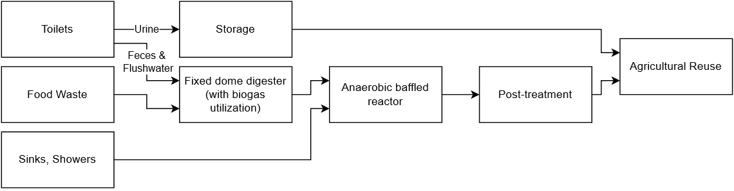
Figure 1: Investigated process using urine diversion
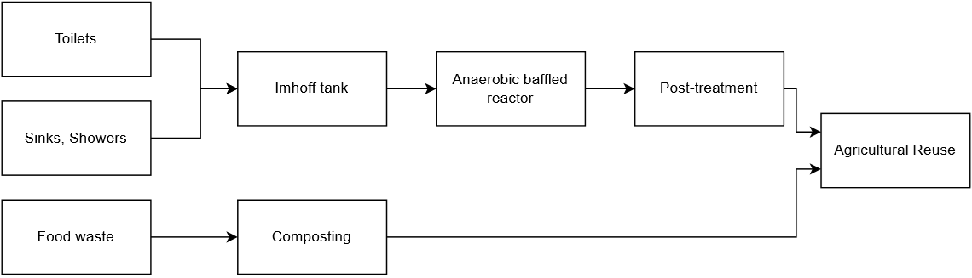
Figure 2: Baseline process compared against

