Bioactive compounds from indigenous bacterial isolate with anticancer activity community and their versatile role in green synthesis of gold nanoparticles

Gourav Bhattacharjee¹, Prof. Ajaikumar B. Kunnumakkara², Prof. Lal Mohan kundu^{1,2}*
¹Centre for Environment, Indian Institute of Technology Guwahati, Assam – 781039, India.
² Department of Chemistry, Indian Institute of Technology Guwahati, Assam – 781039, India.
(Email id of: lmkundu@iitg.ac.in)

Abstract
Several bacterial species, such as Clostridium, Klebsiella, Pediococcus, Lactobacillus, and Pseudomonas have been found to have potential anticancer activity. More than 1500 active compounds are under development, and 500 are under clinical trial.[1-5] In this study, we have isolated a bacterial strain (GB_SG_008) from the soil, which shows high anticancer activity against specific tumor cells.
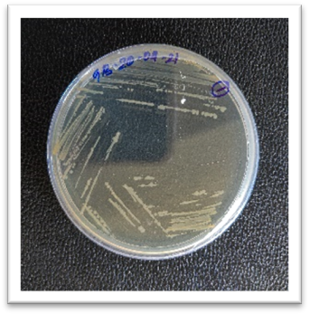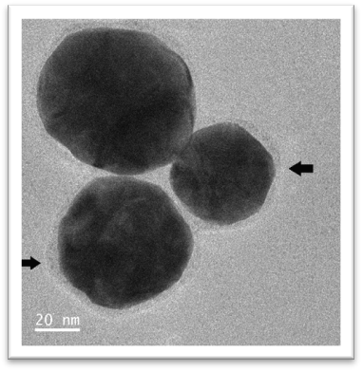
Figure 1. Images showing the bacterial population (GB_SG_008) growing on an LB agar plate (left) and AuNPs synthesized from extracellular supernatant of the same bacteria (right).
In this work, we have also discovered that the extracellular metabolites containing the bioactive compounds were found to reduce gold salt to produce gold nanoparticles (AuNP). The AuNP was found to have a spherical shape with around 40 to 60 nm in diameter. The AuNP also possesses a sheath over the surface, which possibly came from the reducing agent present in the extracellular supernatant and working as a capping agent for the AuNP. Finally, a cell viability assay was performed, and it was found that the AuNP and the extracellular supernatant from GB_SG_008 both have anticancer activity against human cancer cell lines. The bacterial strain was further subjected to 16s sequencing to understand the identity of the aforementioned bacterial strain.

References
[1] Cann, S. A. H.; Netten, J. P. Van; Netten, C. Van. Dr William Coley and Tumour Regression: A Place in History or in the Future. Postgrad Med J. 2003 Dec; 79(938): 672–680.
[2] Zacharski, L. R.; Sukhatme, V. P. Coley's Toxin Revisited: Immunotherapy or Plasminogen Activator Therapy of Cancer? J. Thromb. Haemost. 2005, 3 (3), 424–427.
[3] Minton, N. P. Clostridia in Cancer Therapy. Nat. Rev. Microbiol. 2003, 1 (3), 237–242.
[4] Jain, K. K. Use of Bacteria as Anticancer Agents. Expert Opin. Biol. Ther. 2001, 1 (2), 291–300.
[5] Jain, K. K. Use of Bacteria as Anticancer Agents. Expert Opin. Biol. Ther. 2001, 1 (2), 291–300.

