Aluminium Oxide Nanoparticle assisted Polymer flooding of Crude oil: Rheology, Interfacial Tension and Wettability Alteration Characteristics

Dorababu Gulipalli1, Pankaj Tiwari2

1 Department of Chemical Engineering, IIT Guwahati, India

E-mail: gulipalli.dora@iitg.ac.in

Abstract

The demand for crude oil has been continuously increasing with the increase in economic growth, industrialization, and population. Due to this maximizing oil recovery has become essential. Enhanced oil recovery (EOR) is a technique used to increase the amount of oil that can be extracted beyond the primary and secondary stages. Polymer Enhanced Oil Recovery is one of the most widely used EOR techniques. This involves the injection of high molecular weight polymers into the reservoir to improve the viscosity of the injected fluid. This leads to a reduction of mobility ratio between the injected fluid and the oil which in turn improves the displacement efficiency. Nanoparticles can further increase the viscosity of the injectant fluid and also provide better stability at higher temperatures. In addition to this, they also have an impact on other mechanisms responsible for EOR such as Interfacial tension (IFT) and Wettability alteration. This present work deals with the effect of Aluminium oxide (Al₂O₃) nanoparticles on various mechanisms of Polymer enhanced oil recovery. The polymer used for this study was Guar gum, a biopolymer. The rheological behaviour of the Guar gum-Al₂O₃ system was studied at 25⁰C and 75⁰C. The Polymer concentration chosen for the study was 5000 ppm. At 25⁰C and 1s⁻¹ shear rate, the viscosity of 5000 ppm Guar gum is 0.379 Pa.s. which increased to 0.434 Pa.s. for 0.5 wt.% Al₂O₃. The increase in viscosity was less because of the high adsorption of Al₂O₃ metallic nanoparticles. The Guar gum-Al₂O₃ system showed better stability at higher temperatures as the loss of viscosity was less. The viscosity of Guar gum decreased to 0.195 Pa.s. at 75⁰C i.e., the loss of viscosity was 49% whereas for 0.5wt.% it was 0.353 Pa.s. The loss of viscosity when nanoparticles were included was around 19%. The Interfacial Tension was measured at 30⁰C for Guar gum and Guar gum-Al₂O₃ system. The IFT decreased with an increase in nanoparticle concentration. Guar gum was able to decrease the IFT from 14.60 mN/m to 12.07 mN/m. The IFT values were 8.463 mN/m and 5.337 mN/m for 0.1 wt.% and 0.2 wt.% respectively. Wettability alteration is studied using contact angle measurements of polymer and polymer-nanoparticle fluids on an oil-saturated core slice. Although the initial change in contact angle was low the change of angle with time increased with an increase in nanoparticle concentration The lowest contact angle was obtained for 0.5 wt.% Al₂O₃ concentration which was initially 90.76⁰ and further decreased to 32.41⁰ after 10 min. The ability of polymer nanofluid to form an emulsion with crude oil was studied using the Emulsification Index (E₂₄). The characterization of the prepared chemical slug suggests its suitability to improve the EOR process.
Student Academic Board (SAB), Indian Institute of Technology Guwahati, Guwahati, Assam, India

Keywords: Enhanced Oil Recovery, Guar gum, Nanoparticles

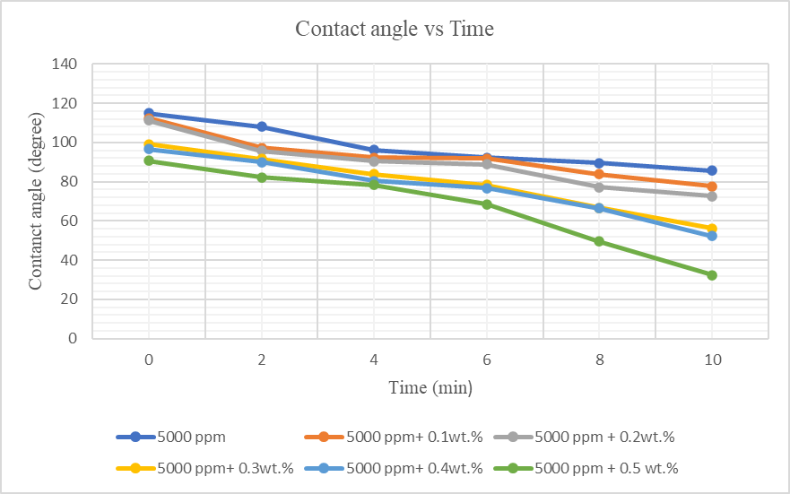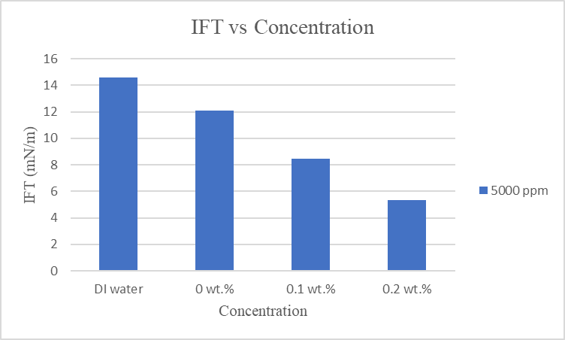
Fig: Contact angle vs time for Guar gum and Guar gum_Al₂O₃ nanoparticle solutions
Fig: IFT values of Guar gum and Guar gum_Al₂O₃ nanoparticle solutions

