Two-dimensional CFD Simulations of Two Phase flow in Curved Microchannel

Gunjan Yadav^{1*}, Raghvendra Gupta^{1,2,3}

1 Department of Chemical Engineering, IIT Guwahati, India
²Centre for Sustainable Polymers, IIT Guwahati
³Jyoti and Bhupat Mehta School of Health Sciences and Technology, IIT Guwahati

*Corresponding Author: gunjan.yadav@iitg.ac.in

Abstract

Microreactors are being increasingly used for gas-liquid and liquid-liquid reactions and other unit operations due to the advantage of high interfacial area density. Microreactors include straight as well as curved sections. The flow behaviour in the straight section is axisymmetric, but at curved section is not axisymmetric. For example, at the curved section, the liquid film surrounding the gas bubble in the slug flow regime is observed thinner on the inner wall than on the outer wall. In this work, we study the effect of curvature on bubble flow in a continuous liquid in a U-shaped channel using computational fluid dynamics (CFD). The volume of fluid (VOF) approach is used to model two-phase flow. In the VOF method only one set of mass and momentum conservation equations are solved together with an advection equation for the volume fraction of fluids. The governing equations are solved using ANSYS Fluent, a commercial CFD solver. The gas phase is air and the liquid phase is taken as water. The generation of air bubble represented by red colour can be seen in the volume fraction contours in three different geometries in Figure.1. The width of the channel is 1 mm and the inner radius of curvature is 0.5 mm, 1mm, 2mm, respectively, to study the effect of radius of curvature on film thickness shown in Figure.1. The mesh is more refined at the inner side of the channel than outer side such that the thin film surrounding the bubble can be captured. The effect of two-phase velocity and radius of curvature on the film thickness and velocity field is investigated.
Student Academic Board (SAB), Indian Institute of Technology Guwahati, Guwahati, Assam, India
Research & Industrial Conclave 2023 "An amalgamation of Academia, Industry & Start-up”
"

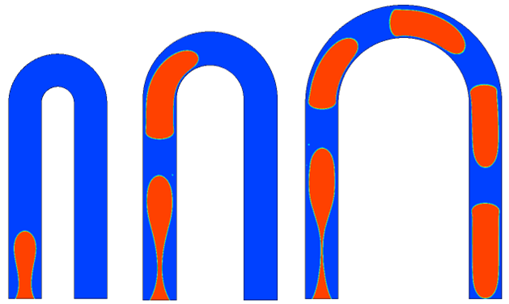
Fig.1 volume fraction contours

Key Words: Microreactor, Computational fluid dynamics, Volume of fluid

