Semi-Aromatic Polyamide-Based Membrane for Textile Industries Wastewater Treatment: Molecular Insights
G. Nagendraprasad¹, Adupa Vasista1, Santanu Karan², Das Chandan¹, K. Anki Reddy³

¹ Department of Chemical Engineering, Indian Institute of Technology, Guwahati, 781039, Assam, India
² Membrane Science and Separation Technology Division, CSIR-Central Salt and Marine Chemicals Research Institute, G.B. Marg, Bhavnagar, 364 002, Gujarat, India
³ Department of Chemical Engineering, Indian Institute of Technology, Tirupati, 517 619, Andhra Pradesh, India

E-mail: g.nagendra@iitg.ac.in

Abstract
Research & Industrial Conclave 2023 "An amalgamation of Academia, Industry & Start-up”
"

Despite the increased interest in forward osmosis (FO) in recent years, the technology’s advancement in commercial and industrial applications has been hampered by the absence of suitable FO membranes, which demands the exploration of new membranes targeted for some specific uses. Polyamide (PA) thin−film composite (TFC) membranes with high performance are in high demand. However, enabling PA TFC membranes to overcome the perm−selectivity trade-off is still challenging. A fundamental understanding of semi−aromatic PA (SAPA) in the FO process at the molecular scale is crucial to improving their performance capabilities, leading to significant societal and industrial benefits. Here, an atomistic model was built with an equilibrated mixture of hydrolysed trimesoyl chloride and piperazine monomers to address this issue. Nonequilibrium molecular dynamic simulations are used for investigating the membrane model structure and transport characteristics of water and two different solutes, NaCl and Na₂SO₄, through the SAPA FO membrane. Results reveal that the hydrophilic functional groups (−COOH) of the membrane facilitate the transport of water molecules, increasing the water transport across the free volume of the membrane network due to the interactions between the water molecules and the membrane atoms. The SAPA membrane exhibits a high-water flux without sacrificing the rejection of Na₂SO₄ (> 99%). The pathways of monovalent solute ions (Na⁺ and Cl⁻) follow the same fashion as water molecules; in contrast, divalent solute molecules (Na₂SO₄) are trapped due to high units of −COOH groups in the membrane. The performance of the SAPA membrane in this work reveals the potential of PA TFC membranes in the textile industry for wastewater treatment.
Student Academic Board (SAB), Indian Institute of Technology Guwahati, Guwahati, Assam, India
.

Keywords: Piperazine, Trimesoyl chloride, Semi−aromatic polyamide membrane, Forward osmosis,
non-equilibrium molecular dynamics

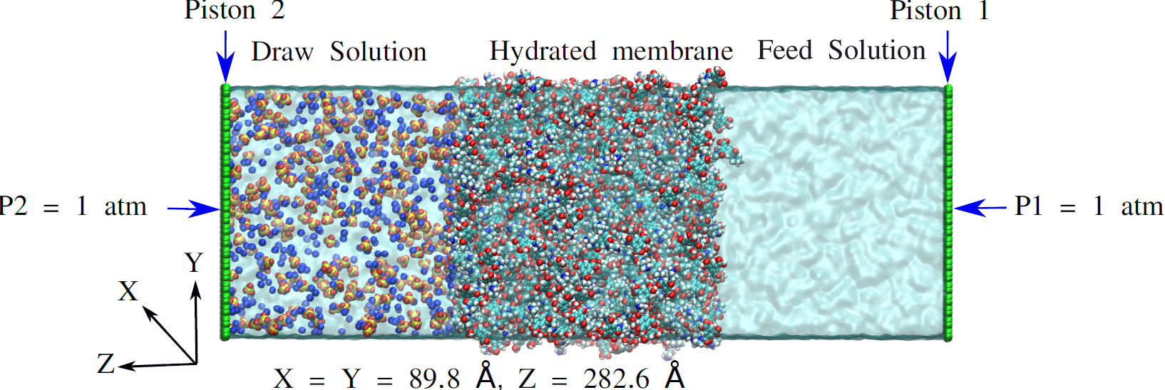 | 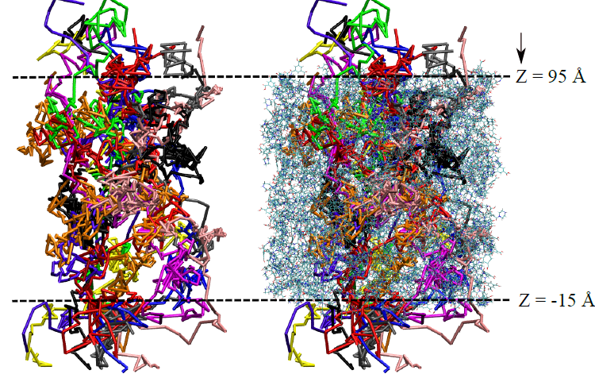
Figure 1: FO simulation system | Figure 2: Pathways of water molecules

