Evolution of scour depth around oriented Spur dikes

A. Harish K Patel¹ , B. Sukhjeet Arora¹, C. Chandramauli shah¹, D. Joychen kenglang¹ and Bimlesh Kumar^{1*}

1 Department of Civil Engineering, Indian Institute of Technology Guwahati (IITG), India

E-mail: harish_kumar@iitg.ac.in; sukhjeet@iitg.ac.in; kumar.chandramauli@iitg.ac.in; jkenglang@iitg.ac.in; bimk@iitg.ac.in

Abstract
Student Academic Board (SAB), Indian Institute of Technology Guwahati, Guwahati, Assam, India
Research & Industrial Conclave 2023 "An amalgamation of Academia, Industry & Start-up”
"

The study conducted experiments on rectangular-shaped spur dikes, which are structures built along the river bank to prevent erosion by deflecting the flow of water away from the bank. The research aimed to determine the most suitable orientation for these structures by examining the temporal variation in bed morphology and scours. The study focused on three different angles, namely 60º, 90º, and 120º, and analyzed the development of scour over time at intervals of 2 hours, 12 hours, and 24 hours. Results revealed that the 90º orientation caused the greatest scour depth, while the 120º orientation caused the least. Compared to the other orientations, the 90º orientation produced a maximum local scour depth that increased by 32% and 43% after 2 hours, 24.5% and 41.7% after 12 hours, and 30.9% and 46.4% after 24 hours. The scour depth started at the tip of the spur dike and was most significant there. The scour hole downstream of the spur dike widened, and a dune-like structure formed between the first and second spur dikes. The longitudinal extents of scour diameter were 19 cm, 21 cm, and 16 cm downstream of spur dike-1, and the transverse extents of the scour hole at the spur dike tip were 38 cm, 40 cm, and 26 cm for the 60º, 90º, and 120º orientations, respectively.
Keywords: Spur dikes, Scour depth, Temporal variation

Result:
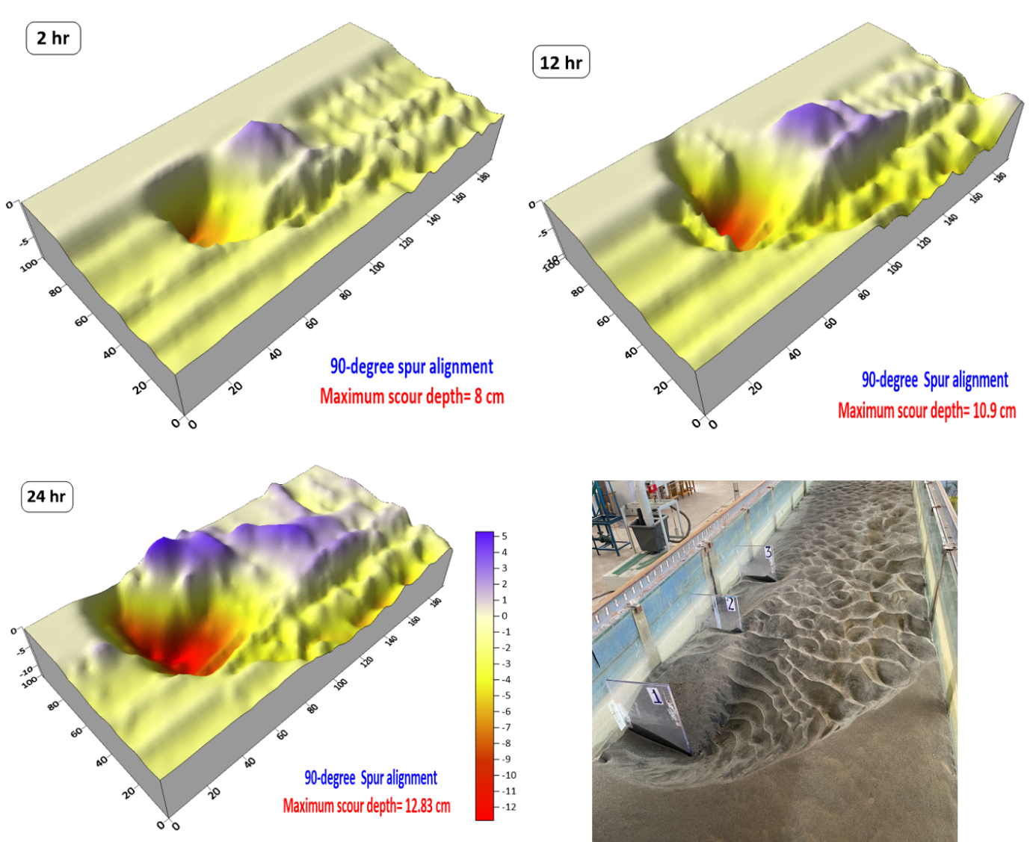
Figure 1. Temporal scour development around 90-degree oriented spur dikes

