Design and development of plasma process for finishing of optical component and its characterization
Hari Narayan Singh Yadav¹* and Manas Das¹

¹ Department of Mechanical Engineering, Indian Institute of Technology Guwahati, Assam, India

*E-mail: h.narayan@iitg.ac.in

Abstract

Nowadays, the finishing of optical components has drawn the attention of many researchers. The modern optics industry demands rigorous surface quality with minimum defects and challenging optics machining technologies. There are always certain defects on the final surfaces of the components, such as micro-cracks, lattice disturbances, etc., formed in conventional contact machining processes. It is severe for hard-brittle functional materials, such as crystals, glass, and ceramics. To get an ultra-smooth surface with zero sub-surface defect for fused silica, medium-pressure plasma processing (MPPP) is developed. The process works based on the chemical reactions between excited radicals and workpiece surface atoms, and atomic-level precision machining can be achieved. The gas composition of 90:10, the pressure ratio of 1:1, the total pressure of 5 mbar, and the RF power of 80 W have been obtained as the optimum condition using preliminary experiments. The experiments are performed at a radio-frequency (RF) power of 80, 40, and 20 W for different total chamber pressures, i.e., 5,10, and 20 mbar. The results revealed the maximum thickness reduction at 5 mbar and 80 W for 45 mins of machining time. The maximum reduced thickness and material removal rate achieved are 6.54 μm and 0.10 mm3/min, respectively, at 5 mbar and 80 W. Also, reduced thickness variation and MRR are investigated at different total pressures and RF powers. The surface finish of fused silica is measured using a 3D profiler before and after plasma processing. The result revealed that the surface morphology and machined cracks are reduced after plasma polishing. It is evident by the workpiece contrast that the substrate surface, after plasma processing, achieved a good surface finish without any surface defects and surface contamination. The surface roughness is marginally increased from 0.28 µm to 0.30 µm after plasma processing at optimum parametric conditions. Hence, the medium-pressure plasma can support the polishing process to achieve better-quality surfaces. EDX analysis of the fused silica substrates is conducted to measure elemental composition on the substrate surface. Two elements, i.e., Si and O, appear before the process, and Si, F, O, and C are present after plasma processing. The weight % of C (i.e., 0.02%) observed after plasma processing may come from the O ring used in the plasma chamber.
Research & Industrial Conclave 2023 "An amalgamation of Academia, Industry & Start-up”
"

Keywords: Plasma polishing, Fused silica, Surface roughness, FESEM, EDX

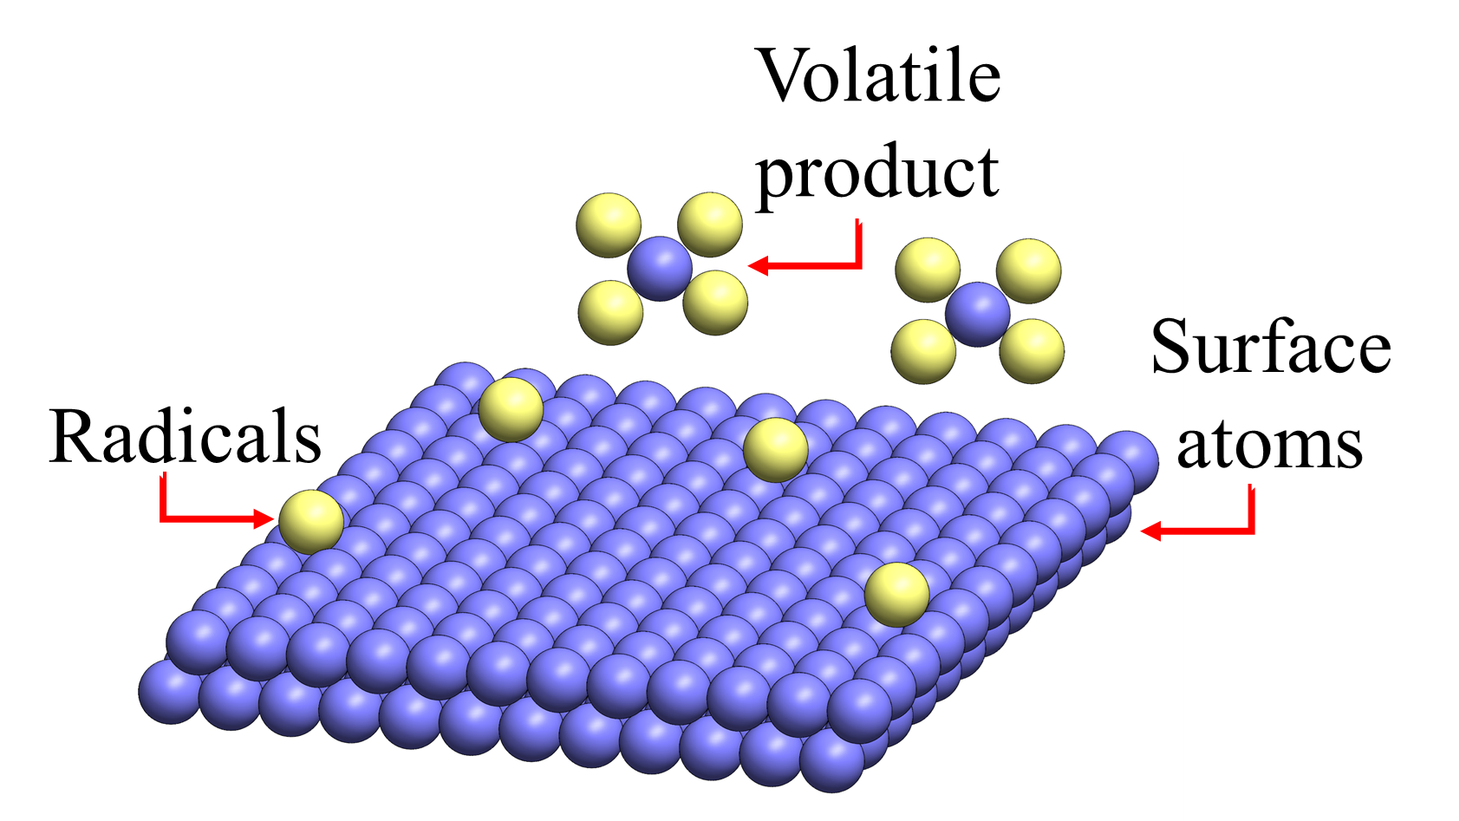
Student Academic Board (SAB), Indian Institute of Technology Guwahati, Guwahati, Assam, India

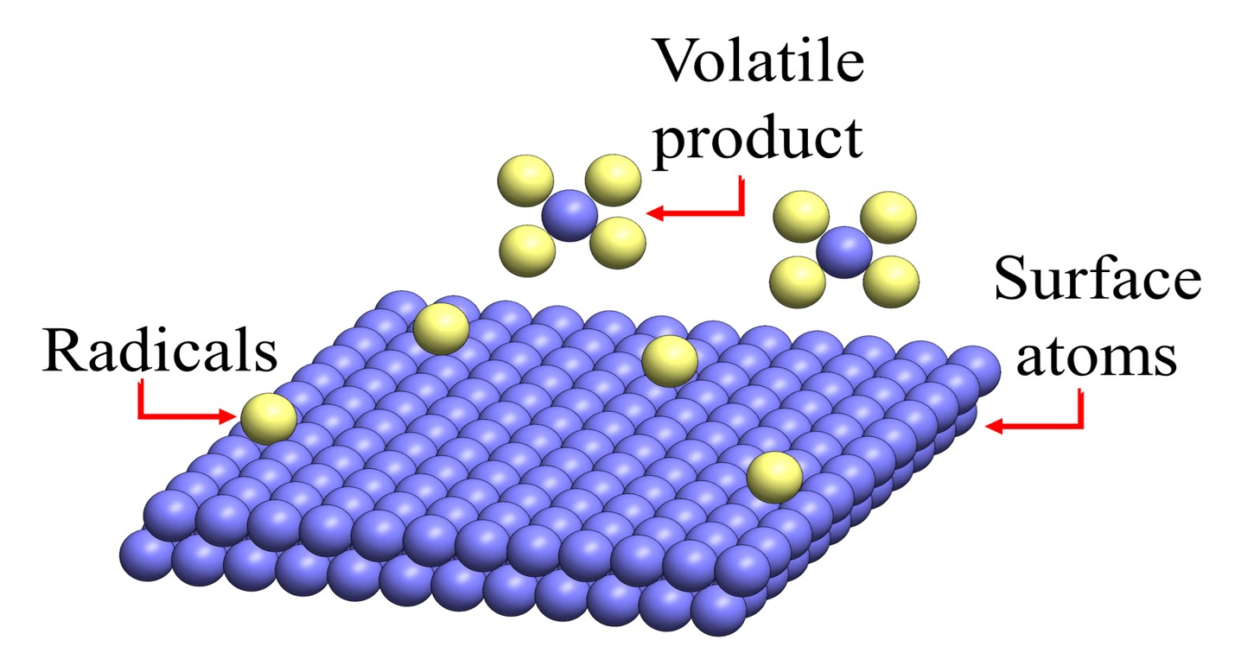
Fig. 1 Principle of plasma process

