Plasma based finishing process applied on optical component and its characterization
Hari Narayan Singh Yadav¹* and Manas Das¹

¹ Department of Mechanical Engineering, Indian Institute of Technology Guwahati, Assam, India

*E-mail: h.narayan@iitg.ac.in

Abstract
In current years, technology is developed in the electronic field, and the manufacturing sector created a large demand for optical components. The optical components are the most important and necessary components of making electronic chips and semiconductor-related production. In those fields, the quality of the surface is very important. Polishing the optical material is not easy. It is a more critical process. It is very hard to polish the surface of the material by using a traditional polishing method. In order to satisfy all those drawbacks, a plasma polishing process has been introduced. The plasma process prevents surface and subsurface damage while polishing optical components. The present article focused on the advanced plasma process considered over the past decade and will be comprehensively reviewed, discussing their principles, applications and challenges. Moreover this article addresses the investigation of surface morphology and chemical composition before and after the process using the plasma process.
Research & Industrial Conclave 2023 "An amalgamation of Academia, Industry & Start-up”
"

Keywords: Plasma polishing, Fused silica, Surface roughness, FESEM, EDX
Student Academic Board (SAB), Indian Institute of Technology Guwahati, Guwahati, Assam, India
Characteristics of the optical substrate
The optical substrates' properties are primarily determined by their atomic structure and chemical composition. Hence, it is crucial to employ a non-contacting technique. Since there is no physical contact between the tool and the working surface during this procedure, there are no surface or sub-surface damages, only fine surface quality. The surface properties and their impact on the optical component are shown in Table 1.

Table 1. Optical components characteristics
Surface characteristics | Effect
Shape accuracy | Aberrations in Geometrical
Damage in subsurface | Minimum loss and low lifespan
Absorption and reflection | Minimum loss
Dispersion | Aberrations in chromatic
Inhomogeneity of physical and chemical | Change in reflection, refractive index
Transmission | Change in intensity of light
Refractive index | Phase of the light is distorted
Strength | Response for deformability
Density | Change in intensity and phase of lights

Experimental setup
This plasma polishing setup consists of gas cylinders (He, O_{2,} and SF₆), mass flow meters (MFM), plasma chamber and RF (radio-frequency) power. The gasses flow into the mass flow meter from the gas cylinder, and a separate controller is used to control the flow rate of the gasses and admitted into the plasma chamber. After the gasses are allowed to enter the process chamber, RF power is used to produce the plasma inside the chamber. Then the plasma generates the radicals and ion species which react with the surface of the workpiece as energetic radicals, ions and electrons. These radicals make surface reactions with the fused silica. Further, the volatile product, i.e. SiF₄, generated and removed the material from the surface. This process eliminates the material from the surface of the workpiece by the radical and ion species. The schematic diagram of the experimental set is illustrated in Fig. 1.

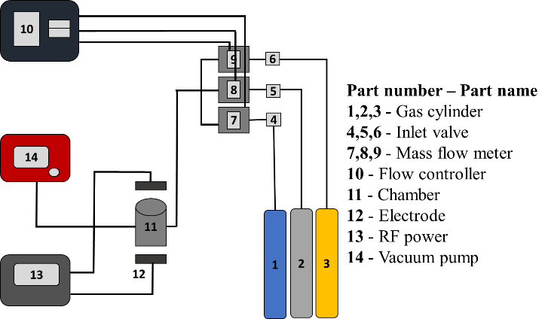
Fig.1.Schematic of the experimental setup

