Rapid in vitro regeneration of plantlets from nodal segment culture of Malus domestica, for functional uses as apple rootstock in grafting

Himanshu Chaudhary, Chetna Sharma, Krishna Kant Pachauri and Rakhi Chaturvedi*
Department of Biosciences & Bioengineering, Indian Institute of Technology Guwahati,
Guwahati-781039, Assam, INDIA

*E-mail: rakhi_chaturvedi@iitg.ac.in

Abstract
Student Academic Board (SAB), Indian Institute of Technology Guwahati, Guwahati, Assam, India

Malus domestica one of the most widely cultivated tree species belongs to plant family Rosaceae, primarily grown for fresh fruit sales but it is also canned to make vinegar, juice, jelly, apple sauce, apple butter, and pie filling. Traditional propagation technique such as grafting are used to keep the rootstock disease-free. On the other hand, in vitro tissue culture methods, appear to be promising approaches for rapidly producing genetically uniform as well as improved cultivars. In this present investigation a suitable protocol was developed for micropropagation of apple cultivars using nodal segment culture. Initially nodal segment explant is inoculated on MS + 4.5 μM BAP + 0.5 µM GA₃ medium for shoot induction. Induction of shoots was observed after 2 weeks of culture (Fig 1 A). Elongated shoot 3-4 cm in length were inoculated in ½ MS + 0.5μM IBA for root development (Fig 1 B). All the cultures were maintained in 16 h light and 8 h dark conditions at 25ºC temperature in culture room. High rates of survivability of plantlets were observed in the potting mixture of soil: sand: compost in ratio of 2:2:1 (Fig 1 D). In conclusion an effective mass multiplication, root development followed by hardening and acclimatization protocol were established in Malus domestica (Apple). This established protocol can be utilized to generate the large amount of genetically identical plantlets in a short time interval.
Research & Industrial Conclave 2023 "An amalgamation of Academia, Industry & Start-up”
"

Keywords: Acclimatization, explant, grafting, micropropagation, rosaceae
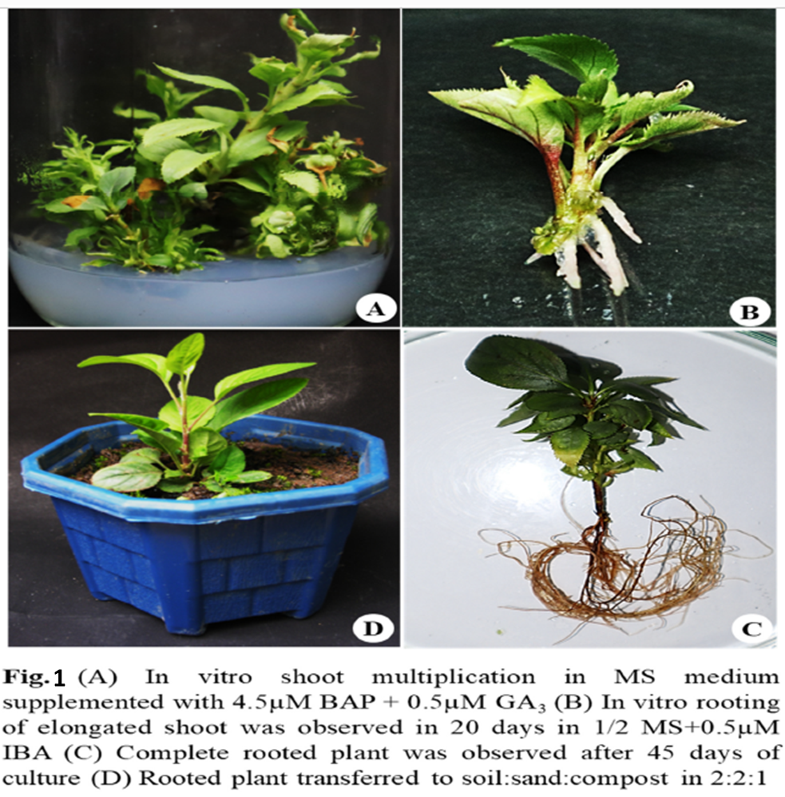

Reference:

1. Dobránszki, J., and Teixeira da Silva, J. A. (2010). “Micropropagation of apple - A review.” Biotechnol. Adv., 28, 462–488.
2. Karhu, S. T. (1997). “Sugar use in relation to shoot induction by sorbitol and cytokinin in apple.” J. Am. Soc. Hortic. Sci.

