Design and Development of a semi-active Polycentric knee joint

J.Antonyjefri¹, Ajit Yadav¹, Vaibhav jaiswal², S. Kanagaraj²

1 Department of Medical Devices, National Institute of Pharmaceutical Education and Research Guwahati, Guwahati-781101, Assam, India.

2 Department of Mechanical Engineering, Indian Institute of Technology Guwahati, Guwahati-781039, Assam, India.

E-mail: jantonyjefri007@gmail.com

Abstract

As per the world population data sheet [2011], there are more than 30.6 million people who have a locomotive disability. The National Limb Loss Information Centre (NLLIC) reported that 87% of people suffer from lower extremity disability, and 38% among them are above-knee amputated persons, who are required to generate 60% higher metabolic energy and three times excess power and torque from the hip for walking compared to a healthy individual. Commercially available prosthetic devices can generate functional joint movements equivalent to the human lower limb with a few limitations, such as affordability and variable walking speed. To overcome the above, an attempt is made to design and develop an affordable semi-active polycentric knee joint, which is expected to mimic the near walking speed of its users. The 2nd generation knee joint developed by IITG is selected to incorporate the proposed work. To achieve this functionality, a hydraulic damper with a spring-integrated prosthetic knee is designed. It is found to control the swing phase of the prosthetic knee, and it also allows individuals to vary the speed of walking. The developed mechanism is expected to provide stance phase stability and knee flexion with speed control without increasing the metabolic cost of the amputee. Nylon, hydraulic damper and stainless steel are chosen to develop the polycentric knee joint. The static stress analysis was done at P3 (1610N) loading condition as per ISO 10328:2016; the maximum Von Mises stress was observed to be 36 MPa, and the designed knee joint safety factor was found to be 1.66. The finite element analysis results demonstrate that the design is secure enough to undergo further implementation of the prosthetic knee in patients.
Student Academic Board (SAB), Indian Institute of Technology Guwahati, Guwahati, Assam, India

Keywords: SPEED ADAPTIVITY, STANCE PHASE STABILITY, AFFORDABILITY
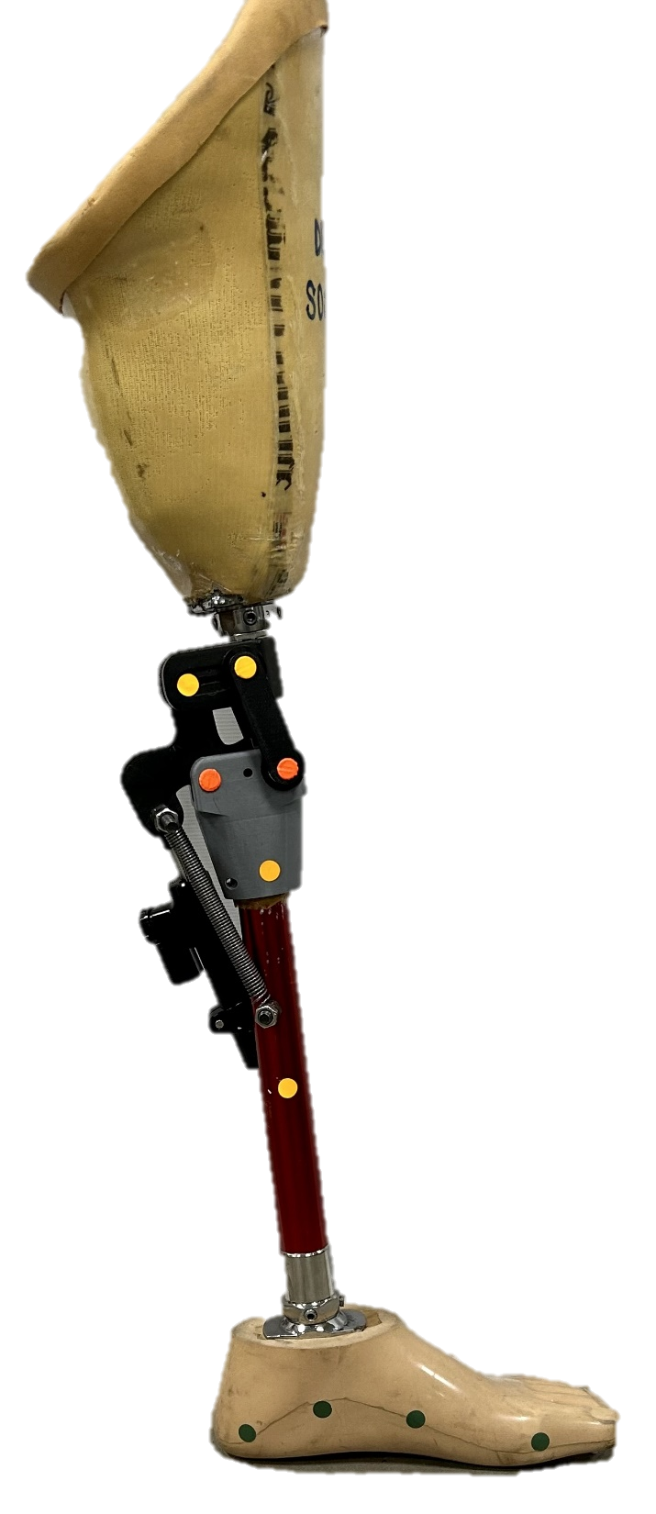

Fig. 1. Semi-active prosthetic knee joint

References:
[1] S.Kanagaraj et al. (2017). Trends and challenges in lower limb prostheses. IEEE Potentials https://Digital Object Identifier 10.1109/MPOT.2016.2614756

