Numerical investigation of liquid flow in a bifurcating channel

Jayant Prasad1, Raghvendra Gupta2

1 Department of Chemical Engineering, IIT Guwahati, India
2 Department of Chemical Engineering, IIT Guwahati, India

E-mail: j.prasad@iitg.ac.in

Abstract

This study presents the numerical simulation of single phase liquid (water) flow in a bifurcating channel using the open-source Computational Fluid Dynamics (CFD) software, OpenFOAM. The channel consists of a main channel that bifurcates into two branches of different sizes. The objective of the study is to investigate the effect of inlet velocity, bifurcation angle, and branch size on the flow patterns, pressure drop, and flow distribution in each branch. The simulation results are analysed to understand the flow behaviour and the pressure drop along the channel.
Student Academic Board (SAB), Indian Institute of Technology Guwahati, Guwahati, Assam, India
Research & Industrial Conclave 2023 "An amalgamation of Academia, Industry & Start-up”
"
The results show that the flow behaviour is highly dependent on the inlet velocity, bifurcation angle, and branch size, with different flow patterns observed at different conditions. The pressure drop is found to increase with an increase in the inlet velocity, bifurcation angle, and branch size, which can be attributed to the change in the flow pattern These insights can be useful in the design and optimization of various industrial processes involving single phase fluid flow.

Keywords: Bifurcating channel, CFD, Single phase

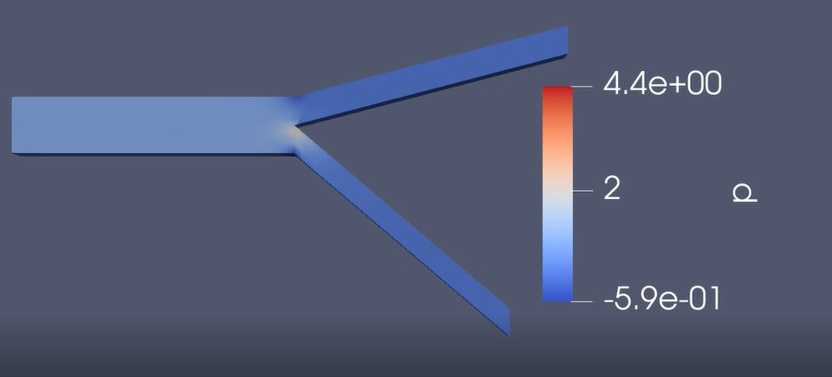
Fig. 1. Pressure distribution in bifurcating channel

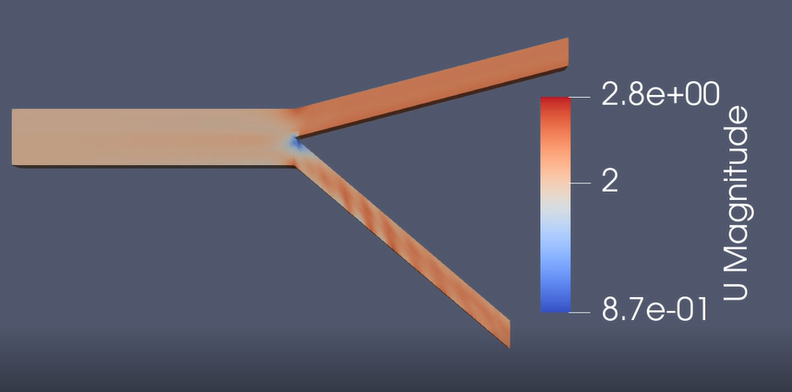
Fig. 2. Velocity distribution in bifurcating channel

