Isolation Improvement in CPW-fed UWB Diversity Antenna utilizing Fractal Neutralization Line

Arya Paul1, Jeet Banerjee1 and Rowdra Ghatak2

1 Department of Electrical & Electronics Engineering, Adamas University, Kolkata, India
2 Department of ECE, NIT Durgapur, India

E-mail: aryapaul@stu.adamasuniversity.ac.in

Abstract

This contribution, nominates and investigates a compact co-planar waveguide fed (CPW) Ultra-wideband (UWB) Multiple-Input–Multiple-Output (MIMO) antenna. The configuration exploits a novel 2nd order Hilbert fractal neutralization line and a T-shaped defect in the common ground structure for enhancement of wideband isolation. The antenna exhibits UWB characteristics ranging from 5 GHz to 11.3 GHz. The two-element wideband MIMO antenna is realized within a compact layout of 32.94 mm×26.75 mm=881.14 mm². The isolation among the pair of planar monopoles is found to be > -17 dB throughout the band of interest even with a negligible inter-element spacing of 0.48 mm. Moreover, the envelope correlation coefficient (ECC) of the UWB MIMO antenna is calculated to be < 0.01. The concurrence admits the diverse simulation results verify that the proposed arrangement can be a worthy competitor for handy UWB as well as UWB MIMO systems.
Student Academic Board (SAB), Indian Institute of Technology Guwahati, Guwahati, Assam, India
Research & Industrial Conclave 2023 "An amalgamation of Academia, Industry & Start-up”
"
Keywords: Ultra-wideband (UWB), Multiple-Input Multiple-Output (MIMO), Defected Ground Structure (DGS), Fractal Neutralization Line (FNL), Envelope Correlation Coefficient (ECC), Co-planar waveguide (CPW), Planar Monopole (PM)
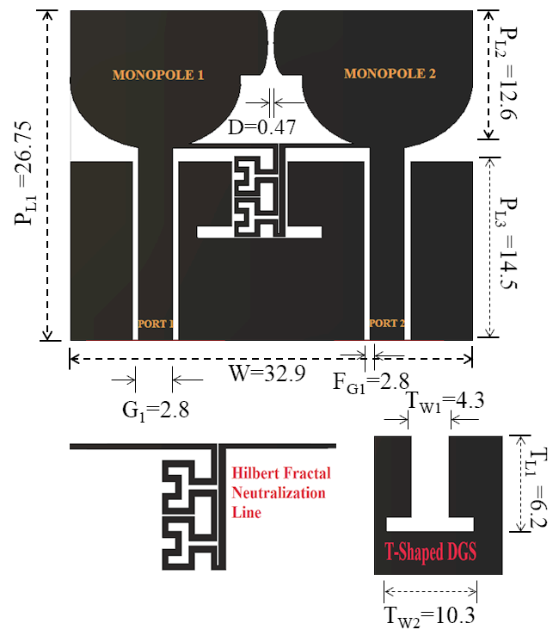
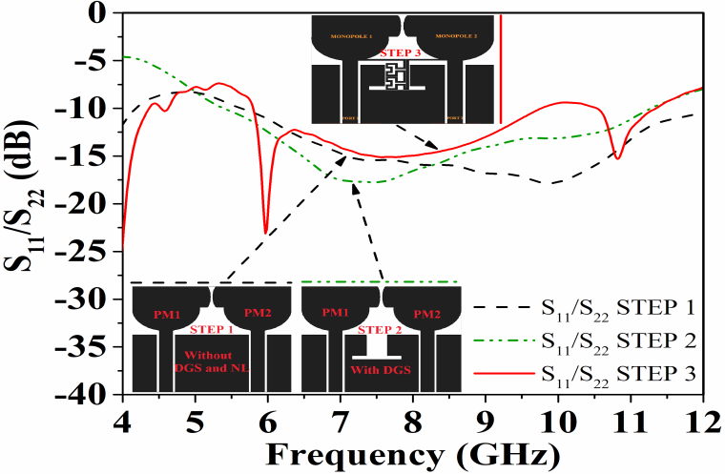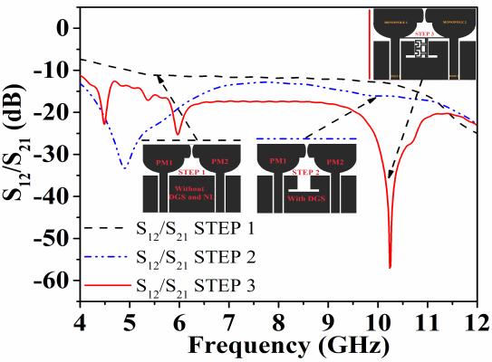
(a) (b) (c)
Fig. 1. (a) Schematic view of the CPW fed UWB MIMO antenna. (b) S₁₁/S₂₂ for sequential stages of antenna design (c) S12/S21 characteristics for sequential stages of antenna design.
References:
Referencs | Antenna overall dimension  (mm²) | Bandwidth  (GHz) | Isolation  (dB) |  | ECC | Int. Element Spacing (mm)
[1] | 65×30=1950 | 2370 MHz-2490 MHz | >19 | <0.01 |  | 14 mm
[2] | 100×60=6000 | 1.62–2.92 GHz | >15 | <0.39 |  | 20 mm
[3] | 35×33=1155 | 3.1 GHz to 5 GHz | >20 | <0.1 |  | 2.2
[4] | 40×100=4000 | 1.7-2 | >15 | <0.5 |  | 22
This work | 26.75×32.94=881.14 | 2.63-10.63 | > 15 | < 0.1 |  | 0.47
- S. Su, C. Lee and F. Chang, “Printed MIMO-Antenna System Using Neutralization-Line Technique for Wireless USB-Dongle Applications,” IEEE Transactions on Antennas and Propagation, vol. 60, no. 2, pp. 456-463, Feb. 2012.
- Y. Wang and Z. Du, “A Wideband Printed Dual-Antenna with Three Neutralization Lines for Mobile Terminals,” IEEE Transactions on Antennas and Propagation, vol. 62, no. 3, pp. 1495-1500, March 2014.
- S. Zhang and G. F. Pedersen, “Mutual Coupling Reduction for UWB MIMO Antennas with a Wideband Neutralization Line,” IEEE Antennas and Wireless Propagation Letters, vol. 15, pp. 166-169, 2016.
- A. Diallo, C. Luxey, P. Le Thuc, R. Staraj and G. Kossiavas, "Study and Reduction of the Mutual Coupling Between Two Mobile Phone PIFAs Operating in the DCS1800 and UMTS Bands," in IEEE Transactions on Antennas and Propagation, vol. 54, no. 11, pp. 3063-3074, Nov. 2006.

