Drying of Calendula using different embedding materials

Jutika Goswami and Dr. Supriya Langthasa
Department of Horticulture
Biswanath College of Agriculture, AAU, Biswanath Chariali

E-mail: jutikagoswami11@gmail.com

Abstract
Keywords: Embedding method; Desiccants; Dry flower

The most promising area in floriculture is the dry flower industry. Dry flowers are a good standby for the florist’s, since designs can be made up during the slack periods and arrangement can be displayed where the fresh flowers are unsuitable from the grower’s point of view. India is one of the leading countries in exporting dried materials. The industry exports around 500 varieties of dried flowers and dry flowers are highly in demand in USA and UK markets. Among various techniques of drying suggested by different scientist, most recommended method is the “embedding method” sustain normal shape of materials. The most commonly used desiccants are silica gel, sand, borax etc. A number of flowers respond well to drying such as Helichrysum, Zinnia, Marigold, Rose, Pansy, Chrysanthemum, Sweet William etc. So the present investigation was conducted using Calendula flower in the Laboratory of Dept. of Horticulture, Biswanath College of Agriculture, Biswanath Chariali, during the year 2020, to retain their physicochemical properties at post-harvest storage using different embedding materials. The experiment was conducted in 2 parts viz. In Hot Air Oven and in Microwave Oven at different temperature and time. The overall acceptability of resulted materials depending on colour, shape, texture etc were evaluated.

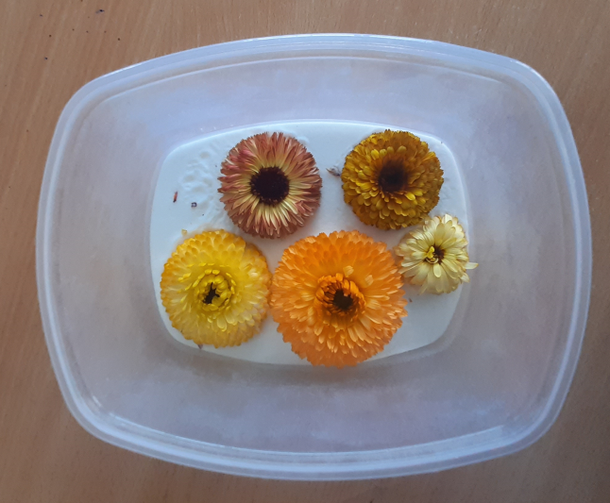
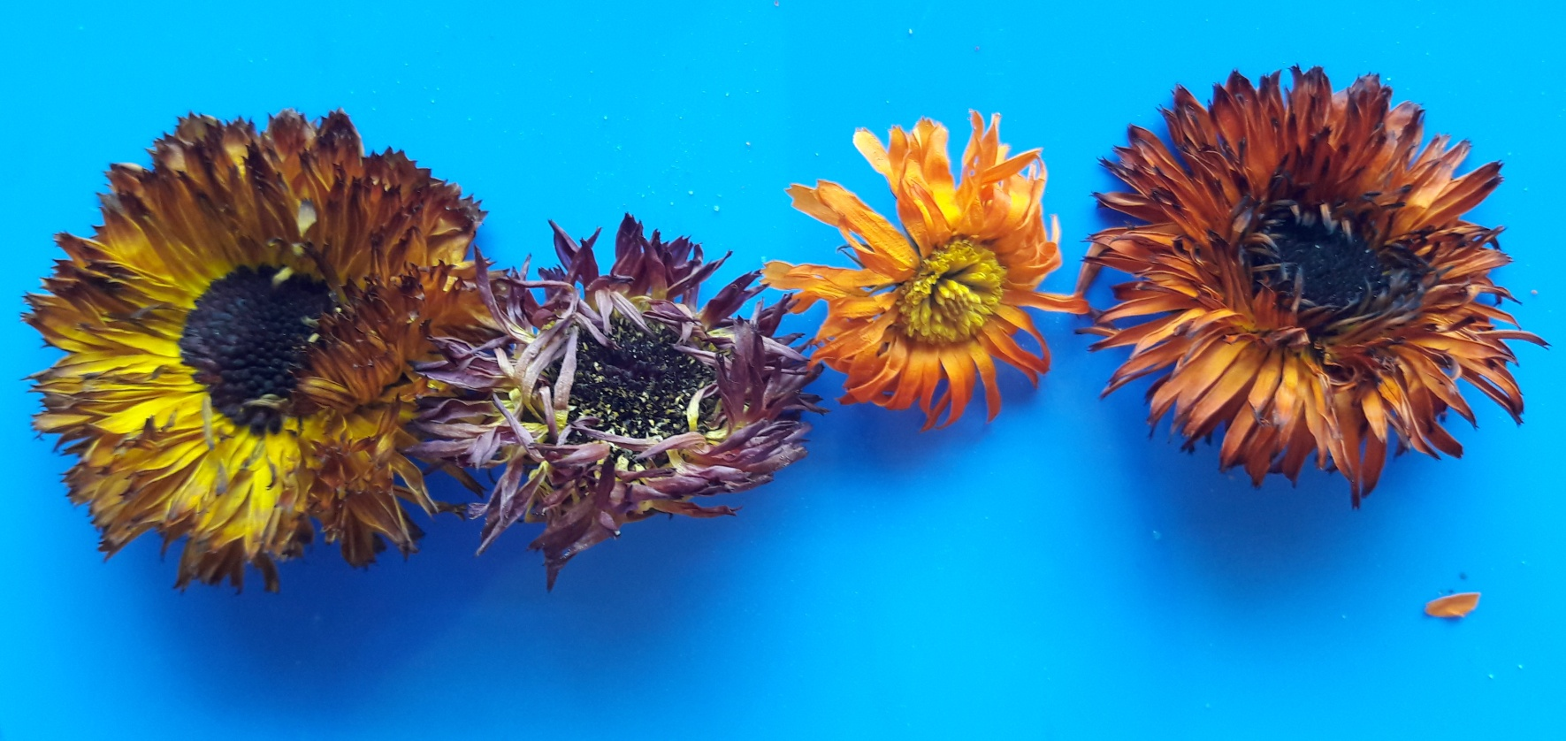

Figure 1 : Drying without desiccants
Figure 2 : Drying with desiccants

