Nanotechnology-based drug repurposing to bypass therapeutic bottlenecks

A. Konika Choudhury 1 ,
B. Siddhartha Sankar Ghosh 2 and C. Arun Chattopadhyay3

1 Centre for Nanotechnology, IIT Guwahati, India
2 Department of Biosciences and Bioengineering, IIT Guwahati, India
³ Department of Chemistry, IIT Guwahati, India

E-mail: konikachoudhury@iitg.ac.in

Abstract
Despite advances in research and medical fields, cancer remains one of the leading causes of death worldwide. The rare mistakes by the fundamental processes can accumulate as mutations. Cancer, therefore is the uncontrolled growth of a cell unleashed by such mutations. Conventional therapies although appreciated, face frequent failures. Moreover, the success rate of clinical trials even after the time and money consuming traditional drug development process, is demotivating. At this juncture, drug repurposing can help as a sustainable therapeutic intervention. It may include abandoned, shelved or in-use drugs. Given that their safety profile is already established, their use is warranted as far as these factors are concerned. Contextually, evidence that antihistamines may inhibit tumours with or without the involvement of histamine receptors, is mounting. Mechanistic studies also suggest the role of lysosomes or immunological pathways in their anti-proliferative activity. However, most drugs, repurposed or otherwise face inherent issues with regulatory barriers. Therefore, to prolong circulation time, stability and specificity, biocompatible nanomaterials can be an attractive mode of delivery systems. Tailored nanostructures can encapsulate one or more pharmaceuticals, thus reducing the risk of monotherapy resistance. This combination regimen can also help control spatiotemporal drug release, yielding a synergistic effect. Recently, we have successfully repurposed an antihistamine, promethazine loaded mannosylated gold nanoclusters against bacteria and biofilms. Additionally, data from our ongoing studies with other potential repurposed drugs show promise against TNBC, cervical cancer and lung adenocarcinoma. Hence, with enough in vitro data, nanotechnology-based repurposing can be moulded into a translationally valid approach.
Research & Industrial Conclave 2023 "An amalgamation of Academia, Industry & Start-up”
"
Student Academic Board (SAB), Indian Institute of Technology Guwahati, Guwahati, Assam, India
Keywords: Theranostic, drug repurposing, antihistamine, histamine

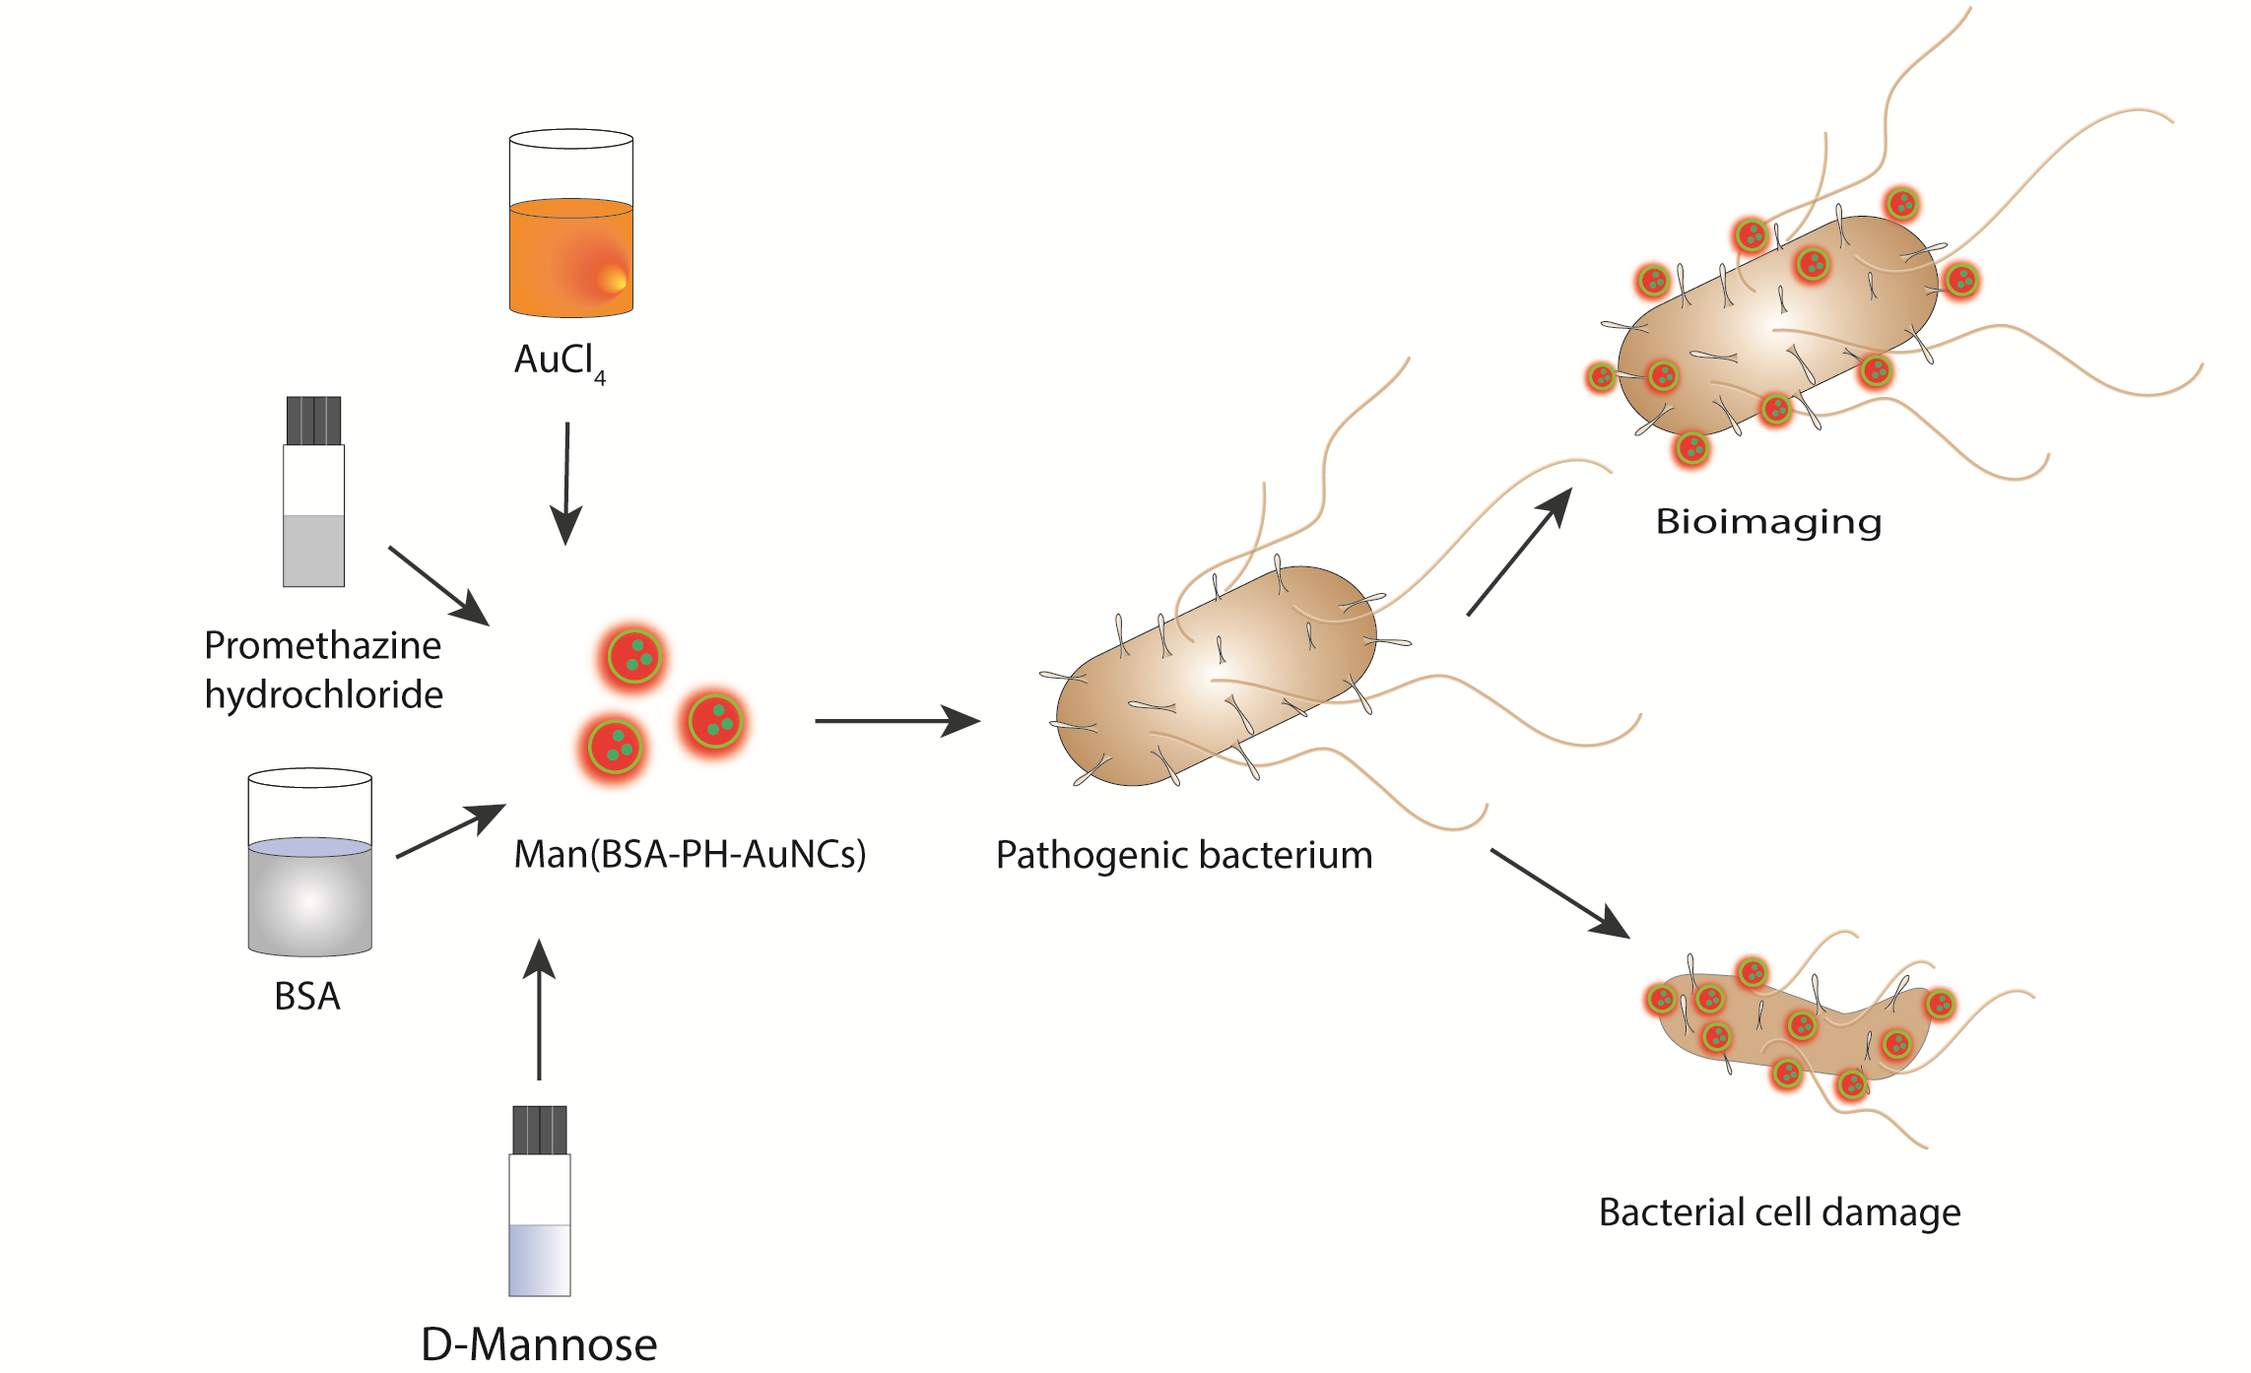
Figure 1: Schematic showing targeting pathogenic bacteria using as-synthesized mannosylated gold nanoclusters incorporated with repurposed antihistamine drug

