Optimization of two-stage integrated process for bio-methanol production with concomitant fixation of methane and carbon dioxide

Krishna Kalyani Sahoo¹ and Debasish Das¹*

1 Department of Biosciences and Bioengineering, IIT Guwahati, India
*Corresponding author, E-mail: krishnakalyani@iitg.ac.in

Abstract

The potential of methanotrophs to utilize major greenhouse gases, such as methane and carbon dioxide, is being exploited to produce methanol. This work comprised of a two-stage integrated process for bio-methanol production using Methylosinus trichosporium, coupled with sequestration of methane and CO₂. The first stage involved generation of methanotrophic biomass via sequestration of methane; which was used as biocatalyst to reduce CO₂ into methanol in the second stage. Maximum biomass titer of 3.39 g L⁻¹ and productivity of 0.60 g L⁻¹ d⁻¹ were obtained in semi-batch stirred tank reactor with methane concentration in inlet gas stream of 2.5% v/v and gas flow rate of 0.5 vvm (Fig.1a, b). The corresponding methane fixation rate was estimated to be 0.32 g L⁻¹ d⁻¹ (Fig.1a, b). Maximum methanol titer of 0.58 g L⁻¹ was obtained in air-tight batch reactor with headspace CO₂ concentration of 50% v/v and liquid to headspace volume ratio 10:90 (Fig.1c, d). The corresponding CO₂ fixation percentage was estimated to be 9.06%. This concept can be implemented in potential industries for sustainable sequestration of CO₂ and methane present in exhaust off-gases and flare gases, and value-addition through methanol production.
Student Academic Board (SAB), Indian Institute of Technology Guwahati, Guwahati, Assam, India

Keywords: Methanotroph, Bio-methanol, Methane, Carbon dioxide.
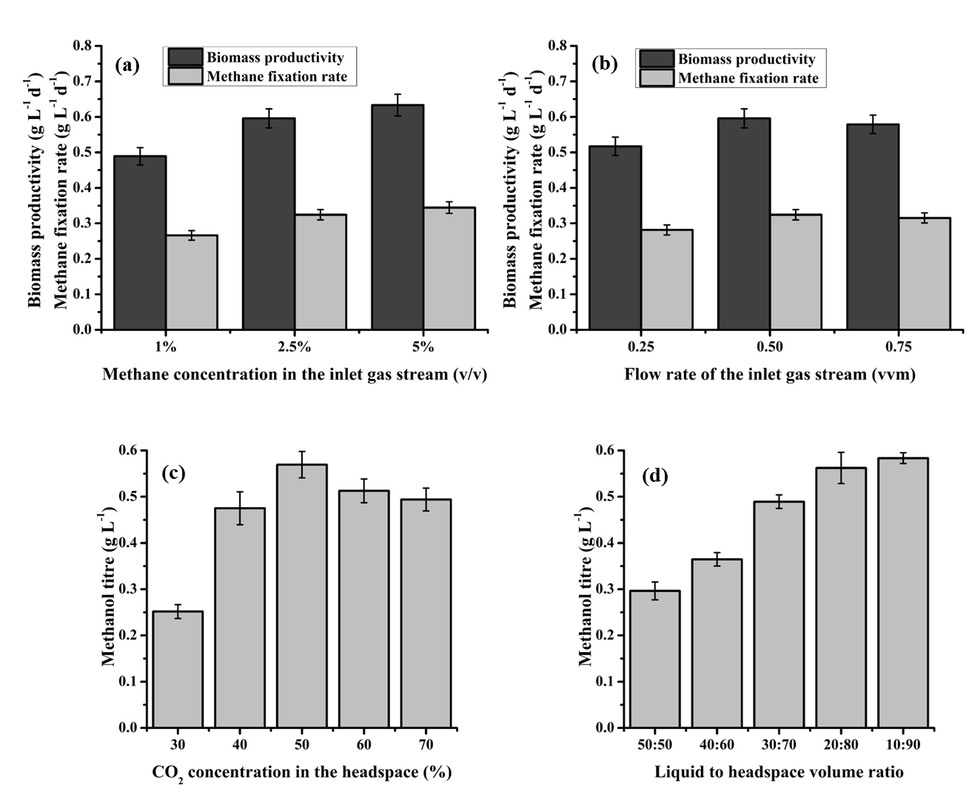
Fig. 1. Biomass productivity and methane fixation rate of the organism grown under different methane concentrations in the inlet gas stream (a) and flow rates of the inlet gas stream (b) in a semi-batch stirred tank reactor. Methanol titer under varying concentrations of CO₂ in the headspace (c) and different liquid to headspace volume ratios (d) in an airtight batch reactor.
Research & Industrial Conclave 2023 "An amalgamation of Academia, Industry & Start-up”
"

Reference:
1. Sahoo, K. K., Datta, S., Goswami, G., & Das, D. (2022). Two-stage integrated process for bio-methanol production coupled with methane and carbon dioxide sequestration: Kinetic modelling and experimental validation. Journal of Environmental Management, 301, 113927.

