Enhancing Barrier Performance of PLA-Based Blends: Insights from Molecular Dynamics Simulations
Kumar Shanu¹ and Amit Kumar^{1,2}
¹Department of Chemical Engineering, Indian Institute of Technology Guwahati
Assam - 781039, India
²Centre for Sustainable Polymers, Indian Institute of Technology Guwahati
Assam - 781039, India
Research & Industrial Conclave 2023 "An amalgamation of Academia, Industry & Start-up”
"
Email – kshanu@iitg.ac.in, amitkumar@iitg.ac.in
Molecular simulations of polymeric materials (including blends and nanocomposites) help in understanding their macromolecular structure, thermodynamics, mechanical and barrier properties. Poly (lactic acid) (PLA) is a promising biodegradable polymer, that is widely being explored as a potential alternative to conventional polymers in various applications such as food packaging. Despite the use of PLA in various applications, its usage is restricted due to poor gas barrier properties, brittleness, low degradation rate, and high operational cost for industries. Poly (butylene adipate-co-terephthalate) (PBAT), which has excellent flexibility and ductility, is a promising candidate for blending with PLA to enhance its properties (1). In the present study, we have generated realistic molecular models of pure PLA, pure PBAT and their blends (see images below) whose densities compare well with the experimental densities reported in literature. Materials Studio 7.0 (2) has been used for the preliminary modelling of the amorphous polymer structures and the LAMMPS software package, with the CVFF force field, has been used for detailed equilibration of the polymer matrix. Molecular dynamics simulations of oxygen, water, and carbon dioxide transport in the modelled polymers and blends show a decrease in the mean-square displacements and self-diffusion coefficients of the gases with increasing PBAT content in the blends. The effects of molecular structure and interactions in PLA-PBAT blends on gas transport have also been investigated.
References:
- Ludwiczak, J., Frąckowiak, S., & Leluk, K. (2021). Study of Thermal, Mechanical and Barrier Properties of Biodegradable PLA/PBAT Films with Highly Oriented MMT. Materials, 14(23), 7189.
- Wei, Q., Sun, D., Zhang, K., Wang, Y., Guo, Y., & Wang, Y. (2021). Research on the miscibility, mechanical properties and printability of polylactic acid/poly (ε-caprolactone) blends: insights from molecular dynamics simulation and experiments. Journal of Materials Science, 56(16), 9754-9768.
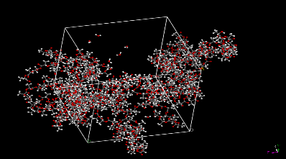  4 PLA (100 units) + 20H₂O | 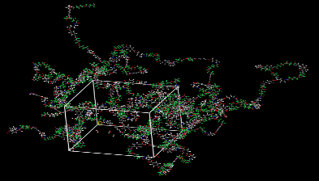  4 PBAT (50 units) + 20H₂O | 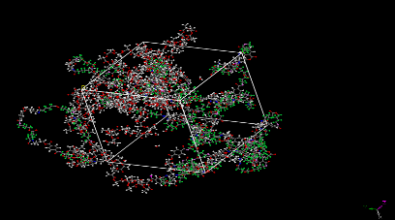  2 PLA + 2 PBAT + 20H₂O

Student Academic Board (SAB), Indian Institute of Technology Guwahati, Guwahati, Assam, India

