New Class of Diketone based Bidentate NS Ligands and Copper(II) Complexes: Synthesis, Characterization and BSA binding interaction

K. Malakar1 and M. Velusamy1

1 Department of Chemistry, North Eastern Hill University, Shillong, Meghalaya, India

E-mail: kakoli0091@gmail.com

Abstract

Six new Copper (II) complexes of N2S2 based Schiff based bi-dentate ligands derived from dithiocarbazates have been explored in this work to discover their versatile chelating and biological properties. The novel copper (II) complexes [Cu(L)₂] where L= Methyl -2-(1-phenylethylidene)hydrazine-1-carbodithioate (L1), N'-(2-Oxo-1,2-diphenyl-ethylidene)-hydrazinecarbodithioic acid methyl ester (L2), N'-(1,2-Bis-(4-methoxy-phenyl)-2-oxo-ethylidene)-hydrazinecarbodithioic acid methyl ester (L3), N'-(2-Oxo-2H-acenaphthylen-1-ylidene)-hydrazinecarbodithioic acid methyl ester (L4), N'-(10-Oxo-10H-phenanthren-9-ylidene)-hydrazinecarbodithioic acid methyl ester (L5), N'-(1-Ethyl-2-oxo-1,2-dihydro-indole-9-ylidene)-hydrazinecarbodithioic acid methyl ester (L6) have been prepared and structures has been confirmed with all available characterization techniques like NMR, IR, UV and CV. The SXRD of 1 and 3 show distorted square planar geometry. The existence of the static quenching mechanism is shown by the Stern–Volmer analysis on the data pertaining to Tryptophan quenching. The Stern-Volmer and Scatchard plots were adopted so that they could be used in the calculation of the binding constants. The binding constants are found in all of the complexes to be on the order of 10⁴. Therefore, these findings have the potential to contribute to the development of medications based on Cu(II).
Student Academic Board (SAB), Indian Institute of Technology Guwahati, Guwahati, Assam, India

Keywords: Copper complexes, Distorted square planar geometry, Stern-Volmer plot, binding constant

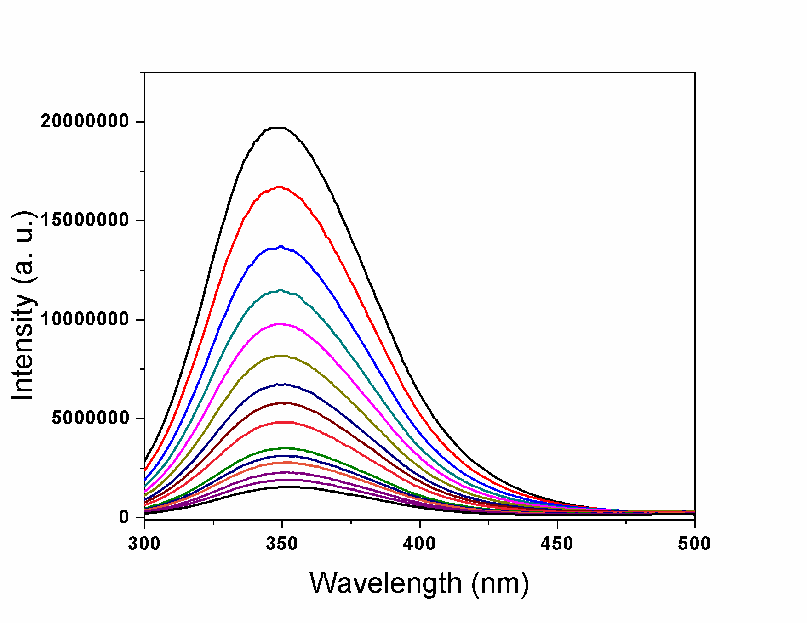
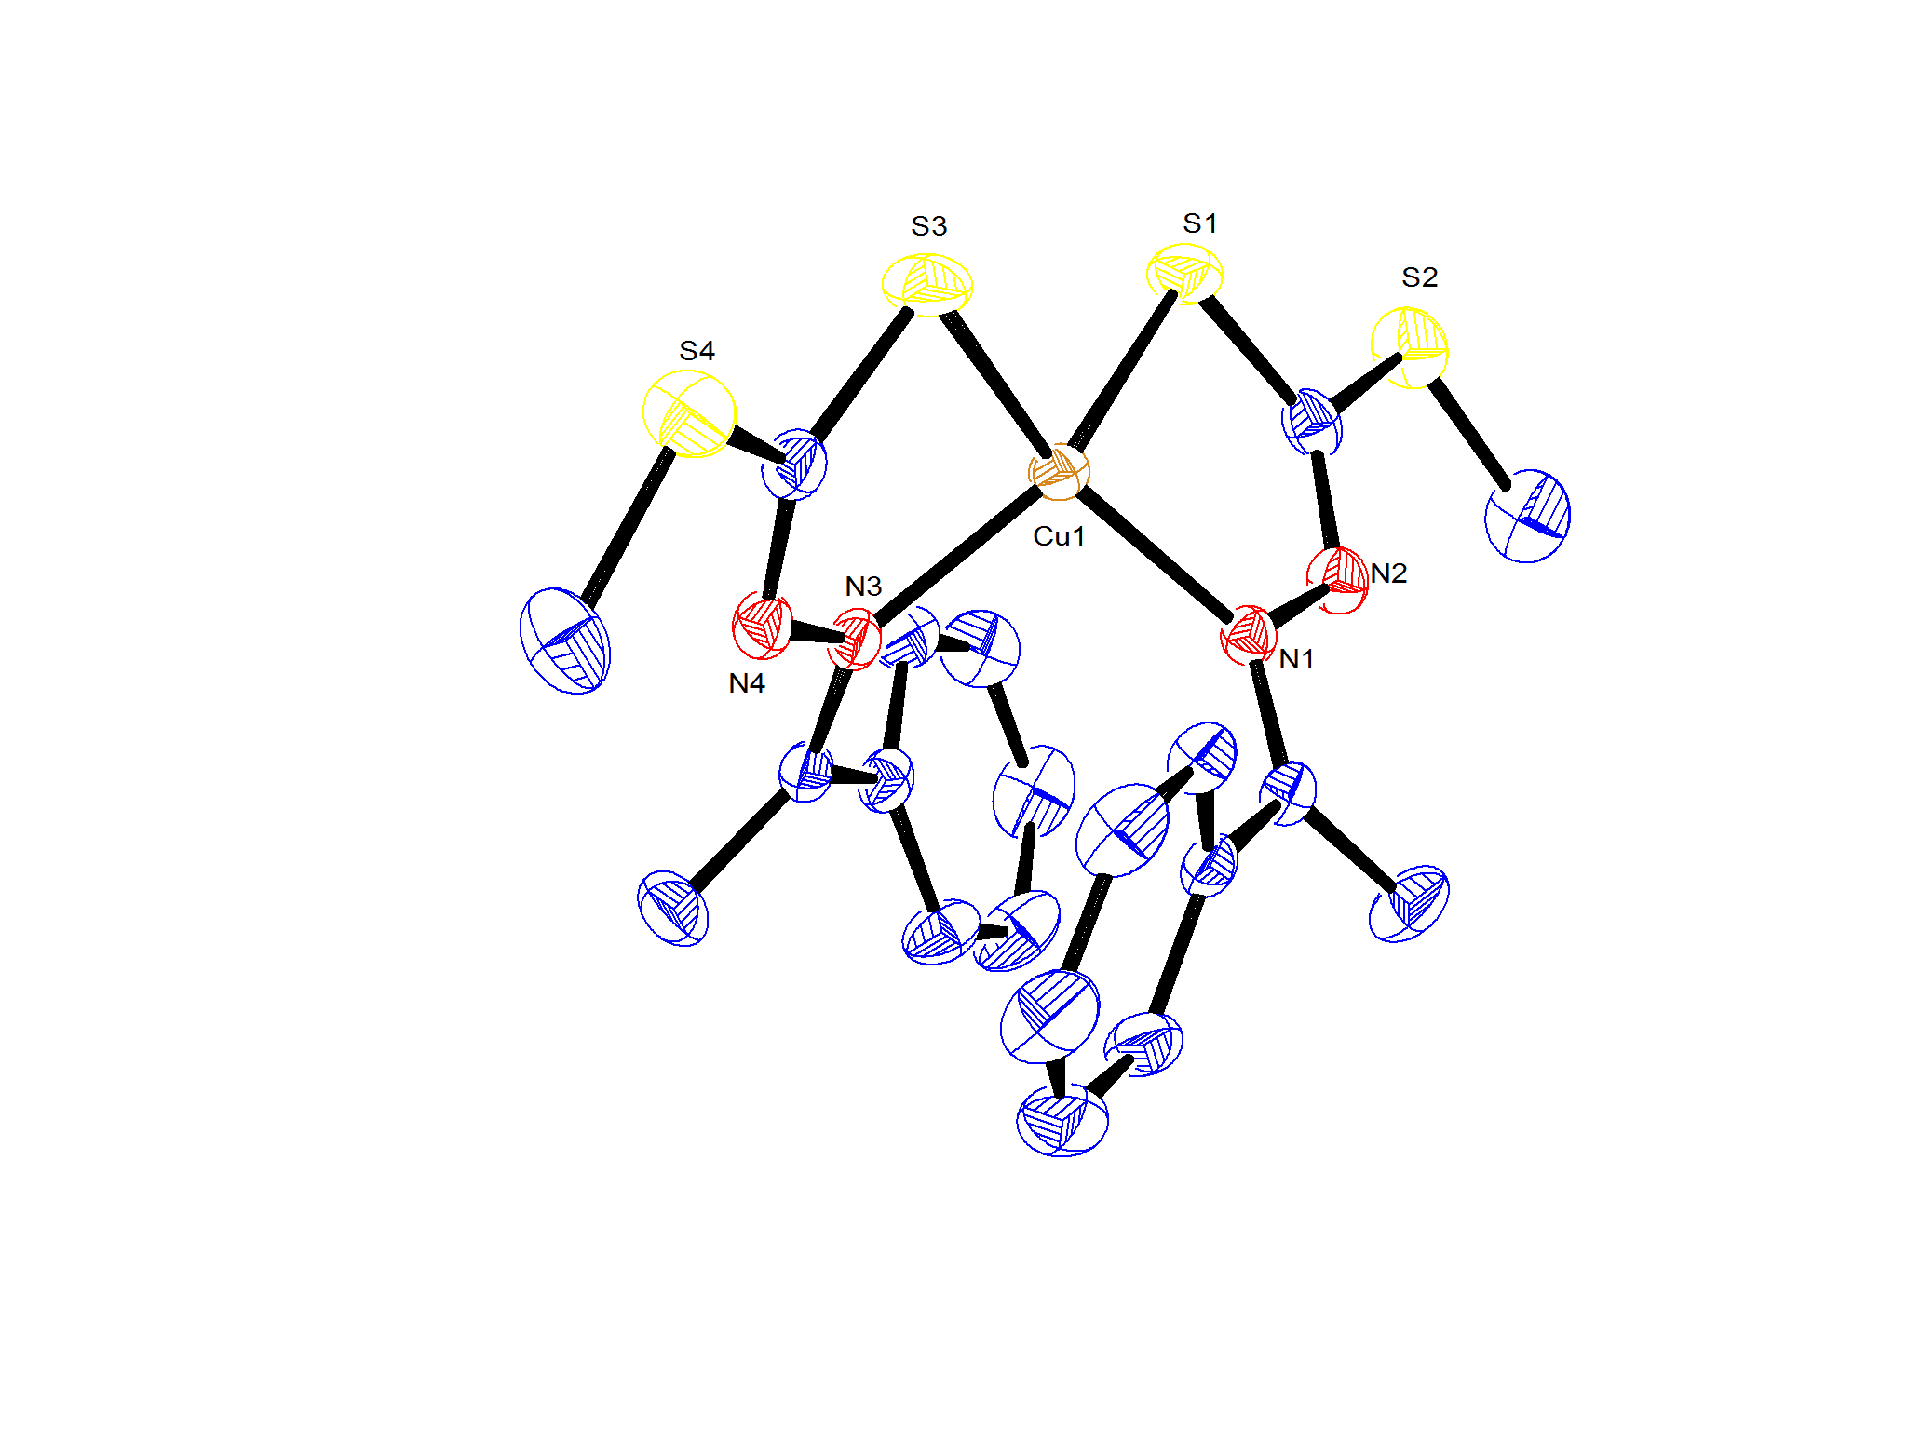

Figure 1. SXRD of 1 (left) and Fluorescence quenching spectra of BSA
with different concentration of 1 (right).

