Bed-to-Vehicle Caremover (BVC)

P. Kishore Kumar1*, Zainab Sariya², S Kanagaraj³

1 Centre for Intelligent Cyber-Physical Systems, IIT Guwahati, India
2 School of Health Science an Technology, IIT Guwahati, India
3 Department of Mechanical Engineering, IIT Guwahati, India
E-mail: kishorekumarp@iitg.ac.in

Abstract

Healthcare workers are highly susceptible to work-related musculoskeletal disorders (WMSDs), primarily affecting the low back and shoulders due to patient handling activities. Passive back-support exoskeletons have been introduced as a potential intervention to reduce physical risks associated with WMSDs. However, their benefits and limitations are dependent on task and exoskeleton design, and inadequate applications can compromise the health and safety of caregivers and patients. During simulated patient transfer tasks between a wheelchair and a bed, passive back-support exoskeletons were found to have significantly different effects on trunk postures, shoulder postures, hand pull forces, and muscle activities in the erector spinae and middle deltoid muscles. The effects varied depending on the patient transfer method used (squat pivot, stand pivot, and scoot) as shown in Figure 1. Usability measures suggest that a simple, easy-to-use, and easy-to-learn design may promote the adoption of back-support exoskeletons in healthcare settings.
Student Academic Board (SAB), Indian Institute of Technology Guwahati, Guwahati, Assam, India
Research & Industrial Conclave 2023 "An amalgamation of Academia, Industry & Start-up”
"
While passive exoskeletons have shown promising benefits in reducing trunk muscle activities and energy expenditure during repetitive lifting and manual assembly tasks, it is therefore important to improve the efficacy of the exoskeletons in patient handling to ensure the health and safety of both caregivers and patients. Bed-to-Vehicle Caremover (BVC) is a passive exoskeleton to perform patient transfer related tasks efficiently with reduced risk of injury and strain to the caregiver.

Keywords: work-related musculoskeletal disorders (WMSDs), passive exoskeletons,

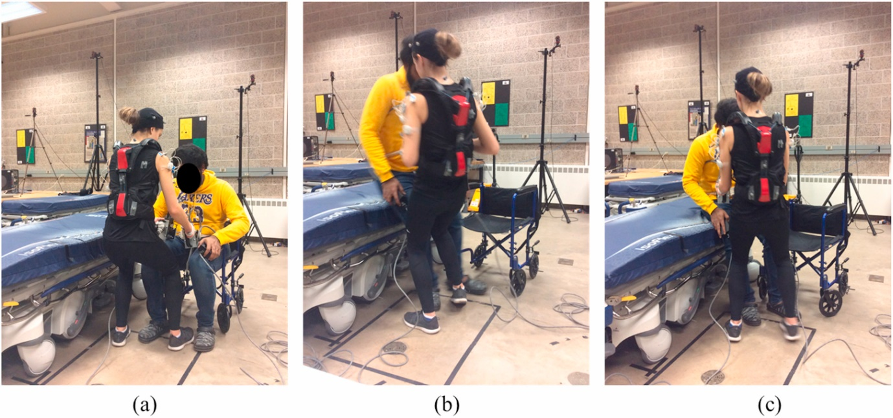
Figure 1: Showing the patient transfer from wheelchair to bed during (a) Squat pivot, (b) Stand pivot and (c) Scoot manoeuvres by a caregiver on a patient [1]
References:
[1] Jaejin Hwang et al, Effects of passive back-support exoskeletons on physical demands and usability during patient transfer tasks; Applied Ergonomics, Volume 93, 2021

