Biomechanical Analysis of lower extremity peripheral neuropathy: a case report

L. Boruah2 , S. K. Dwivedy1,2 and S. Kanagaraj1,2

1 Department of Mechanical Engineering, IIT Guwahati, India
2 Centre for Intelligent Cyber Physical System, IIT Guwahati, India

E-mail: lipika.boruah@iitg.ac.in

Abstract

Peripheral neuropathy (PN) is very prevalent in India, ranging from 5 to 2400 per 10,000 people [1]. This is a group of conditions of nervous system occurs outside the pia matter of the brain. People with lower extremity PN are more likely to experience severe foot issues [2]. It can lead patients to experience changes in the distribution of plantar pressure, kinetic and spatio-temporal variables during walking. This study presents a case of 51 years man showed typical symptoms of lower extremity PN, which is confirmed through nerve conduction velocity test by a neurologist. He had the history of tuberculosis 5 years back and recently experienced numbness and cold intolerance in his feet. In this study, plantar pressure distribution, vertical ground reaction force (GRF), spatio-temporal parameters, time up and go (TUG) test and pelvic motions during gait are evaluated and are compared with a healthy subject of same age group, body mass index, no history of PN. In the plantar pressure measurement PN subjects showed less pressure on the midfoot, asymmetrical gait lines (black doted lines) as compared to the healthy subject as shown in the Fig. 1. Significant difference is found in cadence, TUG and maximum forces of vertical components of GRF in the PN subject as compared to the healthy. Step length asymmetry is also a factor seen in the PN subject which is affecting the overall gait. This report is an effort to assess the crucial biomechanical factors in lower extremity PN, which will be useful for the people ongoing rehabilitation.

Student Academic Board (SAB), Indian Institute of Technology Guwahati, Guwahati, Assam, India

Keywords: PERIPHERAL NEUROPATHY, PLANTAR PRESSURE, GAIT, BIOMECHANICAL ANALYSIS

(a)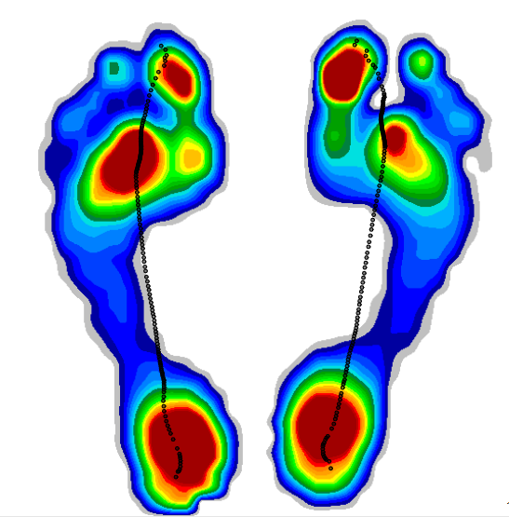 (b)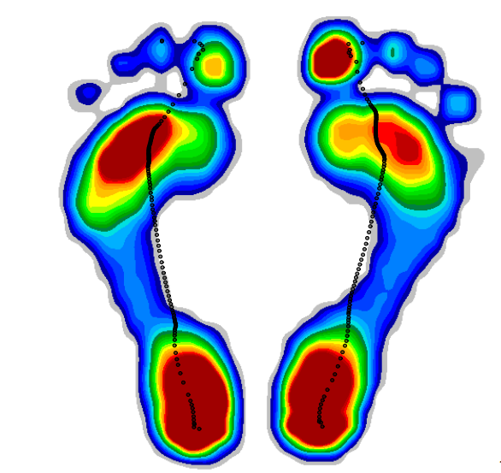
Fig. 1. Plantar pressure distribution of (a) the PN subject and (b) the healthy subject.

References:
[1] Trivedi, S., Pandit, A., Ganguly, G., & Das, S. K. (2017). Epidemiology of peripheral neuropathy: An Indian perspective. Annals of Indian Academy of Neurology, 20(3), 173.
[2] Elabd, O. M., El Nahass, B. G., & Ibrahim, M. M. (2023). Pathological gait in partial foot amputation versus peripheral neuropathy. Gait & Posture, 100, 41-48.

