Optofluidic Planar Microreactor for Oxygen Evolution from Photocatalytic Water Splitting

Laxmi Prasad Rao Pala 1 and *Nageswara Rao Peela ^{1,2}

1 Department of Chemical Engineering, Indian Institute of Technology Guwahati, Assam, 781039, India
2 Center for Nanotechnology, Indian Institute of Technology Guwahati, Assam, 781039, India.

*E-mail: peelanr@iitg.ac.in

Abstract

. An innovative optofluidic planar microreactor has been developed by coating a glass reactor plate with a photocatalyst film (IrO₂/TiO₂), while utilizing plain glass as a cover plate. The plain glass was etched to create a spacer between the reaction and cover plates, resulting in a planar microreaction compartment. The microreactor's efficacy was tested for water splitting activity under visible light (using a 400 W metal halide lamp) with sodium iodate as an electron acceptor. In-depth analysis was conducted on the rate of oxygen production, taking into account the catalyst coating thickness and the reactant flow rate. Remarkably, an impressive oxygen evolution rate of 3.99 mmol h⁻¹ g⁻¹ (1.84 µmol h⁻¹ cm⁻²) was observed at an optimal flow rate of 0.3 mL min⁻¹, with a 3078 ± 362 nm thick IrO₂/TiO₂ film under visible light. Furthermore, the IrO₂/TiO₂ film's stability was evaluated over four cycles, indicating its superior activity and firm adherence to the glass substrate
Student Academic Board (SAB), Indian Institute of Technology Guwahati, Guwahati, Assam, India

Keywords: Optofluidic planar microreactor, Iridium oxide, Titanium dioxide thin film, Photocatalytic water splitting, Oxygen evolution, Sol-gel spin coating

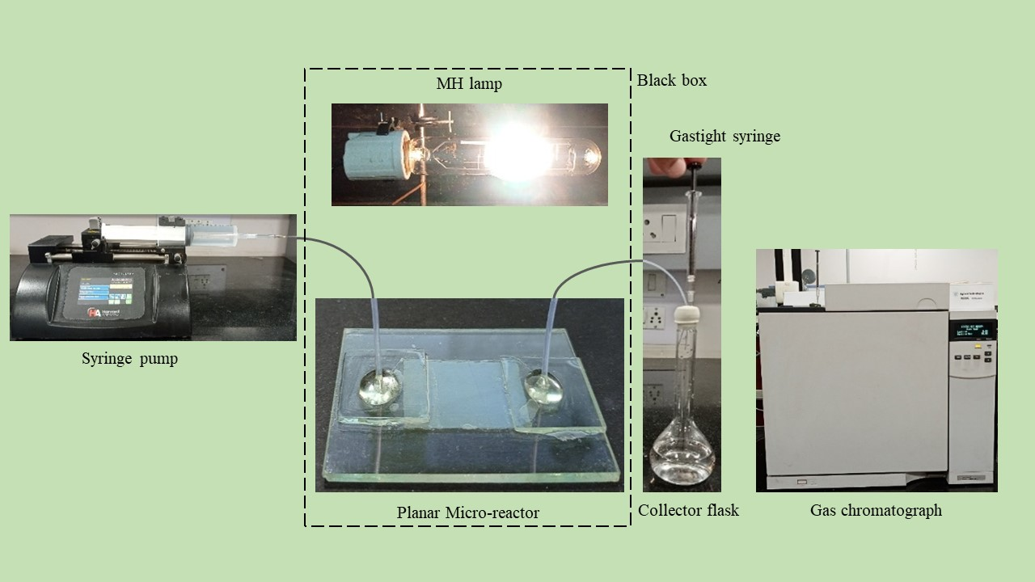
Figure 1: Experimental test rig for the water splitting reaction in the optofluidic planar microreactor
a)
b)
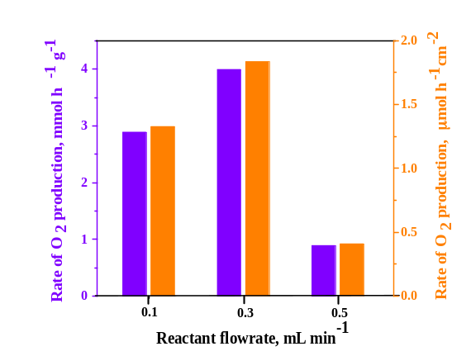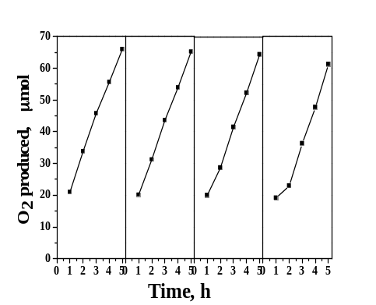
Figure 2: (a) Rate of oxygen production with the variation of reactant flowrate; and (b) Recycle stability of IrO₂/TiO₂-24x film

