Development of Aggregation-Induced Emission (AIE) based Probes

Laxmi Raman Adil¹ and Parameswar Krishnan Iyer^{1,2}

¹ Department of Chemistry, Indian Institute of Technology Guwahati, Assam, India.
² Center for Nanotechnology, Indian Institute of Technology Guwahati, Assam, India.
E-mail: laxmi@iitg.ac.in, ramanadil@gmail.com

Abstract

Fluorescent materials have attracted substantial attention since the first report of the ﬂuorescence by Nicolás Monardes (1565). Fluorescent materials have wide applications such as chemical/biological sensing, bioimaging, organic light-emitting diodes (OLED) etc.¹ Mostly, all the classical fluorescent material have intense emission in less concentration, but low or no emission in higher concentration due to robust intermolecular and intermolecular interactions, this phenomenon is called aggregation-caused quenching (ACQ). Some novel organic compounds, attached with rotable and nonplanar groups, showed enhance emission due to the formation of aggregates; this phenomenon is termed as aggregation-induced emission (AIE).² Presently, designing and synthesis of new AIE fluorescent materials and employing them in various applications are attractive research themes.
Student Academic Board (SAB), Indian Institute of Technology Guwahati, Guwahati, Assam, India
Research & Industrial Conclave 2023 "An amalgamation of Academia, Industry & Start-up”
"
In my Ph.D. thesis, we have transformed ACQ active material into AIE active materials using positional isomerization and Carbon-Carbon bond exclusion and by incorporation of different rotatable groups. We have used newly synthesized materials (small molecules and polymer) for secret ink, chemical sensing, bioimaging and antimicrobial etc. applications (Figure 1).^{3,4}

Keywords: Aggregation-caused quenching, aggregation-induced emission, stimuli-responsive emission, sensing, pathogen imaging

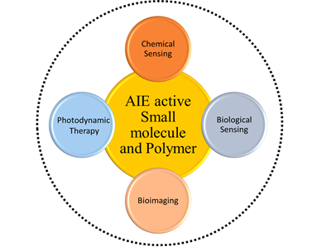

Figure 1 : AIE active materials and their various applications.
References

(1) Valeur, B.; Berberan-Santos, M. N. A Brief History of Fluorescence and Phosphorescence before the Emergence of Quantum Theory. J. Chem. Educ. 2011, 88 (6), 731-738.
(2) Luo, J.; Xie, Z.; Lam, J. W. Y.; Cheng, L.; Chen, H.; Qiu, C.; Kwok, H. S.; Zhan, X.; Liu, Y.; Zhu, D.; et al. Aggregation-induced emission of 1-methyl-1,2,3,4,5-pentaphenylsilole. Chem. Commun. 2001, (18), 1740-1741.
(3) Adil, L. R.; Iyer, P. K. Effects of incorporating regioisomers and flexible rotors to direct aggregation induced emission to achieve stimuli-responsive luminogens, security inks and chemical warfare agent sensors. Chem. Commun. 2020, 56 (55), 7633-7636.
(4) Adil, L. R.; Gopikrishna, P.; Iyer, P. K. Receptor-Free Detection of Picric Acid: A New Structural Approach for Designing Aggregation-Induced Emission Probes. ACS Appl. Mater. Interfaces 2018, 10 (32), 27260-27268.

