One-step synthesis of Mn-carbon dot nanoprobe for signal-on detection of arsenic and reversible temperature sensing

Lingaraj Behera1 , Debasish Pati2 and Sasmita Mohapatra*1

1 Department of Chemistry, National Institute of Technology, Rourkela 769008, India
2 Department of Life Science, National Institute of Technology, Rourkela 769008, India
*E-mail: sasmitam@nitrkl.ac.in (S. Mohapatra).

Abstract

Manganese dioxide-carbon dot (MnO₂CD) composite nanoparticles of size 45 nm have been synthesized in a single step from hydrothermal decomposition of KMnO4, polydopamine, and citric acid for multipurpose applications. The mild emission of MnO₂CD particles at 425 nm under excitation wavelength of 340 nm substantially increases in the presence of arsenite, because of redox reaction between MnO2 and arsenite to give soluble Mn^{2+.} This single probe sensor shows selective and sensitive response to arsenite in the linear range of 0–100 nM with a detection limit of 5.75 nM. This MnO₂CD probe also shows satisfactory performance for detection of organoarsenic and organothioarsenic compounds such as dimethylarsenate (DMA), dimethyldithioarsinate (DMDTA), and dimethylmonothioarsinate (DMMTA). Interestingly, this sensor works well for monitoring arsenic in a plant root vascular system through fluorescence and confocal imaging which has been reported for the first time. Further, the fluorescence intensity of MnO₂CD changes reversibly with temperature in the range of 25–75◦C. This nanobionic sensor not only opens up a universal opportunity to detect As(III) in environment as well in agriculture but also sensing temperature in a microenvironment.
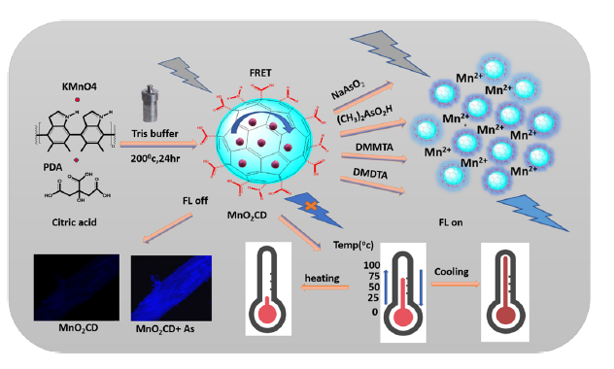
Figure: Schematic representation of the work

Keywords: MnO₂CD, Fluorescence, Arsenic, Temperature sensor, Nanobionic sensor

Reference
1.Behera, L., Pati, D., Sahu, B.B. and Mohapatra, S., 2022. One-step synthesis of Mn-carbon dot nanoprobe for signal-on detection of arsenic and reversible temperature sensing. Colloids and Surfaces A: Physicochemical and Engineering Aspects, 653, p.130002.

