Isolation and structure characterization of recombinant Rhamnogalacturonan exolyase from Bacteroides thetaiotaomicron expressed as inclusion bodies in E. coli.

Madhulika Shrivastava*, Jebin Ahmed and Arun Goyal
Carbohydrate Enzyme Biotechnology Laboratory, Department of Biosciences and Bioengineering, Indian Institute of Technology Guwahati, Guwahati-781039, Assam, India.
*Corresponding Author: m.shrivastava@iitg.ac.in
Abstract
Pectin plays an important role in growth and development of plants. It has functional roles in higher plants such as in cell wall porosity, signalling and leaf abscission. It is abundant in growing and dividing cells and in the middle lamella and cell corners. Structurally, pectin is a heteropolysaccharide that contains galacturonic acid, rhamnose, arabinose, xylose and galactose. Based on the nature of backbone, linkage and side-chains, pectin is further classified as homogalacturonan, rhamnogalacturonan-I and rhamnogalacturonan-II Homogalacturonans and substituted galacturonans are the principal components of pectin. Rhamnogalacturonan I and Rhamnogalacturonan II are the predominant substituted galacturonans1. Exo-rhamnogalacturonan lyases hydrolyze the β-glycosidic linkage between Rhamnose (Rha) and Galacturonic acid (GalA) of Rhamnogalacturonan-I (RG-I) backbone which forms 4-deoxy-4,5-unsaturated GalA (ΔGalA) at the non-reducing end by β-elimination reaction. The recombinant pET28a (+) plasmid containing gene encoding exo-rhamnogalacturonan lyase from Bacteroides thetaiotaomicron (BtRGL26) was transformed in E. Coli BL21 (DE3) cells for protein expression. However, the recombinant BtRGL26 was expressed as insoluble inclusion bodies. In the current study, the insoluble inclusion bodies containing inactive BtRGL26 were solubilized by using denaturing solution (4M Urea and 1 mM β-Mercaptoethanol) and refolded using rapid dilution and dialysis. The (10%, w/v) SDS-PAGE displayed homogenous and soluble protein band of BtRGL26 of apparent molecular mass 123 kDa which was in agreement to the theoretical molecular mass of BtRGL26 (Fig. 1). The refolded BtRGL26 was found to be enzymatically active on Rhamnogalacturonan-I (RG-I) from potato pectic fibre and polygalacturonic acid citrus. The three-dimensional structure of BtRGL26 was modelled using Alphafold2 server. The modelled structure was energy minimized using YASARA energy minimization server and further validated by ERRAT (95.11%) and VERIFY-3D (81.67%). Secondary structure of BtRGL26 was deduced by far-UV Circular dichroism spectrum using Circular Dichroism spectropolarimeter (Fig. 2). Molecular docking analysis of BtRGL26 with its ligands revealed that Tyr636, Arg811 and Arg825 are involved in catalysis.
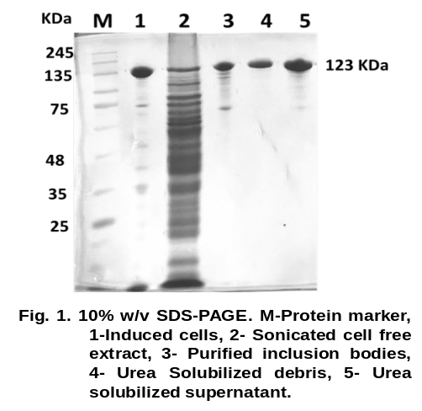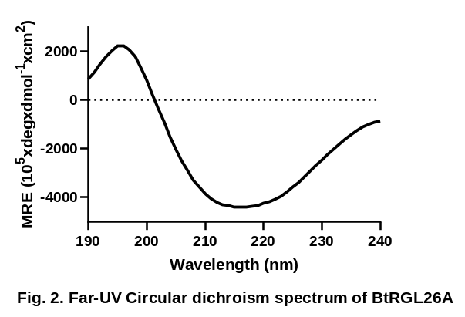

Keywords: Pectin, Rhamnogalacturonan I, Bacteroides thetaiotaomicron, Exo-rhamnogalacturonan lyases, Inclusion bodies

