An approach to green and cost effective bioethanol production from delignified rice straw using crude recombinant enzyme cocktail

Premeshworii D Maibam 1 and Arun Goyal1,2

1 School of Energy Sciences and Engineering, Indian Institute of Technology Guwahati, India.
2Department of Biosciences and Bioengineering, Indian Institute of Technology Guwahati, India.

E-mail: p.maibam@iitg.ac.in

Abstract

Second generation (2G) ethanol production is facing major research challenges due to lack of suitable fermentation techniques, technology for extraction of maximum fermentable sugars and single microorganism efficient to convert both hexose and pentose sugars into bioethanol. The present study focused on simultaneous saccharification and fermentation of delignified rice straw using Saccharomyces cerevisiae NCIM 3215 and tailor made crude recombinant enzyme cocktail. Choline chloride: acetic acid based deep eutectic solvent pretreated rice straw was used as a substrate for bioethanol production. Crude recombinant enzyme cocktail comprising bifunctional cellulolytic chimeric enzyme (CtGH1-L1-CtGH5- F194A) with cellobiohydrolase (CtCBH5A), endo-1,4-β-xylanase (CtGH11A) and β-Xylosidase (BoGH43) in the ratio 35.1:41.8:10.0:13.1 accounting for 5.6 FPU/mL cellulase and 104 U/mL xylanas was used at an enzyme doses of 500 U/g_{pretreated biomass} for the fermentation process. Fermentation was performed with controlled pH and uncontrolled pH to evaluated the effect of pH in the overall ethanol yield. At uncontrolled pH condition, a fermentation with 10%, v/v inoculum of pre-culture S. cerevisiae at 35°C, 150 rpm for 50 ml with 3 %, w/v biomass loading resulted in ethanol titre of 4.32g/L at 12 h of fermentation with a yield of 0.19 g/g_{pretreated biomass} and a productivity of 0.35 g/L/h. Under controlled pH of fermentation a higher productivity, 0.47 g/L/h and yield of ethanol titre, 0.23 g/g_{pretreated biomass} was achieved at same operating parameters.

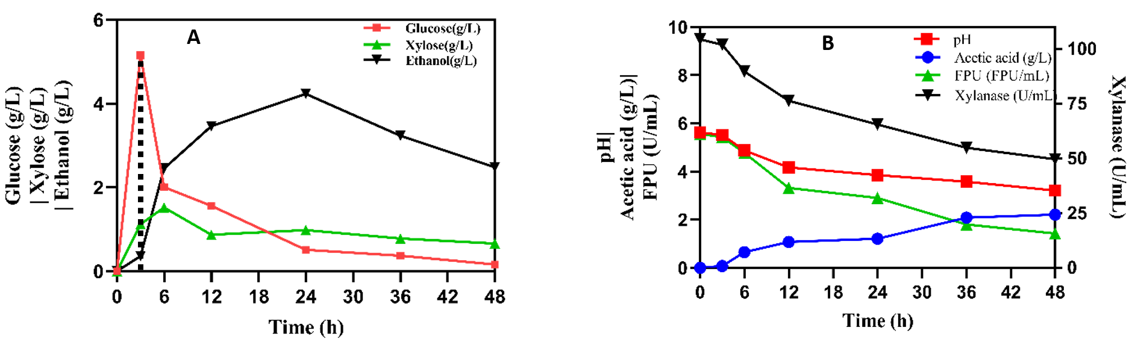
Fig. 1. SSF profile of delignified rice straw using S. cerevisiae and tailor-made crude recombinant enzyme cocktail. (A) substrate and product profile and (B) pH, inhibitor and enzyme activity.

Keywords: Bioethanol, crude enzyme cocktail, saccharification, fermentation, delignification

