Catalyst synthesis and characterization for steam reforming of methanol
Masresha Adasho¹, P. Muthukumar^{1*}, Nageswara Rao Peela²

1 Department of Chemical Engineering, Indian Institute of Technology Guwahati, Assam, 781039, India
2 Department of Chemical Engineering and Centre for Nanotechnology, Indian Institute of Technology Guwahati, Assam, 781039, India.

E-mail: peelanr@iitg.ac.in

Abstract

This research work focuses on the synthesis and characterization of Cu/ZnO/Al₂O₃ catalysts for steam reforming of methanol (SRM). The catalysts were synthesized using coprecipitation (Fig. 1) and hydrothermal methods, which were then characterized by various techniques. The characterization results revealed that the coprecipitated catalyst has improved catalytic properties for SRM, including lower particle size, more uniform particle distribution, and a larger surface area. The SRM experimental results showed that the coprecipitation-synthesized catalyst exhibited a higher methanol conversion and hydrogen yield than the hydrothermally-synthesized catalyst, indicating that the coprecipitation method is a promising approach for synthesis of highly active and selective catalysts for SRM.
Keywords: SRM, CO-precipitation, hydrothermal, characterization

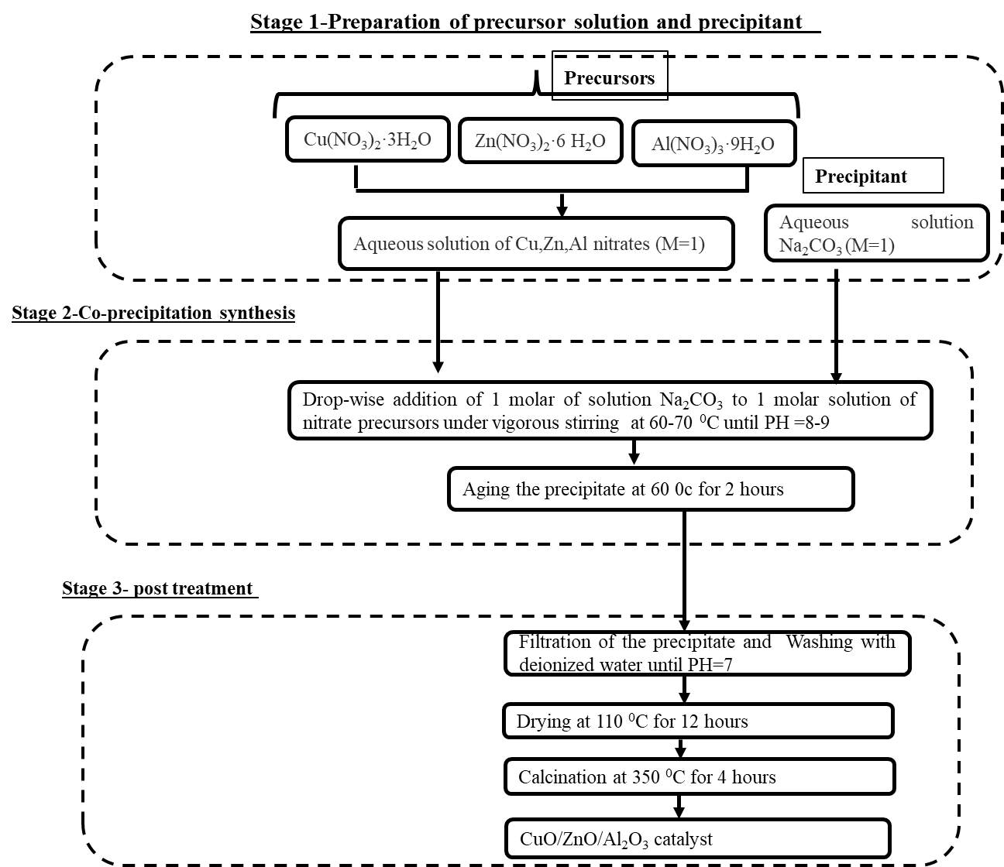
Figure 1: CuO/ZnO/Al₂O₃ catalyst synthesis by co-precipitation method

