Spectroscopic Signatures of Photoinduced Charge Transfer and Interlayer Coupling in Two-dimensional Bi₂O₂Se/MoS₂ Heterostructures

Md Tarik Hossain¹, Larionette P.L. Mawlong², Tadasha Jena², Abhilasha Bora¹ and P.K. Giri^{1,2}

1 Department of Physics, IIT Guwahati, India
2 Centre for Nanotechnology, IIT Guwahati, India

E-mail: tarik@iitg.ac.in

Abstract

Interlayer charge transfer (CT) based on band alignment is crucial in various optoelectronic applications such as photoluminescence modulation, superior photodetection, etc. Stacking layered nanomaterials with different functionalities is a competent approach to witness CT. In this regard, the stacking of van der Waals (vdW) materials has been extensively studied to date. However, the stacking of vdW material with Non-vdW (nvdW) material is rarely reported for CT studies. Herein, we demonstrate the stacking of nvdW Bi₂O₂Se layer on vdW MoS₂ layer to investigate interlayer CT dynamics utilizing spectroscopic and microscopic tools. Raman and micro-Photoluminescence spectroscopy results indicate that a substantial photoinduced CT occurs across the hetero-interface (see Fig. 1). Kelvin Probe Force Microscopy and I-V characteristics confirm type-II heterojunction formation due to suitable band bending that renders strong interlayer CT across the junction. Low-temperature photoluminescence studies reveal that the robust interlayer coupling between the hetero-layers enhances the CT process. Our results show that the trion-phonon coupling is stronger than exciton-phonon coupling in the heterogeneous system. These results shed light on the fundamental properties of vdW-nvdW two-dimensional heterostructures and implementing them in next-generation optoelectronic applications.

Keywords: CHARGE TRANSFER, TWO DIMENSIONAL HETEROSTRUCTURE, ELECTRON-PHONON COUPLING

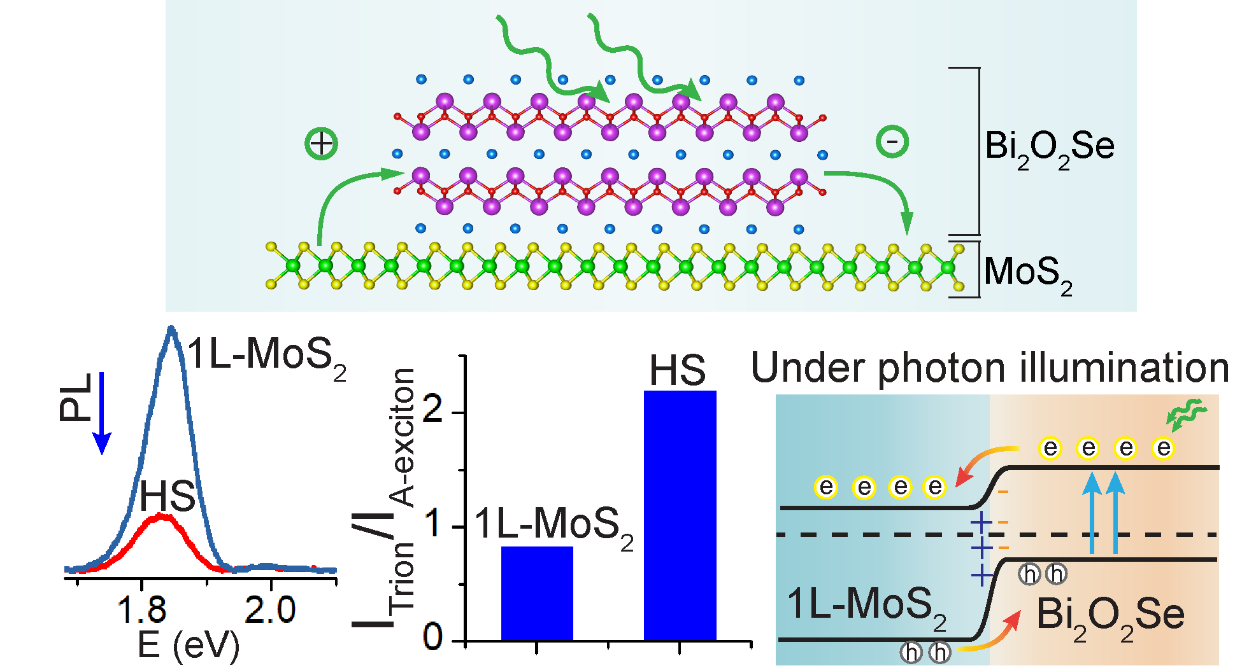

Figure 1: Charge transfer across two-dimensional ultrathin Bi₂O₂Se and monolayer MoS₂ heterojunction.

