Modelling interfacial mass transfer using Volume of Fluid method: Validation Studies

Mohammad Anzar Hussain1, Raghvendra Gupta1,2

1Department of Chemical Engineering, IIT Guwahati, India
²Centre for Nanotechnology, IIT Guwahati, India

E-mail: m.anzar@iitg.ac.in

Abstract

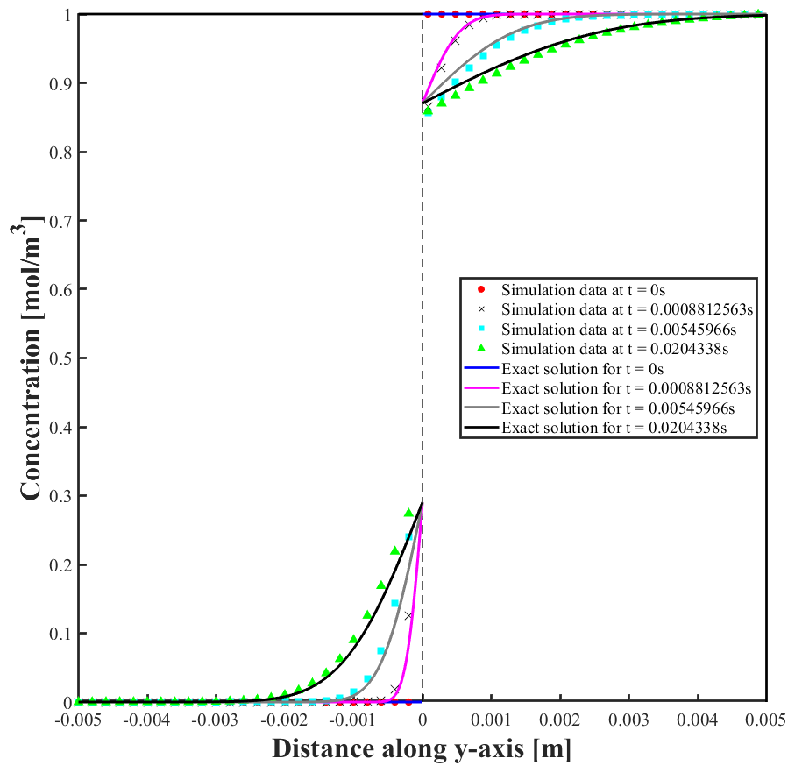
Mass transfer across interfaces are encountered in many multiphase systems. A few specific examples of interfacial mass transfer applications include gas-liquid reactions and liquid-liquid reactions carried out in microreactors such as, hydrogenation and transesterification reactions respectively. Hence, a comprehensive understanding of the combined mass and momentum transfer is a must for an efficient design of multiphase flow systems, such as two-phase Taylor flow in microchannels. The hydrodynamics of two-phase Taylor flow in microchannels comes under segregated multiphase flow that are best modelled using interface tracking methods, Volume of Fluid (VOF) method being one of them. In VOF method, the volume fraction serves as a marker function that remains constant in each phase. The interface is tracked via advection equation and an interface reconstruction scheme helps keeping interface sharp, that are written for the volume fraction value that changes abruptly from one cell to another. Modelling mass transfer across an interface requires accounting of the concentration jump in addition to the continuity of the fluxes. One way to achieve this is by modifying the scalar transport equation with an additional term to account for the concentration jump near the interface, that converts the solubility law into a solubility flux in the VOF framework. Before the proposed numerical method is adopted to simulate mass transfer across Taylor bubble interface, a proof of concept and preliminary validation is a must to illustrate the ability of the modified scalar transport equation on the concentration resolution. The objective of the current work is to validate the numerical method developed to model interfacial mass transfer based on the volume of fluid (VOF) method. The simulation of a single component mass transfer across the interface of a two-phase flow system by the numerical model is carried out using OpenFOAM, an open source computational fluid dynamic package. Validation of the individual cases: steady state conduction at equilibrium, unsteady conduction for short contact times, unsteady convection and transient conduction with lumped system analysis, is carried out by comparing with analytical solutions obtained for each case. Figure 1 shows one such simulation scenario carried out for unsteady conduction of single component across two-phase interface for short contact times. The study confirms the proposed numerical method to be capable of simulating interfacial mass transfer in two-phase flow systems.
Student Academic Board (SAB), Indian Institute of Technology Guwahati, Guwahati, Assam, India
Research & Industrial Conclave 2023 "An amalgamation of Academia, Industry & Start-up”
"
Figure 1. Concentration profile of a single component getting diffused across the interface of a stagnant two phase system. The interface lies at 0 on the x-axis. The analytical solution is for unsteady conduction obtained for short contact times.

Keywords: Computational Fluid Dynamics, Volume of Fluid, Mass transfer, OpenFOAM.

