Modelling of pulsed sieve plate column with 17% plate opening

Premsagar Pillajetti¹, Raghvendra Gupta¹, Rajesh Kumar Upadhyay²*
1 Department of Chemical Engineering, Indian Institute of Technology Guwahati, Guwahati, Assam-781039, India
2 Department of Chemical Engineering and Technology, Indian Institute of Technology (BHU), Varanasi, Uttar Pradesh-221005, India
E-mail: rku.che@iitbhu.ac.in

Abstract

.
Student Academic Board (SAB), Indian Institute of Technology Guwahati, Guwahati, Assam, India
Pulsed columns have specific applications in hydrometallurgy and nuclear fuel reprocessing. There is lack of information on experimental validation of local RMS velocities between the two sieve plates. With this as objective our current article is focussed at the modelling of two dimensional and three-dimensional pulsed sieve plate column. A single-phase turbulence model is investigated with structural hex mesh. Operating conditions and the geometric model are tuned in accordance with the experimental environment, and the results are compared with the experimental measured values from the radio active particle tracking study. Our model values from the structural mesh are found to be slightly under fitting in relation to the experimental measured values from our radio active particle tracking technique. The pattern of velocity magnitude variation is found to be similar that the values are highest in the annular core zone. Analytical demonstration of this phenomena is shown in our previous article.
Research & Industrial Conclave 2023 "An amalgamation of Academia, Industry & Start-up”
"

Keywords: 3D Modelling, Simulation, Computation Fluid Dynamics, Pulsed Column, Validation

In an initial investigation, the column is created using reduced geometry to resemble the geometric settings of our lab setup. The column is initially examined to validate the RTD as a whole. Water is employed as the medium in the current pulsed column, and the bottom wall is applied with sinusoidal user defined function. The column is filled with water at a rate of 120 LPH, and the sieve plates are spaced 5 cm apart. Our model's results are contrasted with certain model results from the literature that have decreased geometry at this geometrical condition. Our 3d model values predicted similarly to those of the literature model RTD values, whereas the 2d model values underpredicted. Magnitudes based on RTD have first been validated. The local velocities of pulsed columns with 17% sieve plate opening areas and 5cm plate spacing have little experimental data. The column is made to simulate the geometrical and operational parameters of our studies, which use 10 cm plate spacing. The results are found to be more accurate at forecasting trends and magnitudes. second order upwind scheme provided better agreement with the experimentally determined values. Figure 1 shows the schematic of the pulsed column, the sieve plates are arranged with 10 cm plate spacing and the active column is of 50 cm length and 7.6 cm diameter. The sieve holes are of 3 mm and fractional free area of the plate is 17%. The column is being operated at a pulsation velocity of 2.7 cm/s, and the superficial speed of the liquid being pumped is 0.76 cm/s, or 120 LPH. For the specified operating condition, the mean values are found to be similar to 1.5 to 2 cm/s while the RMS values are discovered to be slightly high from 2.5 to 3.6 cm/s. Figure 2 shows the time averaged axial root mean square velocity between the zone of 2nd and 3rd plate.

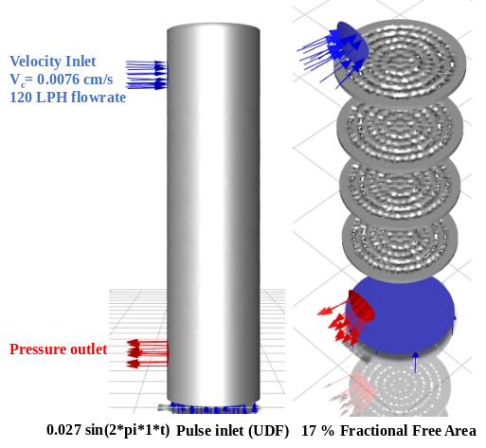  Figure 1. Schematic of Pulsed sieve plate column | 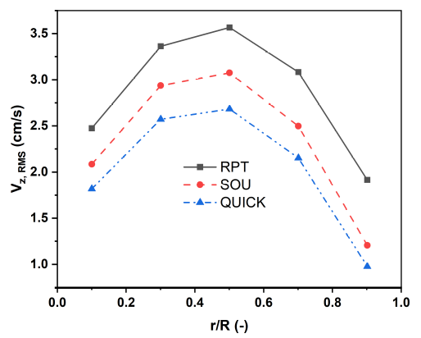  Figure 2. Time averaged axial RMS Velocity between 2nd and 3rd sieve plates

