Patient-specific 3D models from coronary computed tomography angiography

Mudrika Singhal*1 , Raghvendra Gupta 1,2, Bishwajeet Saikia 3, Amit Malviya4, Amitav Sarma3, Pranjal Phukan5

1 Department of Chemical Engineering, IIT Guwahati, India
2 Jyoti & Bhupat Mehta School of Health Sciences & Technology, IIT Guwahati, India
3 Department of Anatomy, NEIGRIHMS Shillong, Meghalaya, India
4 Department of Cardiology, NEIGRIHMS Shillong, Meghalaya, India
5 Department of Radiodiagnosis & Imaging, NEIGRIHMS Shillong, Meghalaya, India

E-mail: mudrikasinghal@iitg.ac.in

Abstract

Coronary computed tomography (CT) angiography is a non-invasive imaging technique used for production of detailed images of the coronary arteries. It is used as a diagnostic tool for detection of abnormalities and atherosclerosis or plaque build-up in the arteries. In this work, we aim to construct patient-specific 3D models of the coronary arteries from the CT images in an image-processing based software. CT angiograms of patients have been collected at NEIGRIHMS Shillong and the construction of 3D model from the medical image data set is done in SimVascular, an open-source software for patient-specific modelling, following the steps outlined in Fig. 1(a). A constructed 3D model of the coronary artery along with a section of aorta can be seen in Fig. 1(b). These models provide an information about the anatomy and the branching patterns of the arteries. From the models constructed, it is observed that the branching pattern varies for each patient and the length of the arteries is also different. In the left coronary branch, generally 2-3 sub-branches consisting of septal branches can be seen. In the right branch, for majority of the patient data, a single branch is seen. The constructed 3D models are characterised via parameters such as curvature and tortuosity, which are planned to be used for studying the atherosusceptibility of the vessels.
Student Academic Board (SAB), Indian Institute of Technology Guwahati, Guwahati, Assam, India
Research & Industrial Conclave 2023 "An amalgamation of Academia, Industry & Start-up”
"
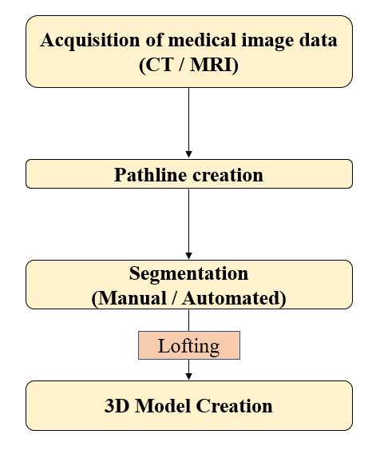
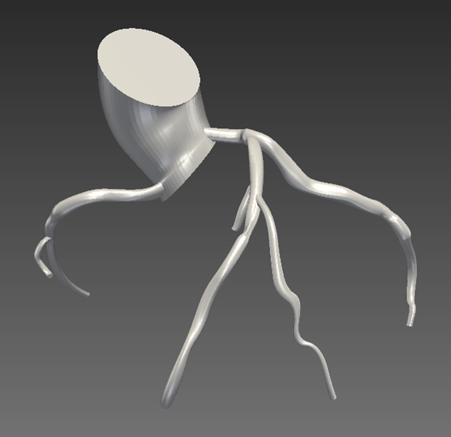
(a)
(b)
Figure 1. Workflow: From medical image to 3D model

Keywords: Coronary arteries, patient-specific models.

