Facile ACQ-to-AIE transformation via polyfluorene modification with versatile properties at the molecular and aggregate level

M. A. Chanu1 and P. K. Iyer 1, 2, *

1 Department of Chemistry, IIT Guwahati, India
2 Centre for Nanotechnology, IIT Guwahati, India

E-mail: manitachanu@iitg.ac.in

Abstract

Molecular movements are key features of matter and play crucial roles in their structures and behaviours. However, due to the diversity and complexity of structures and behaviours, studying motion-structure-property correlations remains a problem, particularly at all levels of structural hierarchy, from molecules to macro-objects. A serious of Conjugated polymer (CPs) P1, P2 and P3 were developed by incorporating different mole fraction of AIE monomer into the polyfluorene backbone in order to unravel the correlation between photophysical property and their structure-property relationships at the molecule and aggregate levels. By changing the mole fraction of AIE monomer the photophysical properties of the resulting copolymers are highly tuned which are quite useful for various types of application. Further, the PFCN polymer is utilized for bioimaging application. Although small molecules AIGens are widely used for bioimaging, the exploration of new AIE CPs will be promising research in the near future, considering less toxic better thermostability and amplification of signals by minor perturbation known as the Molecular wire effect.
Student Academic Board (SAB), Indian Institute of Technology Guwahati, Guwahati, Assam, India

Keywords: Conjugated polymer, molecular wire effect, ACQ, AIE

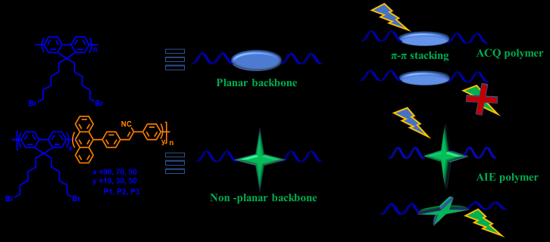
TOC: Transformation of ACQ polymer into AIE polymer

