Behaviour of Beam-Column Connection Secured with One-sided Expansion Anchors Under Cyclic Loading for Hollow Steel Structures

Mangesh Jadhav¹, and Kishor Kulkarni²

¹Research Scholar, Department of Earthquake Engineering Indian Institute of Technology, Roorkee
²Scientist, Central Building Research Institute, Roorkee
E-mail: ¹mangesh.jadhav67@gmail.com, ²kishorsk@cbri.res.in

Abstract

Prefabricated structures made a significant revolution in construction industries. Most prefabricated structures are made of steel because steel structures can be erected rapidly and their construction and demolition time can be minimized. Till now, most of the steel structures are built-up with conventional steels sections, which are designed and constructed by conventional methods. This leads to heavy or uneconomical structures. Tubular steel sections are the best replacements to the conventional ones with their use and comparatively better properties. But the problem with the tubular sections is the joint between the beam and column. Many researchers have proposed joint configuration for hollow structures but it is need to make a new and easy configuration for the prefabricated structures that saves time and also, suitable for seismic regions.
Student Academic Board (SAB), Indian Institute of Technology Guwahati, Guwahati, Assam, India
In this study the two new beam-column joints for hollow steel structures are proposed. The evaluation of mechanical performance of beam-column connections secured with one-sided steel expansion anchors (referred as blind bolts) for the steel-framed building components of Hollow Steel Section (HSS) is carried out. The two types of one-sided expansion anchors beam-column connections including Flange with Straight Rib Plate Connection (FSRPC) and Collar with Inclined Rib Plate Connection (CIRPC) were experimentally tested under quasi-static cyclic loading. Based on the experimental test results moment rotation, hysteresis behavior, stiffness, energy dissipation and ductility properties were evaluated. The detailed Finite Element (FE) analysis is carried out to simulate the connection's behavior and to describe the experimental responses under quasi-static cyclic loading. The results FE analysis shows a good comparison with the experimental results. The performance of FSRPC and CIRPC beam-column connections under cyclic loading exhibits the superior strength, stiffness and ductility.

Keywords: Hollow Steel Sections (HSS), Blind Bolts, Ductility, Energy Dissipation
Research & Industrial Conclave 2023 "An amalgamation of Academia, Industry & Start-up”
"
Proposed Connections with One sided Expansion Anchor:
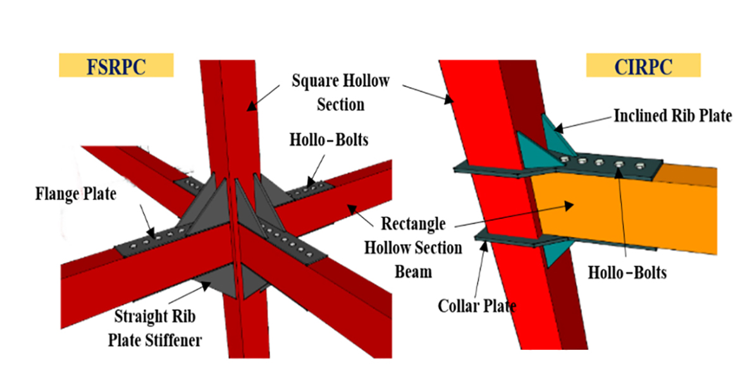 | 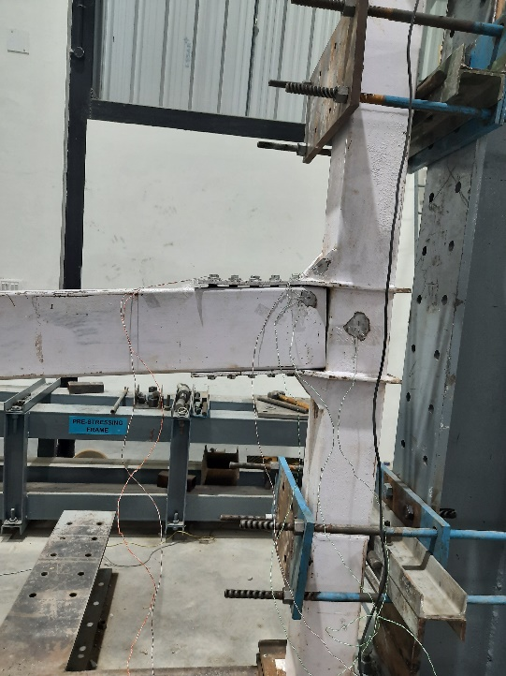
Fig. 1. Proposed Beam-Column Joints for HSS | Fig. 2. Investigated Test Specimen

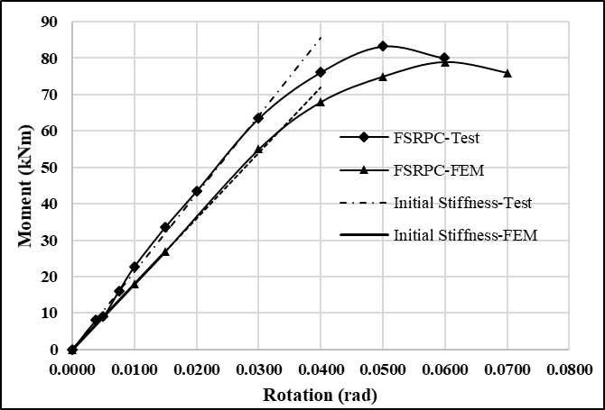 | 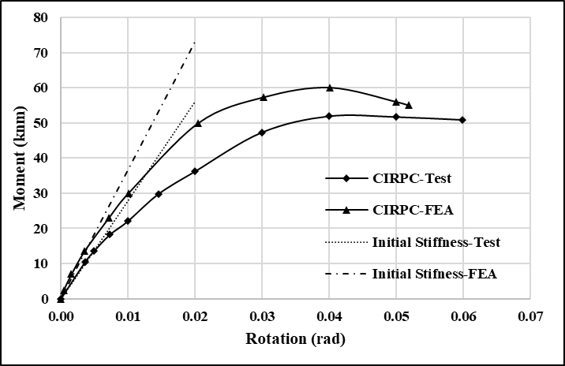
a | b
Moment -Rotation relationship a) FSRPC b) CIRPC

