A study for Fabrication of an Affordable Motorized Lower Limb Exoskeleton System (Wearable Device) for Paraplegic Person.

Monuranjan Dowarah1 and Santosha Kumar Dwivedy2

1,2 Department of Mechanical Engineering, IIT Guwahati, India
E-mail: monudh@iitg.ac.in

Abstract
Student Academic Board (SAB), Indian Institute of Technology Guwahati, Guwahati, Assam, India
In this work, a detailed study is carried out towards the fabrication of an affordable motorized lower limb exoskeleton (LLE) a wearable device for paraplegic people. To measure the movement of hip, knee and ankle angles goniometer is used. Spring balance has been used to find the holding torque of the joints to estimate the required motor torque. SolidWorks software is used to draw the 3D CAD model. Ansys software is used to perform structural analysis of the designed parts. Finally, the fabrication of the device has been done with a steel frame, stepper motor, linear actuator, motor driver and Arduino microcontroller board to control the system.
Research & Industrial Conclave 2023 "An amalgamation of Academia, Industry & Start-up”
"
Keywords
LOWER LIMB EXOSKELETON, SOLIDWORKS, ANSYS, LINEAR ACTUATOR, STEPPER MOTOR, ARDUINO
Rationale for the study
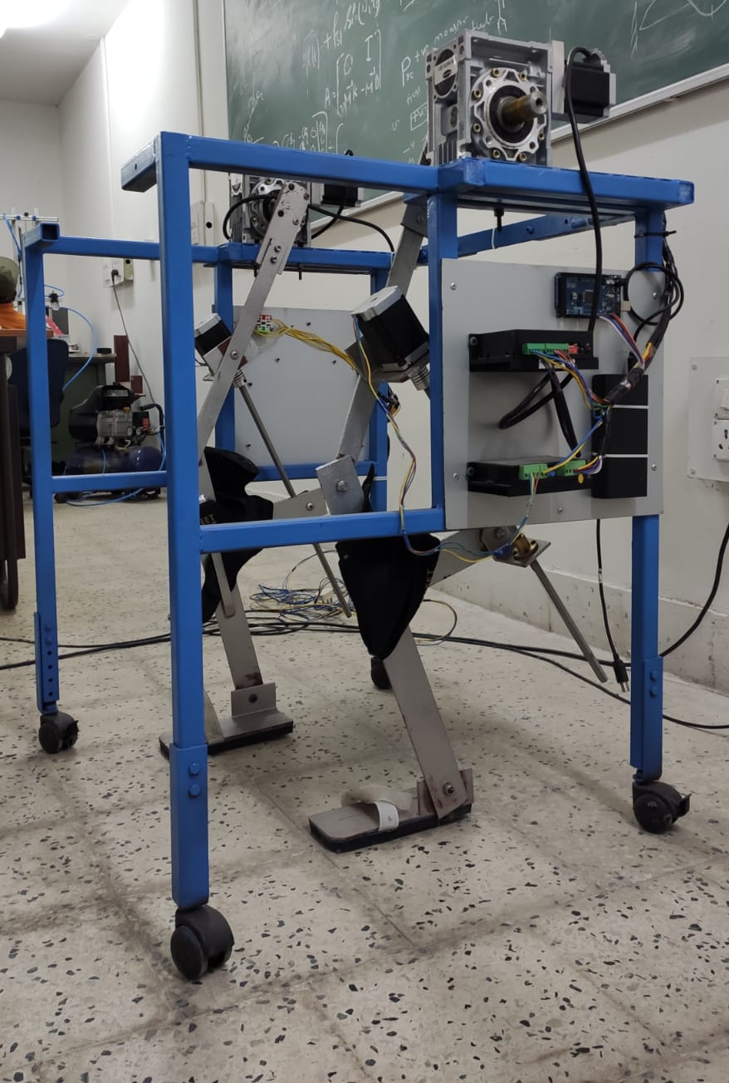
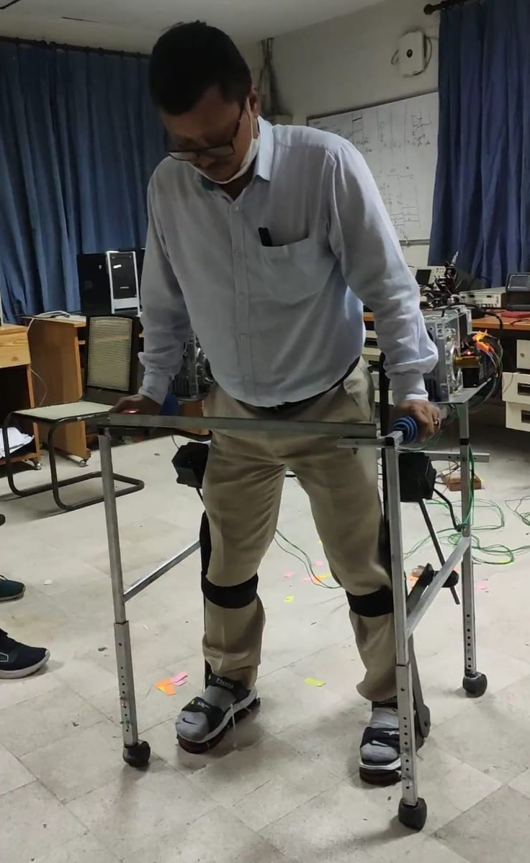
As per the Indian Census of 2011 (2016 updated), there are about 2.68 Cr people with disability of motion, among which paralytic people comprising a major part of it. Majority of the cases of paralysis arise due to strokes, and estimates of 2015 show that India has a total of approximately 1.8 million cases of stroke annually, the number rising each year. Owing to their low incomes, majority of these paralytic patients opt for manual wheelchairs as a means to restore their mobility. However, the annual wheelchair has these pose a few limitations such as use on uneven terrain and limited independent to move. Whereas, the Motorized Lower Limb Exoskeleton system gives more freedom to move these paraplegic persons as compare to these wheelchairs.

(a)
(b)
Figure.1: (a)Final Prototype of Motorized Lower Limb Exoskeleton device and (b) Device with a healthy subject

