Multiple particle tracking microrheology as a tool for biomaterial design

Nayanjyoti Kakati¹, Saurabh Dubey², Omkar Deshmukh¹, Dipankar Bandyopadhyay^{1,2,3}
¹Department of Chemical Engineering, Indian Institute of Technology Guwahati, Assam, India
²Centre for Nanotechnology, Indian Institute of Technology Guwahati, Assam, India
³Jyoti and Bhupat Mehta School of Health Sciences and Technology, Indian Institute of Technology Guwahati, Assam, India
E-mail: dipban@iitg.ac.in

Abstract

Student Academic Board (SAB), Indian Institute of Technology Guwahati, Guwahati, Assam, India
Research & Industrial Conclave 2023 "An amalgamation of Academia, Industry & Start-up”
"
Multiple particle tracking (MPT) microrheology is a passive microrheology technique used to study the viscoelastic behaviour of biomaterials. Microrheology is the rheological study of a material in a localised level. In this technique, fluorescently labelled tracer particles are added to the sample and their Brownian motion is tracked over time by using confocal laser microscopy. Based on the movements of the tracer particles the material’s microrheology is calculated. In the recent years microrheology of various biomaterials has been characterized in order to know their local viscoelastic behaviour. This technique is also useful for the design and development of novel biomaterials for various tissue engineering applications. Based on specific requirements, different types of biomaterials are used as scaffold material for tissue engineering. Among them, agarose and polyacrylamide gels are extensively used in 3D cell culture applications. However, due to their inert behaviour they are unable to mimic the native environment. Hyaluronic acid and collagen are promising biomaterials, in that they can facilitate the 3D environment as well as cell ECM crosstalks. Here in this work MPT has been used to characterize the viscoelastic behaviour of hyaluronic acid-based hydrogels.

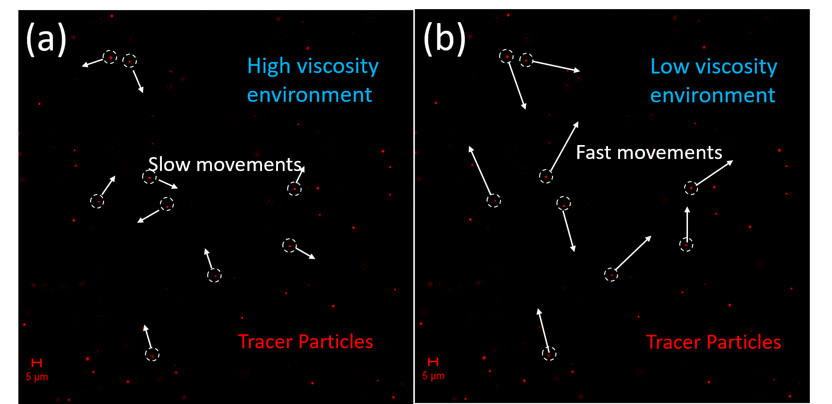
Figure 1. Tracking of fluorescently labelled tracer particles in (a) high viscous and (b) low viscous environment under confocal laser microscope.
Keywords: MICRORHEOLOGY, HYALURONIC ACID, BIOMATERIAL

